INVESTIGATION OF ADDITIVES MIGRATION
FROM SALTED SERUM BAGS

D.Ikermoud⁽¹⁾, H.Benaissa⁽²⁾, N.Belhaneche-Bensemra⁽¹⁾
⁽¹⁾Laboratoire des Sciences et Techniques de l'Environnement, Ecole Nationale Polytechnique, BP 182 El-Harrach, Alger, Algérie
⁽²⁾Laboratoire de la Police Scientifique, Ben Aknoun, Alger, Algérie

Abstract
The aim of this paper is to study the interactions between plastic packaging which is used to store salted serum at 0.9% of NaCl and the physiological liquid. For this purpose, the bags were stored in real conditions of storage by respecting temperatures and time of conservation. Samples were taken off every 4 months to be analyzed.
Fourier transform infrared (FTIR) spectroscopy was used to investigate the migration phenomena, the atomic absorption spectrometry (AAS) was used to follow the migration's evolution of metals from bag's plastic and the gas chromatography coupled with mass spectrometry (GC/MS) was used for the determination of DOP migration.
The results obtained by the three techniques showed the migration of the serum bags additives in the physiological liquid. This migration depends on time contact.
Key words: PVC, migration, salted serum, FTIR, AAS, GC/MS.

INTRODUCTION
Plastics are everywhere, from a technical and economic point of view, they have become essential for the manufacture of consumer products. The plastics use for the fabrication of disposable medical devices has increased in recent years. The development of such devices has unquestionably represented a definite advance in medical safety and storage, handling and delivery of biologic and physiologic products.
Poly(vinyl chloride) (PVC) is widely used in the packaging industry as a soft and plasticized material because of its advantageous economics of production and useful properties. PVC is extensively used as a packaging material for pharmaceutical items [1].
Various additives such as plasticizers (phthalic and phosphoric acids), heat stabilizers as metal soaps (Pb, Cd, Ba, Ca and Zn carboxylates) and some di and mono-alkylin compounds, e.g. maleates, carboxylates, mercaptides and lubricants are generally incorporated [1, 2]. The addition of such substances is necessary for processing and for achieving the desired chemical and mechanical properties. However, these low molecular weight additives frequently possess a high mobility in PVC materials and in contrast to the macromolecules, are capable of migrating from the packaging material into the packed product [3-5]. Several approaches have been developed to reduce matter transfers [6-10].
The phtalates as plasticizers (DOP, DIDP, TOTM, etc...) may be physiologically objectionable because they are able to migrate from PVC packaging towards the medium in contact with it. This leaching affects the quality of the plastic like flexibility and glass transition temperature [11,12].
Toxicologically, it has been proved that high dosage and long term exposure or during prolonged administration of di-isoctyl phtalate (DOP or DEHP) causes hepatic peroxisome proliferation in rats and mice. Furthermore, it can be cause of liver cancer to rodents and adverse effect on the reproductive development for young male rats. Molecular analyses in fetal rat testes after in utero exposure to phtalates have shed light on the potential mechanisms via which phtalates suppress testicular testosterone production [13, 14]. In addition phthalates were suspected to increase asthma and bronchial obstruction in children [15].
In this work, the interactions between plastic packaging used to store salted serum and the physiological liquid are investigated.

EXPERIMENTAL
1.Materials
The physiological serum bags used in this study are transparent. These bags are commercial products in drugstores and used in hospitals. They are produced by the Italian company S.I.F.R.A EST SPA which is specialized in the production of flexible containers in PVC. The nitric acid used in the mineralization has the purity of 65%, it is purchased from the Spanish company Panreac Quimica Slu and used as received. The di-octyl phthalate (DOP) used in the identification and quantification of the plasticizer in the composition of the formulation of physiological serum bags is a low volatile substance produced by Société Générale of Tunisia Plasticizers. Tetrahydrofuran and chloroform of high purity HPLC grade from Panreac Quimica Slu were used. The methanol used in GC/MS has a purity of 99.99%, it is produced by Sigma Aldrich from Germany.

2. Migration testing
Migration tests were conducted using salted serum bags, stored in real conditions by respecting the temperatures and the time of conservation. The test conditions were 36 months at temperature between 5 and 30 °C. A sample was taken off every four months. It was washed with deionised water and dried at 40° C. A bag without contact with salted serum was taken as a witness.

3. Characterization methods

FTIR spectroscopy analysis
The FTIR spectra of the PVC films were taken using a PerkinElmer, Spectrum One model infrared spectrophotometer with 120 scans per sample and a resolution of 2 cm⁻¹. The technique used is U.A.T.R (Universal Attenuated Total Reflexion). IR solution software was used for spectra processing data.

AAS analysis
Before analysis, mineralization of the samples was performed [16]. The analysis was carried out with an AAnalyst 800-PerkinElmer with Zeeman effect for graphite furnace system and on AAnalyst 400-PerkinElemer with deuterium lamp for flame system.

GC/MS analysis
The separation of plasticizers from PVC was done by the dissolution/precipitation process. A small piece of bag (3mm x 2mm) was weighed and dissolved in THF at ratio of 1g plastics in 40ml THF. PVC was precipitated by addition of methanol (THF/Methanol=1:2,5 v/v). The filtrate was then separated from PVC precipitated by filtration and the solvent evaporated. The filtrate was dried at 80 °C for 40 min. The dried extract was dissolved in chloroform and analyzed on PerkinElemer GC connected to MS detector [17, 18].
The injector temperature was 300 °C with splitless mode, the detector temperatures were 180 °C for the carrier liquid and 150 °C for the source. Carrier gaz was helium with a flow of 1.2 ml/min. A 30 m capillary PE-5MS ((5% diphenyl, 95% dimethyl polysiloxane), i.d=0.25 mm, d.f=0.25µm, PerkinElemer) was used under the following conditions : 90 °C held for 3 min, heated up to 280 °C at a rate of 6 °C/min and held for 13 min. Molecular mass in the range 50-650 amu was scanned.
The dosage of DOP in the control bag and bags those have undergone the migration test was performed by establishing a calibration curve produced by mixing DOP standard in chloroform at concentrations that covered the concentration range found in the polymer extracts; the resulting line was linear with correlation coefficient of 0.998. Three analytical replicates were analyzed for each concentration.

RESULTS AND DISCUSSION

Identification of the constitutive polymer and additives
Identification of the polymer
In the case of a mixture of polymer and additives, the overall infrared spectrum is substantially the sum of constituent spectra, any differences are due to interactions between the components. Generally, it does not operate by direct interpretation of the different bands of the spectrum, but by comparison with reference spectra of known products, however based on some characteristic bands that present the sample spectrum to be identified. Figure 1 represents the superposition of the infrared spectra of PVC and serum bag.
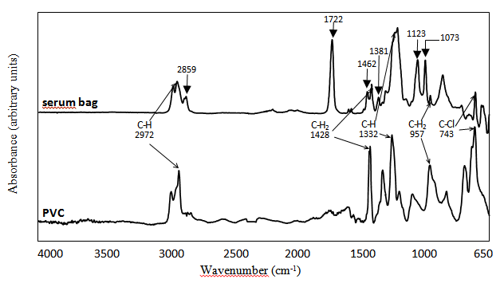
Figure 1: Infrared spectra of PVC and serum bag.

A number of characteristic bands of functional groups of PVC are found in the serum bag like the bands at 2972, 1428, 1332, 957 and 743 cm⁻¹, which allow to identify PVC as the constitutive polymer of the tested serum bags [19,20].
The comparison of infrared spectra of PVC and serum bag shows a presence of bands at 2859, 1722, 1462, 1381, 1123 and 1073 cm⁻¹, which permits to expect a possible presence of additives such as dioctyl phthalate (DOP) as plasticizer, epoxidized soybean oil, and zinc stearate as heat stabilizers and a phenol derivative as an antioxidant [20].

Identification of DOP by GC/MS
To identify DOP plasticizer, the witness pocket was analysed by GC/MS method. The identification of the peak was deduced by searching in the MS libraries (NIST) and further confirmed by running the known chemicals for DOP.
The identification and quantification of DOP in serum bags were performed using m/z 149 [21].

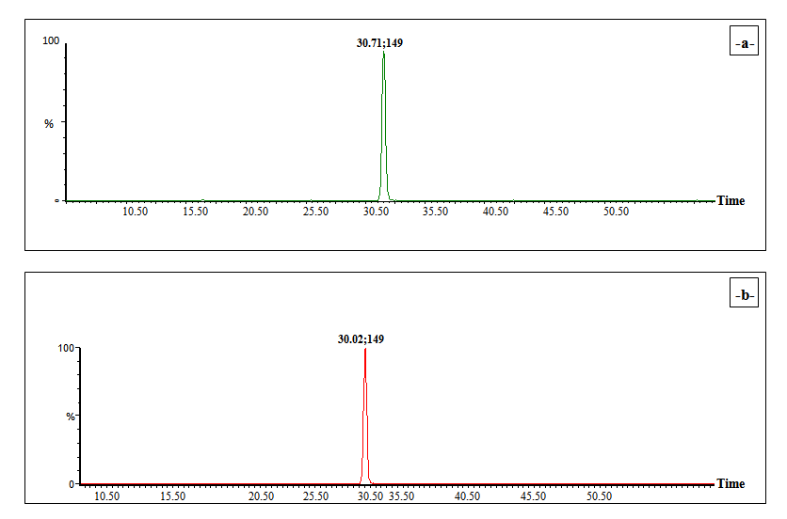

Figure 2 : Chromatograms : -a- of the extract from the serum bag.
-b- of the standard DOP.

From the chromatogram of the extract of the reference serum bag and of the standard DOP analyzed by GC/MS in the same operating conditions, the presence of one major peak can be noted. It has a retention time of 30.71 minutes with m/z 149 which is practically the same retention time of DOP (30.02 min) and which confirms that the plasticizer used in the manufacture of these pockets is dioctyl phthalate. It is to be noted that all phthalate plasticizers have a basic characteristic peak at m/z = 149.
These results were confirmed in figure 3 which shows the mass spectra of the control bag extract and the DOP standard. Through these spectra, it can be confirmed that the plasticizer used in the serum bags formulation is the di-2 ethyl hexyl phtalate (DEHP) which is also a ramified dioctyl phthalate.

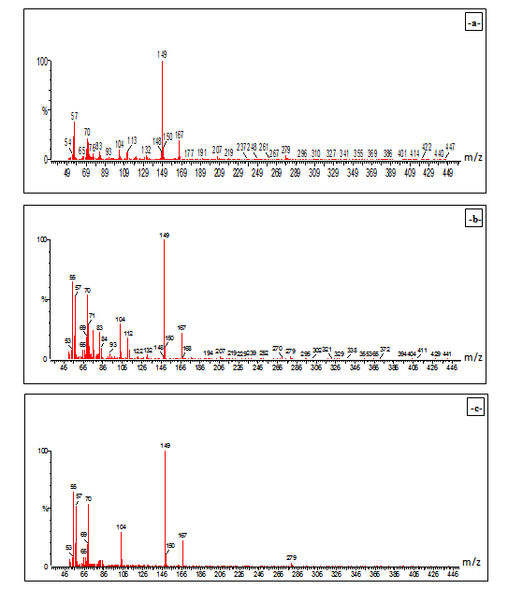

Figure 3 : Mass spectrum : -a- of the extract from control serum bag.
-b- of the standard DOP.

Study of the migration phenomena
FTIR spectroscopy investigation of the PVC films after migration testing
The study of FTIR spectra of the witness bag and bags contacted the serum for various times in months was performed in order to follow the evolution of characteristic bands' additives in the formulation of the polymer constituting these bags.
The comparison of PVC films spectra shows a decrease specially of the carbonyl band at 1722 cm⁻¹ and other bands like 2859, 1462, 1381, 1123 and 1073 cm⁻¹, which refers to functional characteristics groups due to additives [22].
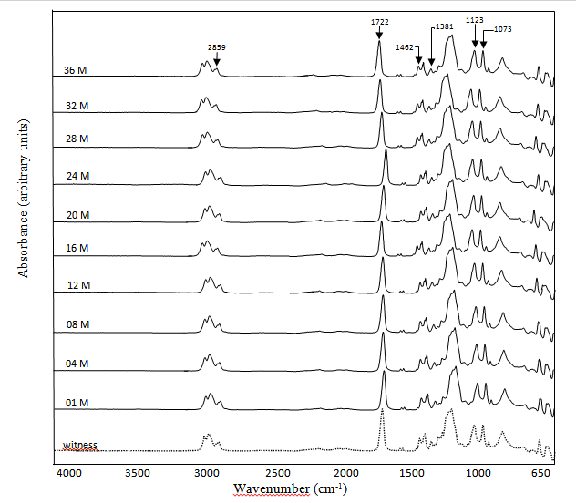

Absorbance

Figure 4: FTIR spectrum of serum bags at different contact time (months).
The ester band at 1722cm⁻¹ would be associated with the presence of plasticizer from the phthalates family whose presence was confirmed by GC/MS analysis and thermal stabilizer of the family of epoxidized oils. Generally, dioctyl phthalate (DOP) and epoxidized soybean oil are the most used additives [22, 23].
To study the changes undergone by each band, a semi-quantitative estimation was carried out by calculating the following absorbance ratios: A2859/A1428, A1722/A1428, A1462/A1428, A1381/A1428, A1123/A1428, A1073/A1428. The band at 1428 cm⁻¹ corresponding to the CH₂ bond in PVC is used as a reference band [21]. According to figure 5 gathering the variation of these ratios depending on the contact time, a decrease of all the ratios is observed on all the curves, indicating that the migration of a certain amount of additives present in the poly(vinyl chloride) bag's towards the serum, occurred; this phenomenon was already observed in other studies [24,25].
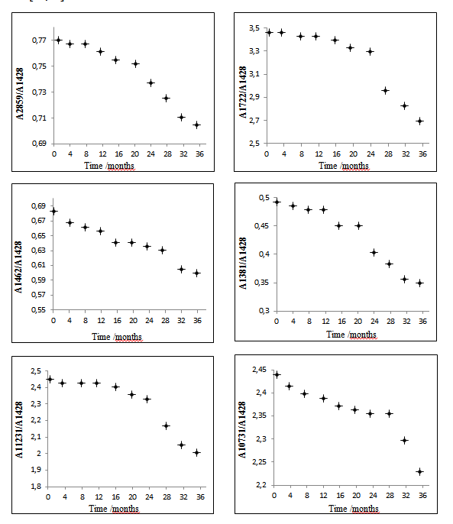

Figure 5: Absorbance ratio's variation as a function of contact time
of serum bags.

AAS investigation
The atomic absorption spectrometry was applied to the determination of the metal content in the control bag and in those that have been in contact with the salted serum for different contact times. The elements analyzed are : copper, manganese, chromium and zinc. These metals are due to the additives added to the polymer during processing.
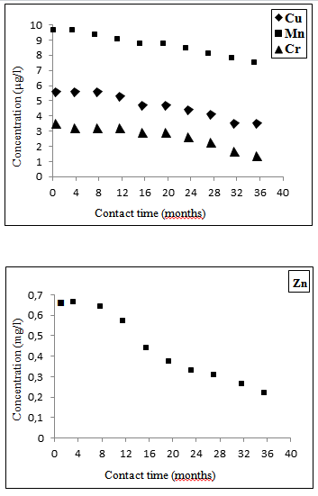

Figure 6: Variation of the residual content of metals in pockets
conditioning the salted serum with time.

According to figure 6, a decrease in all residual metal's concentration in bags containing the salted serum through storage time can be observed.
Thus the results of atomic absorption spectrometry are in accordance with the results obtained by FTIR spectroscopy.

GC determination of DOP migration
Table 1: Peak surface and residual concentration of DOP in the extracts
from witness bag and those undergone migration testing.
- | witness bag | bag stored for 4 months | bag stored for 20 months | bag stored for 36 months
peak area (µv/s) | 3256553 | 3251120 | 3229342 | 3212969
residual [DOP] in each bag (ppm) | 2,391 | 2,387 | 2,371 | 2,359
% of leaching | / | 0,17 | 0.84 | 1.34

According to table 1 and figure 7, it appears that the decrease in specific surface DOP peaks corresponds to the reduction of residual concentrations of this plasticizer in any bag having undergone migration testing, which means the leaching of DOP in the serum due to salinity and time contact as found in other works [26].
These results show the influence of salinity contact time on the migration phenomenon.

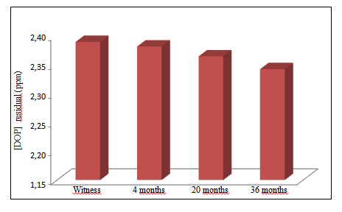

Figure 7: Comparison of the residual rates of the DOP in witness bag
and in those conditioning the salted serum at different time contact.

CONCLUSIONS
From the experimental results, the issues to be noted are the following:
- The application of the FTIR spectroscopy which is a very simple and non destructive technique, allowed to identify PVC as being the constitutive polymer of the salted serum bags.
- The follow-up of the variation of the characteristic bands of the additives according to the time of contact between the bags and the salted serum showed that a phenomenon of migration of these additives took place.
- The AAS results showed that the PVC bags formulation contains : copper, manganese, chromium and zinc. The follow-up of the variation of the residual contents of metals in bags conditioning the salted serum showed the loss of additives during storage time.
- The GC/MS analysis of the control bag and of the bags which were submitted to the tests of migration allowed to confirm that the DOP is the plasticizer used in the formulation of the serum bag and showed that its migration occurred in serum. The phenomenon is influenced by the time of contact.

Acknowledgments
Special thanks to Dr B.Aloui and his team from CRNA (Centre de Recherche Nucléaire d'Alger, Algeria) for allowing us to perform GC/MS analysis. Also thanks to Dr N.Larjane (Université Mouloud Mammeri de Tizi Ouzou, Algeria) and Dr R.Mihoub (Centre National de Toxicologie d'Alger, Algeria) for their help in this work.

REFERENCES
1. Murphy, J. (2003). Additives for Plastics Handbook, (2nd edition, Oxford: Elsevier Advanced Technology).
2. Minagawa, M. (1989). New developments in polymer stabilization, (Polym Degrad Stab), pp. 41-121.
3. Shepherd, J. M. and Gilbert, J., J. Eur. Polym. 17, 285 (1981).
4. Earls, A. O., Axford, I. P., Braybrook, J. H., J. Chromatogr. 983, 237 (2003).
5. Petersent, J.H. and Breindahl, T. (1998). Specific migration of di-(2-ethylhexyl) adipate (DEHA) from plasticized PVC film: results from an enforcement campaign, (Food additives and contaminants), Vol.15, N°5, pp. 600-608.
6. Boussoum, M. O., Hocine, Y. R. and Belhaneche-bensemra, N., Reducing the migration of additives from plasticised poly(vinyl chloride), Int. J. Environ. Stud. 913, 923 (2012).
7. Rahman, M. and Brazel, C.S., J. Prog. Polym. Sci. 29, 1223 (2004).

8. Vergnaud, J. M. and Taverdet, J. L., Preparation of plasticized PVC samples with very low matter transfers, J. Eur. Polym. Vol 22. N° 12. 959, 962 (1986).
9. Andic, J. L., Reyx, D., Brosse, J. C. and Poncin-Paillard, F., J. Ann. Fal. Exp. Chim. 93, 201 (2000).
10. Fugit, J. L., Taverdet, J. and Mazellier, P., J. Ann. Fal. Exp. Chim. 93,301 (2000).
11. Marcilla, A., Garcia, S. and Garcia-Guesada, J. C., Study of the migration of PVC plasticizers, J. Anal. Appl. Pyrolysis. 71, 457, 463 (2004).
12. Shieh, Y. T., Hsiao, T. T., Lung, M. and Yang, H. S., Supercritical CO₂ extraction of phtalate plasticizers from PVC, J. Appl. Sci. Vol 90. 4032, 4037 (2003).
13. Wilkinson, C. F. and Lamb, J. C., The potential health effets of phtalate esters in children's toys: a review and risk assessment, J. Regul. Toxical. Pharm. 140, 155 (1999).
14. Kalfa, N., Philibert, P., Baskin, L. S. and Sultana, C., Hypospadias: Interactions between environment and genetics, J. Mol. Cel. Endocrinol. 335. 89, 95 (2011).
15. Allsopp, M., P. Technical Note 14/00, Greenpeace Research Laboratories: Exeter, (2000).
16. Vandenburg, H. J. and Clifford, A., Analytical extraction of additives from polymer , Analyst, pp. 101R-115R (1997).
17. Wang, Q. and Storm, B. K., Separation and analysis of low molecular weight plasticizers in poly(vinyl chloride) tubes, J. Polymer. Testing. 24, 290 (2005).
18. Fantoni, L. and Simoneau, C., European survey of contamination of homogenized baby food by expoxized soybean oil migration from plasticized PVC gaskets, Food additives & Contaminants, Vol.20, N°11, pp. 1087, 1096 (2003).
19. Krimm, S., Infrared spectra of high polymers, Harrison M. Randall Laboratory of Physics, The university of Michigan, Ann. Arbor. Mich. 51, 172 (1960).
20. Socrates, G. (2001). Infrared characteristic group frequencies, (Wiley, New York), pp. 22-54.
21. Xie, Z. and al., Effects of Bio-based plasticizers on mecanical and thermal proprieties of PVC/wood flour composites, bioresour 9 (4). 7389, 7402 (2014).
22. Krim, S. Flot, V. L. and Shipman, J. J., Infred spectroscopy and assignement for polyvinyl chloride and deutrated analogs , J. Polym. Sci. Part A. Vol 1. (1997).
23. Boussoum, M. O., Belhaneche-Bensemra, N., Study and optimization of a soaking treatment to reduce migration from plasticized polyvinyl chloride, J. Appl. Polym. Sci. 1241, 1247 (2011).
24. Atek, D. and Belhaneche-Bensemra, N., FTIR investigation of the specific migration of additives from rigid poly(vinyl chloride), Eur. Polym. J., 41. 707,714 (2005).

25. Suhrhoff, T. J. and Scholz-Botter, B. M., Qualitative impact of salinity, UV radiation and turbulence on leaching of organic plastic additives from four common plastics — A lab experiment, Marine pollution bulletin, Elsevier. Volume 102. Issue 1. 84,94 (2016).

26. Lu, L., Hashi, Y., Wang, Z.H., Ma, Y. and Lin, J. M., Determination of phthalate esters in physiological saline solution by monolithic silica spin column extraction method, J. Pharm. Anal. Vol 1. Nº 2. 92, 99 (2011) .

