Design of nanostructured powders and mechanical properties of WC-AISI 304 stainless steel composites

Ana M.R. Senos, Department of Ceramics and Materials Engineering, CICECO, University of Aveiro, 3810-193 Aveiro, Portugal

Abstract (300 word limit)
Cemented carbides are constituted by WC and a metallic binder usually processed through powder metallurgy routes. The good compromise between hardness and toughness achieved in cemented carbides designates the common use to cutting, machining and wear applications. The increasing application demands require not only materials with improved properties but also efficient processing techniques. The improvement of mechanical properties, namely hardness, can be achieved through grain size reduction up to the nanoscale range.
In the present work nanostructured powders of WC and stainless steel (SS) have been prepared using two routes: high energy ball milling (HEBM) to produce nanometric particles of WC and SS; and an innovative sputtering coating technique (SC) to coat micrometric WC particles with nanometric SS. For comparison, powders in the micro/submicrometer range were also prepared by conventional milling (CM). Composites of these powders were shaped by pressing and thermal consolidated using vacuum sintering. The final phase composition and microstructure were characterized by X-ray diffraction (XRD) and scanning electron microscopy (SEM/EDS), respectively, together with X-ray mapping for elemental distribution and electron backscatter diffraction (EBSD) for the grain size distribution. High resolution transmission electron microscopy (HRTEM) was also used for grain boundaries inspection and access the nanometric details of the microstructure. Composites from the different powders (HEBM, SC and CM) showed very different values of hardness, HV30, and toughness, KIC, varying from extremely hard parts for the HEBM composites, to impressive high tough composites for the SC parts. These mechanical responses are discussed taking into account the structure/microstructure and grain boundaries details leaded by the designed powder morphology.

Image
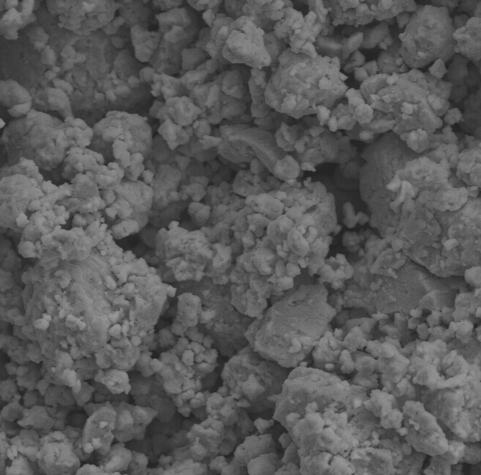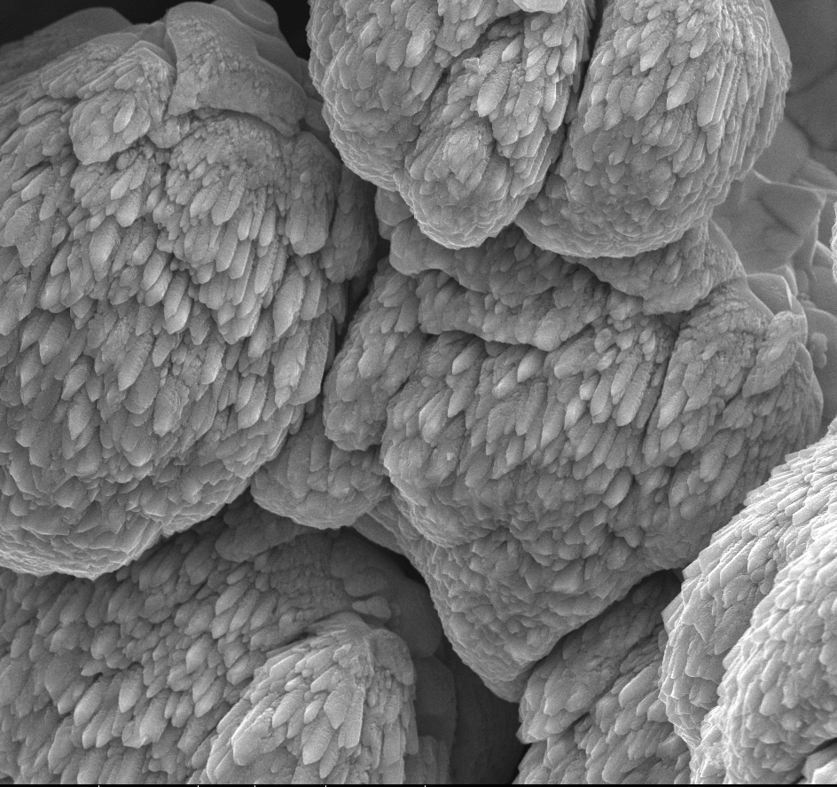
5 μm
(a)
5 μm
(b)

SEM micrographs (a) WC-12SS mixture prepared by HEBM; (b) WC powder sputter-coated with 12SS.
Recent Publications (minimum 5)
621.“Sintering, microstructure and properties of WC-AISI304 powder composites”, B.J. Marques, C.M. Fernandes, A.M.R. Senos, J. Alloys and Compounds, 562, 164-70 (2013). http://dx.doi.org/10.1016/j.jallcom.2013.02.013
2. “Grain Growth Anomaly and Dielectric Response in Ti-rich Strontium Titanate Ceramics”, Luís Amaral, Manuela Fernandes, Ian M. Reaney, Martin P. Harmer, Ana M. R. Senos and Paula M. Vilarinho, J. Phys. Chem. C, 117 (47), pp 24787–24795 (2013). http://dx.doi.org/10.1021/jp4035437
3. “Non-isothermal crystallization kinetics of a Si-Ca-P-Mg bioactive glass”, E.J.C. Davim, A.M.R. Senos, M.H.V. Fernandes , J Therm Anal Calorim, 117 (2), 643-51 (2014). DOI 10.1007/s10973-014-3786-3
4. “Mechanical characterization of WC-10 wt% AISI 304 cemented carbides“, C.M. Fernandes, L.M. Vilhena, C.M.S. Pinho, F.J. Oliveira, E. Soares, J. Sacramento, A.M.R. Senos, Materials Science & Engineering A, 618, 629-36 (2014). DOI 10.1016/j.msea.2014.09.064
5. “Corrosion behaviour of WC-10% AISI 304 cemented carbides”, A.B. Oliveira, A.C. Bastos, C.M. Fernandes, C.M.S. Pinho, A.M.R. Senos, E. Soares, J. Sacramento, M.L. Zheludkevich, M.G.S. Ferreira, Corrosion Science, 100, 322-31 (2015).
Doi: 10.1016/j.corsci.2015.08.006

6. “Abrasive wear resistance of WC-Co and WC-AISI 304 composites by ball-cratering method”, L.M. Vilhena, C.M. Fernandes, E. Soares, J. Sacramento, A.M.R. Senos, A. Ramalho, Wear, 346, 99-107 (2016). Doi: 10.1016/j.wear.2015.11.005

Biography (150 word limit)
Ana Senos is Associate Professor at the Dep. Materials and Ceramic Engineering, University of Aveiro, Portugal. She has been involved in the investigation of ceramics and nanocomposites processing, on the topics of sintering kinetics, microstructural development, grain boundary design, constrained sintering, and the relation with the electrical answer and mechanical behavior of materials.
Current interests are focused on development of nanostructured materials for structural, electrical and nuclear applications and on the study of grain boundary phenomena in electronic functional materials (2D, 3D), for microwave and energy applications.
Is author (co-authored) of more than 130 publications, including 3 Book Chapters, 103 papers (92 from SCI), 19 proceedings and 2 patents, with ca. 1400 citations (h-index=22). She has about 130 communications as oral and poster presentations or as invited speaker.
Orcid number: 0000-0003-4784-9784
Email: anamor@ua.pt

Notes/Comments:

