Evaluation of sputtered PZT thin films on Ti-substrates upon re-crystallization with a thin Pb-overcoat
Ankita Ghatak, PhD, S.N.Bose National Centre For Basic
Sciences, INDIA

Processing of thin lead zirconate titanate (PZT) films on metallic substrates has several advantages such as high frequency operation, low electrical series resistance, low dielectric loss and potential for embedded capacitor systems. As a suitable metal support for PZT films, titanium (Ti) seems to be the most natural choice as it posses high melting point, the thermal expansion coefficient of Ti matches closely to that of PZT and permits good adhesion with low reactivity. However, ferroelectric and piezoelectric responses of PZT films on Ti substrates are found to be not that encouraging. Presence of a non-ferroelectric pyrochlore/ fluorite (Py/Fl) phase on the surface of the PZT film is believed to be the primary cause for poor electrical performance.
In this work, effect of re-crystallization of PZT films with a thin Pb-overcoat has been investigated though structural, morphological, compositional and electrical studies. Sputter deposited PZT thin films on Ti-substrates are found to contain a Pb-deficient and Zr-enriched Py/Fl phase of type Pb₂(Zr,Ti)₂O₆ on the surface of the PZT film. Re-crystallization of these PZT films with a thin lead (Pb) overcoat improves the degree of crystallization, morphology and dielectric/
ferroelectric properties of the films by converting the top Pb-lean and Zr-rich Py/Fl phase into perovskite phase. Structural changes that occur in PZT films upon re-crystallization with a Pb-overcoat have been correlated with ferroelectric characteristics of the PZT films.

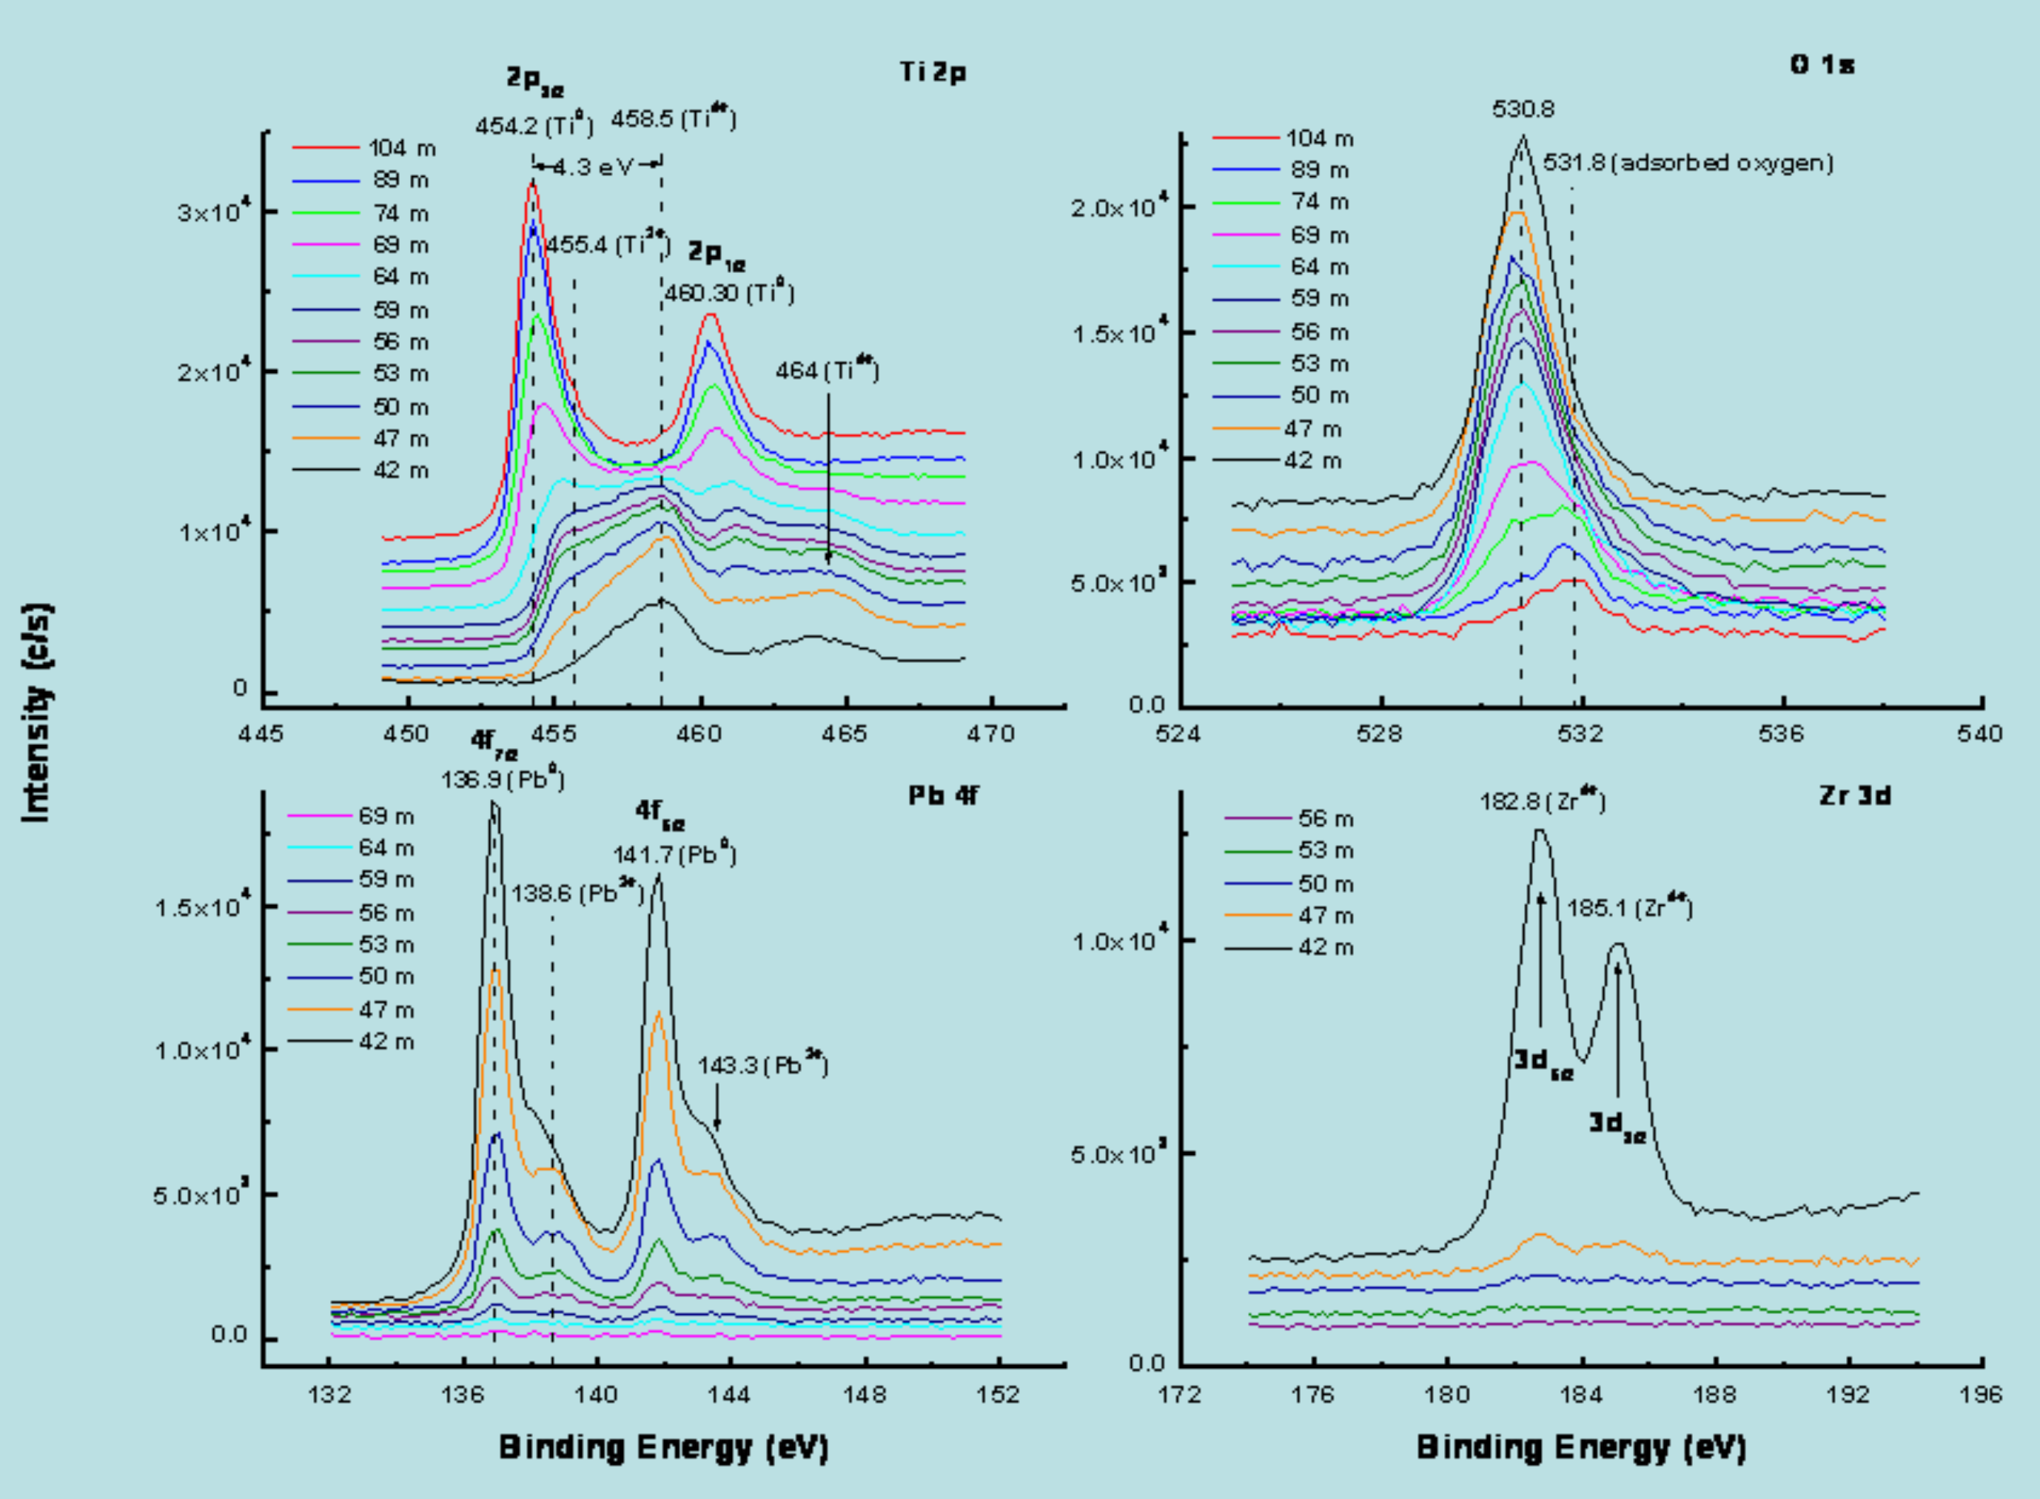
Recent Publications (minimum 5)
- Ghatak A, Roy Moulik S, Ghosh B(2016) Pulsed laser assisted growth of aligned nanowires of WO₃ and their microstructural analysis. RSC ADVANCES 6:31705-31716.
- Roy Moulik S, Ghatak A, Ghosh B (2016) Study of surface chemistry and microstructure of TiO₂ nanostructures on Pt/Si wafers and FTO glass substrates: a comparative approach. Surface Science 651:175-181.
- Datta S, Ghatak A, Ghosh B (2016) Controlled hydrothermal growth of single crystalline nanowires and related nanostructures of perovskite oxide manganites (La_{1-x}A_{x}MnO₃) with adaptable stoichiometry and morphology. Journal of Material Science 51:9679-9695.
- H. Debnath G, Chakraborty A, Ghatak A, Mandal M, Mukherjee P (2015) Controlled Terbium(III) Luminescence in Zinc Sulfide Nanoparticles: An Assessment of Competitive Photophysical Processes. Journal of Physical Chemistry C 119:24132-24141.
- Ghatak A, Debnath G, Mandal M, Mukherjee P (2015)Lanthanide Cation Induced Tuning of Surface Capping Properties in Zinc Sulfide Nanoparticles: An Infrared Absorption Study. RSC ADVANCES 5:32920-32932.


Ankita Ghatak ,National Post doctoral Fellow has her expertise in growth of nanostrcutured binary as well as complex oxides. She has grown aligned 1-D nanostructured binary oxide which has a strong influence in the field of applications. She has a hands on expertise on microstructural analysis of complex oxide nanostructures that has provided up a new field of research from technological point of view. Her interface analysis of complex materials with substrates has open up a challenging field in the device fabrication process. She in her publications has tremendously contributed about the benefit of creating atomically sharp interfaces that will enhance the future device performances. A new approach in looking into atomic columns of manganite nanowires has been achieved by her recently through structural simulation.
.
Email: ankita.ghatak@bose.res.in

Notes/Comments: Invited Speaker

