Interaction of nanoparticles with amino acids and a physiologically important model protein studied by spectroscopic techniques
Karolína M. Šišková, Dept. of Biophysics, CRH, Faculty of Science, Palacký University in Olomouc, Czech Republic

Abstract (300 word limit)
Nanoparticles (NPs) are currently the topic of interest of a bundle of research papers and proposals. There are persistent rumors about NPs toxicity and ecotoxicity, concerns about their increasing release into the environment and attempts to their risk assessment. Many researchers often test the impact of different kinds of NPs on cells, tissues, organs, and/or directly on whole organisms. However, in order to understand the possible NPs impacts it is necessary, in my opinion, at first to evaluate the interaction of NPs with one type of the basic units of all organisms and their cells, i.e. amino acids. Furthermore, it is important to elucidate whether and how can NPs affect the conformation of proteins (their secondary and tertiary structure). Only after gaining such information, the assessment of NPs toxicity and ecotoxicity could be meaningful.
In this study, the interaction of synthesized and commercially available nanoparticles with selected amino acids and a physiologically important transmembrane protein, the sodium/potassium pump (Na+/K+-ATPase) will be investigated by using several spectroscopic techniques. The sodium/potassium pump is an enzyme which is ubiquitous in all animal cells and its malfunctions are related to many diseases such as hypertension, diabetic neuropathies, renal failure, neurological disorders etc.

Image

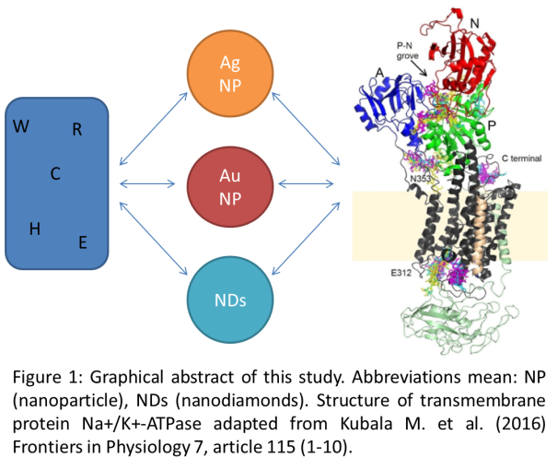

Recent Publications (minimum 5)
- Siskova KM, Vecerova R. et al. (2015) Revisiting spontaneous silver nanoparticle formation: a factor influencing the determination of minimum inhibitory concentration values? AIMS Environmental Science 2:607-622.
- Markova Z, Novak P. et al. (2014) Iron(II,III)polyphenol complex nanoparticles derived from green tea with remarkable ecotoxicological impact. ACS Sustainable Chemistry 2:1674-1680.
- Adegboyega NF, Sharma VK et al. (2014) Enhanced formation of silver nanoparticles in Ag+-NOM-iron(II,III) systems and antibacterial activity studies. Environ. Sci. Technol. 48:3228-3235.
- Sharma VK, Siskova KM et al. (2014) Organic-coated silver nanoparticles in biological and environmental conditions: fate, stability and toxicity. Advances in Colloid and Interface Science. 204:15-34.
5. Siskova KM, Machala L et al. (2013) Mixtures of L-amino acids as reaction medium for iron nanoparticles formation: the order of addition into ferrous salt solution matters. International Journal of Molecular Sciences 14: 19452-49473.

Biography (150 word limit)
Karolína M. Šišková has her expertise in nanoparticle synthesis, characterization, application and in vibrational spectroscopy. She published more than 40 papers as the main author or co-author in impacted scientific journals and presented more than 20 oral contributions and 8 posters on different nanomaterial and spectroscopic conferences and meetings. She graduated in physical chemistry from the Charles University in Prague and in INTER///BIO from the Université Pierre et Marie Curie, Paris VI, in 2006. In 2014, she was awarded the conferment of associate professor degree in physical chemistry. Her h-index is 15 and the number of citations 515 (without self-citations) according to the Web of Science on 20th December 2016. Coming back from her maternity leave in September 2016, she started to work at the Department of Biophysics, Faculty of Science, Palacký University in Olomouc, Czech Republic.
Email: karolina.siskova@upol.cz

Notes/Comments:

