Nano-Si: With good performance in solar cells and lithium ion batteries
Zhihao Yue, PhD, Institute of Photovoltaics,
Nanchang University, Nanchang, P.R. China

Abstract (300 word limit)
We have done much work about silicon (Si) in solar cells and lithium ion batteries (LIBs). In the aspect of solar cell, we used silver (Ag) -assisted chemical etching method to fabricate black silicon solar cells with efficiency over 18% in 2013 and large-scale production was carried out. Besides, nickel, which is cheaper than Ag, was used as assisted metal to fabricate black silicon structure for the first time and surface reflectance of 1.59% was obtained. In the aspect of LIBs, we used Si powders made from broken Si wafers with different electrical resistivity in semiconductor industry as anode material in LIBs. We find out that Si powders made from Si wafers with lower electrical resistivity show better electrochemical performance (higher capacity, and better rate performance) in LIBs. Therefore, broken Si wafers in semiconductor industry should be classified according to their electrical resistivity, which can be convenient for being used as anode raw materials for LIBs.

Image

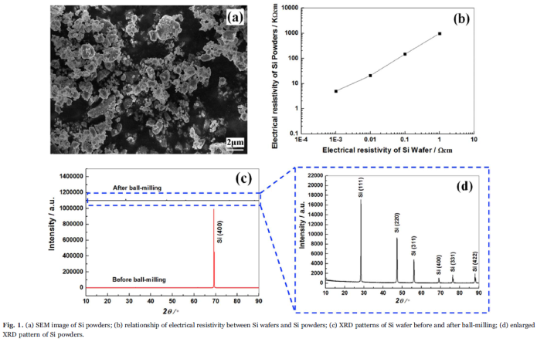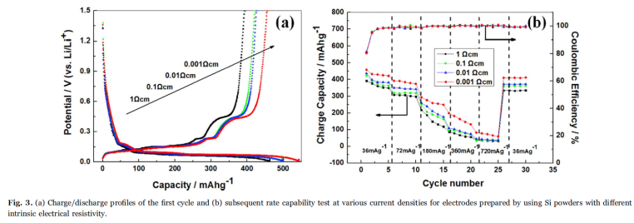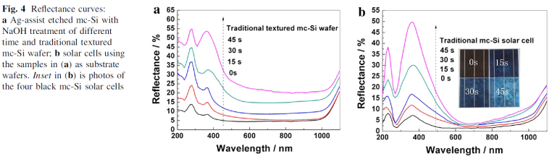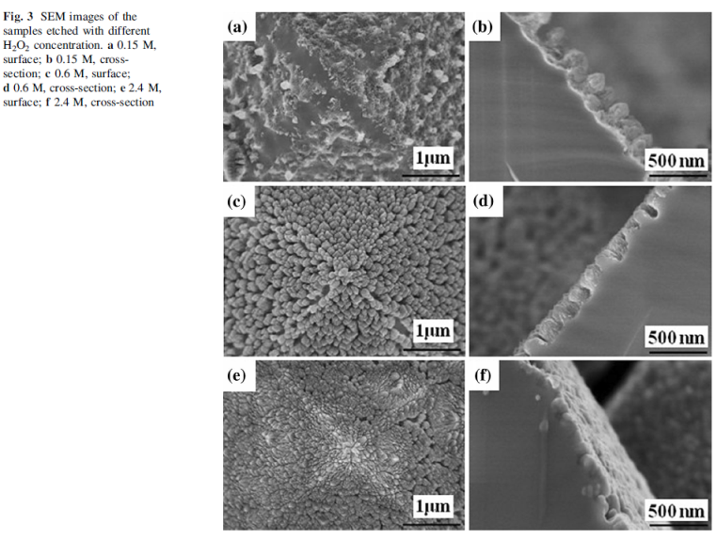

Recent Publications (minimum 5)
- Zhihao Yue, Lang Zhou, Chenxin Jin, Liekai Liu, Guojun Xu, Hao Tang, Haibin Huang, Jiren Yuan, Chao Gao. Study on the effect of intrinsic electrical resistivity of silicon materials on its performance for Li-ion batteries, Materials Letters, 2017, 1 (186): 217-219.
- Zhihao Yue, Honglie Shen, Ye Jiang, Chunbao Rui, Fanjian Kong, Jibo Cai. Large-scale black multi-crystalline silicon solar cell with conversion efficiency over 18%, Applied Physics A: Materials Science & Processing, 2014, 116: 683-688.
- Zhihao Yue, Honglie Shen, Ye Jiang, Jiale Jin, Wei Wang. Formation mechanism of silicon nanostructures by Ni-assisted etching, Journal of Materials Science: Materials in Electronics, 2014, 25(3): 1559-1563.
- Zhihao Yue, Honglie Shen, Ye Jiang, WeiWang, Jiale Jin. Novel and low reflective silicon surface fabricated by Ni-assisted electroless etching and coated with atomic layer deposited Al2O3 film, Applied Physics A: Materials Science & Processing, 2013, 114(3): 813-817.
- Zhihao Yue, Honglie Shen, Ye Jiang. Antireflective nanostructures fabricated by reactive ion etching method on pyramid structured silicon surface, Applied Surface Science, 2013, 271: 402~406.
- Zhihao Yue, Honglie Shen, Hong Cai, Hongjie Lv, Bin Liu. Study on structural properties of epitaxial silicon films on annealed double layer porous silicon, Physica B: Condensed Matter, 2012, 407 (12): 2278~2281.
- Zhihao Yue, Honglie Shen, Lei Zhang, Bin Liu, Chao Gao, Hongjie Lv. Heterojunction solar cells produced by porous silicon layer transfer technology, Applied Physics A: Materials Science & Processing, 2012, 108 (4): 929~934.

Biography (150 word limit)
Zhihao Yue has his expertise in using nano-silicon structures to improve the efficiency of silicon solar cell and the electrochemical properties of silicon anode materials in Lithium ion batteries. He used cheaper metal nickel (compared with silver) as assisted metal to fabricate nanostructures on silicon surface and investigated its etching mechanism deeply, which is the first study about nickel-assisted chemical etching method for black silicon solar cells. Besides, he systematacially studied the effect of intrinsic electrical resistivity of silicon materials on its performance in lithium ion batteries for the first time and found that silicon materials with lower electrical resistivity present better charge-discharge properties.

Email: yuezhihao@ncu.edu.cn
Notes/Comments:

None.

