Transparent Semiconductors: Synthesis, Properties and Applications
Hao Gong, Department of Materials Science and Engineering, National University of Singapore, Singapore

Abstract
In many applications such as special-effect advertisement and displays on window glass, optically transparent or invisible electronics are needed. Transparent oxide semiconductors (TOSs) are fundamentally important for realizing such advanced applications. To be transparent optically, the material needs to be of wide band gap of 3 eV and above. Such a wide gap is typically for an insulator, as conducting metals have almost no band gaps. Therefore, it is necessary to generate shallow level defects serving as donor or acceptor for making the material conductive. One of the most challenging and difficult parts of the TSOs work is the fabrication of highly conductive p-type TSOs and compound semiconductors, whose success can lead to new generation devices and applications. The p-type TSOs we have fabricated successfully include Cu-Al-O, ZnO, and Cu2O, etc. The n-type TSOs and TCOs we have successfully fabricated include nanostructured or/and amorphous ZnO, SnO2, IZO (indium zinc oxide), and ITO (indium tin oxide) thin films. Transparent p-n junction diodes have also been succeeded and investigated (see Figure 1).

In this talk, I will introduce transparent semiconductor, and use indium zinc oxide, zinc oxide, copper aluminum oxide as example to introduce various concept and parameters affecting optical transmittance and electrical conductance. The fabrication of the material will be introduced. Various characterization methods will be described for the determination of different important parameters. The properties of the material prepared under different conditions will be analyzed and discussed.
Image
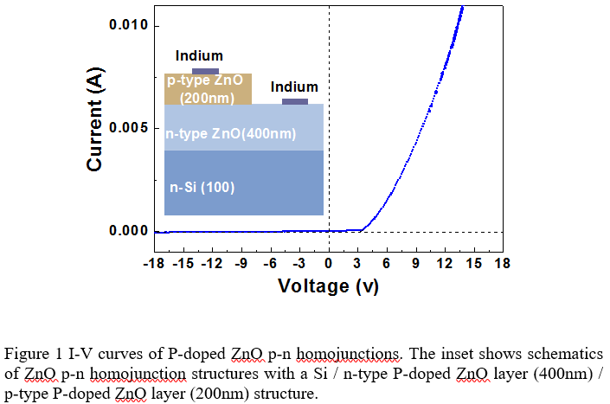
Recent Publications (minimum 5)
- Sha Nie, Jian Sun, Hao Gong, Zequn Chen, Yifei Huang, Jianmei Xu, Ling Zhao, Wei Zhou and Qing Wang¹ (2016) Glucose-assisted reduction achieved transparent p-type cuprous oxide thin film by a solution method. EPL 115:37005.
- Guangxia Hu, Bhupendra Kumar, Hao Gong, E. F. Chor and Ping Wu (2006) Transparent indium zinc oxide ohmic contact to phosphor-doped n type zinc oxide. APL 88:101901.
- Zhang LY; Tang CH; Gong H: Temperature effect on the binder-free nickel copper oxide nanowires with superior supercapacitor performance, NANOSCALE Volume: 6, Issue: 21, Pages: 12981-12989, Published: 2014
- Yin, XS; Tang CH; Sun LF; Shen ZX; Gong H: Study on Phase Formation Mechanism of Non- and Near-Stoichiometric Cu2ZnSn(S,Se)4 Film Prepared by Selenization of Cu-Sn-Zn-S Precursors, CHEMISTRY OF MATERIALS Volume: 26, Issue: 6, Pages: 2005-2014, Published: 2014
- Sun J; Yu JG; Huang YH; Xia YJ; Lai WS; Gong, H: Significant improvement in electronic properties of transparent amorphous indium zinc oxide through yttrium doping, EPL Volume: 106, Issue: 1, Article Number: 17006, Published: 2014

Biography

Dr. Hao Gong is a full professor at department of Materials Science and Engineering, National University of Singapore. He received his B.Sc and M.Sc from Yunnan University, China. He obtained his PhD degree from Delft University of Technology, the Netherlands. His research interests are mainly transparent semiconductors, gas sensors, solar cells and supercapacitors. He has had more than 200 SCI journal publications and several patents.
Email: msegongh@nus.edu.sg

