Fabrication and characterization of novel silk /chitin hydrogel /MCM-41 composite scaffolds for tissue engineering

Abbas Teimouri^{a,} *, Leila Ghorbanian^{b}

ª Department of Chemistry, Payame Noor University, P. O. Box 19395-3697, Tehran, Iran
^{b} Materials Engineering Department, Isfahan University of Technology, Isfahan, Iran

Tissue engineering has recently developed a growing field in the regeneration of tissues Biomaterials are required in tissue engineering techniques for the construction of scaffolds by which relevant cells can be attached, grown, and proliferated. Silk fibroin (SF) is a natural polymer produced by a variety of insects. Recently, silk cocoons from Bombyx mori have been used as an in-access material for tissue regeneration purposes [1].
Chitin, which is known to be a biocompatible and biodegradable polysaccharide, is the most abundant polymer on earth after cellulose. It is fabricated from the shells of shrimp and squid pens. It has also been found that the chitin hydrogel could be prepared by using this solvent system. In recent studies, the calcium solvent system has been found to be a suitable solvent to dissolve the chitin in the mild conditions [2].
silica exhibits several properties associated nwith an ideal material for grafting and scaffolding [3]. The nano ranged bioactive silica particles having large surface area canform a tighter interface with the polymer matrix in composites. Nano-bioglass ceramic particles possessing silica as its one of the chief contents not only provide polymer scaffolds with biomineralization
capability but also increase the stiffness of polymer material without greatly decreasing the mechanical strength [4].
In continuation of our previous studies on the construction of composite scaffolds [5-6], In this research, novel porous composite scaffolds consisting of silk, chitin, and MCM-41 were prepared using the freeze-drying method. The prepared nanocomposite scaffolds were characterized by SEM, XRD, BET, TGA and FT-IR techniques. In addition, swelling, degradation and biomineralization capability, cell viability and cell attachment of the composite scaffolds were evaluated.

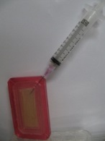 | 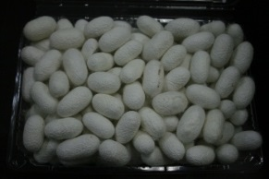
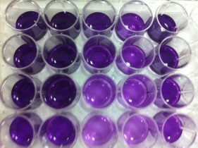 | 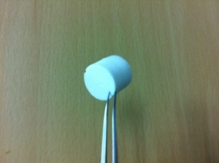
References

1. Wenk, E., Merkle, H. P., & Meinel, L. (2011). Silk fibroin as a vehicle for drug delivery applications. Journal of Controlled Release, 150(2), 128-141.
2. Tamura, H., Nagahama, H., & Tokura, S. (2006). Preparation of Chitin Hydrogel Under Mild Conditions. Cellulose, 13(4), 357-364.
3. Chen, Q. Z., Thompson, I. D., & Boccaccini, A. R. (2006). 45S5 Bioglass®-derived glass–ceramic scaffolds for bone tissue engineering. Biomaterials,27(11), 2414-2425.
4. Kokubo, T., & Takadama, H. (2006). How useful is SBF in predicting in vivo bone bioactivity?. Biomaterials, 27(15), 2907-2915.
5. Teimouri, A., Ebrahimi, R., Emadi, R., Beni, B. H., & Chermahini, A. N. (2015). Nano-composite of silk fibroin–chitosan/Nano ZrO 2 for tissue engineering applications: Fabrication and morphology. International journal of biological macromolecules, 76, 292-302..
6. Azadi, M., Teimouri, A., & Mehranzadeh, G. (2016). Preparation, characterization and biocompatible properties of β-chitin/silk fibroin/nanohydroxyapatite composite scaffolds prepared using a freeze-drying method. RSC Advances, 6(9), 7048-7060.



I am a graduate student at IUT and I am working as associate professor of organic in Payame Noor University. I believe that my teaching and experience combined with my course work and research background in synthesis, catalyst and Theoretical studies make me a strong candidate for the position outlined in your notice. I have had excellent opportunities to teach a variety of courses during my graduate studies, including Synthesis, solid acid catalysts and Theoretical studies.
Email: a_teimoory@yahoo.com,a_teimouri@pnu.ac.ir

