Synthesis and characterization of slag resistant corund - spinel ceramic materials
Zebo Babakhanova PhD, Tashkent Chemical-Technological Institute, Uzbekistan

Abstract
Statement of the Problem: In modern metallurgical production refractory ceramic materials are widely used for casting of liquid metals and as lining of metallurgical furnaces. The aim of the work was to study the MgO-Al₂O₃-SiO₂ system and to develop on the basis of this system new compositions of refractory slag-resistant ceramic materials for the needs of metallurgy, in particular for the production of crucibles for pouring metals. Great interest for preparation of slag-resistant compositions is paid to compositions present in the field of crystallization of spinel MgAl₂O₄ with a melting point of 2105 °C. The following raw materials were used for synthesis: talc-magnesite (Zinelbulak deposit), graphite concentrate (Uzbekistan), electrocorundum (Kazogneupor plant). Crystalline phase of calcinated at 1450 °C ceramics present by the initial minerals - corundum (60-70) and graphite, and the sintering minerals- high-temperature spinel (40-30 wt.%), the binder consist of high-alumina-silicate phase (Fig. 1). Ceramic binder is represented by rounded, irregularly shaped grains <25μm in size; the pores are mostly isolated with a size of 5 to 10 μm. The study of the physical-mechanical properties of synthesized materials showed that the ceramic materials have the density from 2510 to 2860 kg/m³, the water absorption index from 4.6 to 10%, the open porosity from 1.5 to 2.5%, the apparent specific gravity from 3.595 to 3.598. Low porosity and water absorption leads to an increase of slag resistance. The mechanical properties of the samples were determined on 5 samples by the method of nondestructive dynamic resonance. The compressive strength of the samples was from 100 to 120 MPa, the refractoriness of the samples was more than 1800 ^{о}С. Samples were tested for slag resistance to the metallurgical slag of Almalyk Mining-Metallurgical Complex for 1 hour at 1450 ºC. Visual and SEM analysis showed that the samples were not destroyed.
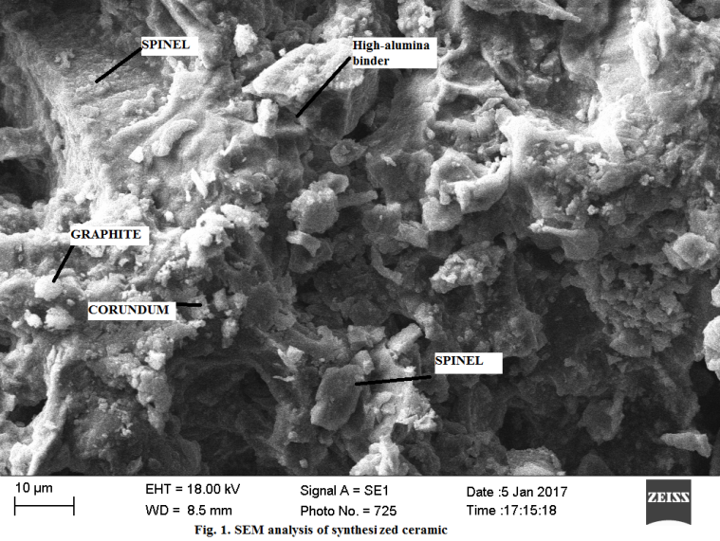
Recent Publications
- Babakhanova Z, Ruzimova Sh., Turgunov Sh (2017) Refractory graphite-containing ceramic materials in the MgO-Al₂O₃-SiO₂ system Universum 2 (35): 5-10.
- Babakhanova Z, Aripova M, Khodjaev N, Khamidov R (2016) The Study оf the Mineralogical Composition and Flotation Parameters of Quartz-Graphitized Schist Chemistry & Chemical Technology. 10: 3: 343-348.
- Babakhanova Z, Aripova M,Ergashev S, Bernardo E, Fiocco L (2016) Оbtaining of advanced ceramics by direct firing of a preceramic polymer and oxide nano fillers The international scientific and technical conference «Аctual problems of innovative technologies in the development of chemical, petroleum-gas and the food-processing industries»: 302-303.
- Fiocco L, Babakhanova Z, Bernardo E (2016) Facile obtainment of luminescent glass-ceramics by direct firing of a preceramic polymer and oxide fillers Ceramics International 42: 6770–6774.
- Babakhanova Z, Aripova M, Bernardo E (2016) The Synthesis of Luminescent Glass-Ceramic Materials Activated with Europium Ions Using Silicon-Organic Compounds (Silicones) Glass and Ceramics, 73(3): 124-127.
- Babakhanova Z, Aripova M (2015) Synthesis of technical ceramic materials using silicon-organic compounds Uzbek chemical journal 3: 16-21.

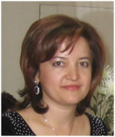 Biography (150 word limit)
Zebo Babakhanova has her expertise in materials science and technology of production of advanced glass and ceramics materials. Her work is devoted to the study of the raw material base of Uzbekistan, the development and introduction of new methods and technologies for the production of technical ceramic materials, in particular the production of refractory and slag-resistant ceramic compositions. At the institute, she actively participates in scientific, educational, administrative and spiritual work. Her PhD thesis was devoted to the study of phase equilibria in two-component systems and the production on their basis of technical glass ceramics. At present, her field of interests is development of new methods of synthesizing of ceramic materials resistant to agressive media and temperatures. New materials can be recommended for use in metallurgy.
Email: babax2013@yahoo.com

Notes/Comments:

Engineering Materials Section

