Melting, forging and phase transformation of a Mn containing β stablized γ-TiAl

Kui Liu, Hao Xu, Xiaobing Li, Lei Shu, Yingche Ma Institute of Metal Research, Chinese Academy of Sciences, P.R. China

Abstract

TiAlMn alloys are lightweight, low cost material with good mechanical property and proper oxidation resistance, which are seemed as a promising material for automotive industrial application. This research was mainly focused on the vacuum induction melting (VIM) and conventional forging of a β-stablizing Ti-42Al-5Mn (at%) alloy, to explore the possibility that whether such cost-effective process can be applied to manufacturing advanced γ-TiAl. The oxygen-enrichment study and melting ingot analysis results show that contamination induced by the stronger interaction reactive between molten liquid and crucible can be minimized during the VIM process when the thermodynamic stable CaO crucible and proper melting technique were adopted. The low oxygen content(＜800ppm wt.%) and chemically homogenized(main element composition within ±0.2%) alloy was successfully produced by using IMR improved melting technique. With regards to conventional forging, based on the guide of hot deform mechanism and the phase transformation behavior studies, both the single step 10kg VIM and 25kg VIM+VAR(vacuum arc re-melting) ingots were successfully forged at a right hot deforming temperature with proper press descent speed.

Finally, the microstructural evolution has been investigated for the forging bar by subjecting to solution and annealing two-step heat treatment. It found that, γ-phases cannot dissolve into β-phases when the solution temperature below T_{solv}(1220℃), and these un-dissolved γ-phases will be coarsening during subsequent annealing at 800℃. Contrarily, when the solution temperature above T_{solv} the γ-phases dissolve completely, and a plenty of refined γ platelets will precipitate from β-phases followed by air cooling. Thereafter, these refined γ platelets will not grow when the above annealing regime is adopted. It indicates that the stability of microstructure can be improved with the proper solution and annealing two-step heat treatment.

In general, this work can provide a strong technical support for developing the cost-effective γ-TiAl alloys.

Image
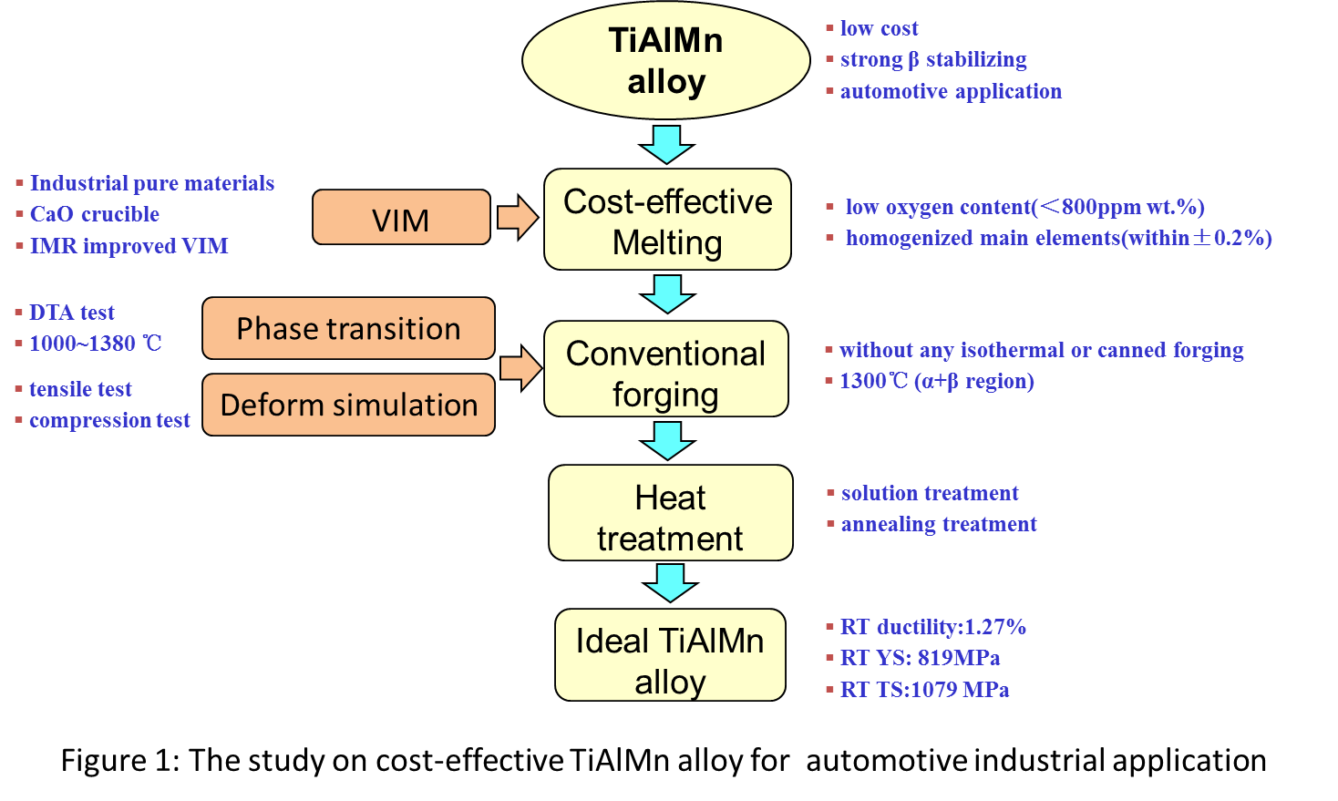
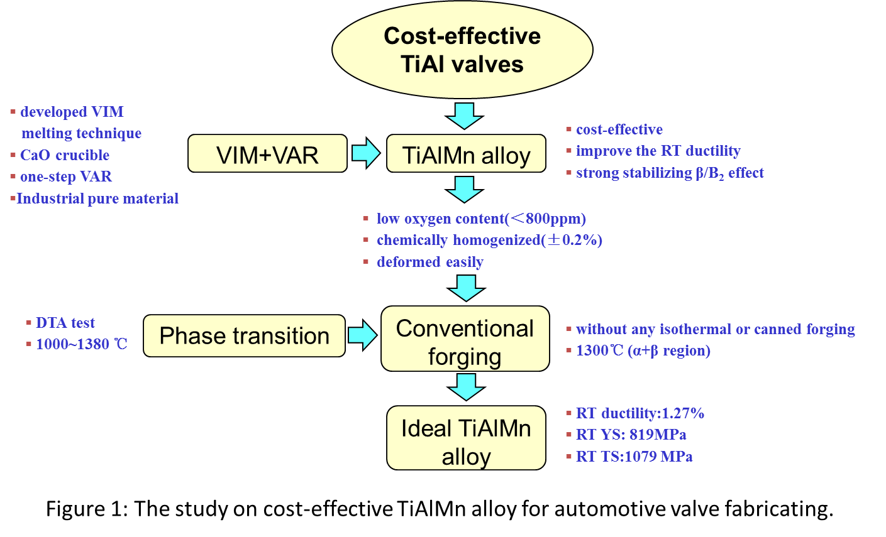
Recent Publications
- X.C. Hao, L. Zhang, X.J. Zhao, T. Liang, Y.C. Ma, K. Liu (2015)Microstructure and Mechanical Properties of a New Ni-Cr-Fe-W-Al Alloy for Advanced Ultra-supercritical Power Plants. Mater. Sci. Forum. 816:586-593
- M. Wang, X.D. Zha, M. Gao, Y.C Ma, K. Liu, Y.Y Li (2015)Structure, Microsegregation and Precipitates of an Alloy 690 ESR Ingot in Industrial Scale, Metall and Mat Trans A. 46(A):5217-5231
- C. Xiong, Y.C. Ma, B. Chen, K. Liu, Y.Y. Li (2013)Modeling of Filling and Solidification Process for TiAl Exhaust Valves During Suction Casting.Acta Metall.Sin.(Engl.Lett.) 26:33-48
- W.D. Wang, Y.C. Ma, B. Chen, K. Liu, Y.Y. Li (2010) Effects of Boron Addition on Grain Refinement in TiAl-based Alloys. J. Mater. Sci. Technol. 26:639-647
- W.D. Wang, Y.C. Ma, B. Chen, M. Gao, K. Liu, Y.Y. Li (2009) Solidification Features of Ti45Al Alloys with Different Boron Addition. J. Mater. Sci. Technol. 25:814-818

 Biography
Dr.Kui Liu got his PhD from the Institute of Metal Research (IMR), Chinese Academy of Sciences (CAS) in 1999. He is the group leader of the Materials for Special Engineering in the Division of Materials for Special Environment of IMR. He has published more than 40 papers and held more than 25 patents. The main research interests of him are special melting high purity reactive materials, like Ni base, NiTi shape memory, TiAl alloys. And the works have got significant progress from his group support and by international cooperation.
Email: kliu@imr.ac.cn

