

Title: Investigation of Uni-directional nanorods, composed microspheres and branched nanorods for QDSSC solar cell application
Name: ARJUNKUMAR BOJARAJAN, RAMALINGAM GOPAL*
Quantum Materials Research Lab (QMRL), Department of Nanoscience and Technology, Alagappa University, Karaikudi - 630003, Tamil Nadu, India.

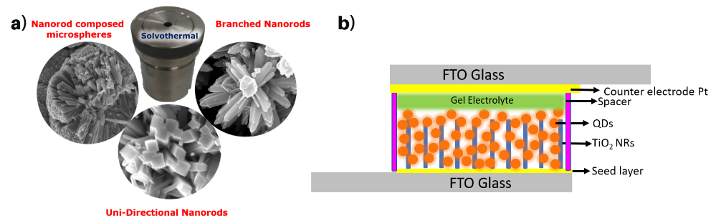
Quantum dot sensitised solar cell (QDSSC) is one of the efficient one at low cost and stable compare to perovskite solar cell. In present work, successfully synthesised three different structures as uni-directional nanorods, composed microspheres and branched nanorods was performed and it was developed by simple solvothermal route. TiO₂ was directly grown on the FTO glass, and it act as seed layer and electron transport layer (ETL). The one-dimensional TiO₂ nanostructures were grown perpendicular to the substrate, its due to the TiO₂ pre nucleation kinetics. The as prepared TiO₂ nanorods have 60 -90nm diameter and length varies from 250-300 nm, which shows the high aspect ratio. The primarily XRD, analysis confirmed the obtained nanorods are rutile phase TiO₂. CdSe Quantum dots were anchored on ETL through chemical bath deposition. J-V characteristics has been observed comparing other structures unidirectional nanorods shown better efficiency 1.76% and Voc: 0.74 V Jsc: 5.78 mA/cm².

Fig.1(a) SEM images of Nanorods (b) Schematic cross-sectional diagram of QDSSC
Biography: Mr. Arjunkumar Bojarajan completed his Bachelor Degree in physics (2016) from Alagappa University and Master Degree in Nanoscience & Technology (2018) from Alagappa University. Currently, he is pursuing his Doctoral Studies in Nanoscience & Technology under the guidance of Dr. G. Ramalingam, Department of Nanoscience and Technology, Alagappa University, Karaikudi, Tamil Nadu, India. Area of research was focused on nanomaterials for solar cells, Optoelectronic devices.
Ramalingam Gopal: has completed his PhD at University of Madras (2013) and working as assistant professor at department of nanoscience and technology, Alagappa University. Recently Tamilnadu state council of science and technology awarded as young scientist award. Currently, he has running ongoing research project in the area of 2D materials, quantum dots for LEDs, solar cell and bio imaging applications.
Presenting author details
Full name: B. Arjunkumar
Contact number: +91 97518 50305
Twitter account: @arjunku55551037
Linked In account: Arjunkumar Bojarajan
Category: Oral presentation

