Ultrasonic Surface Treatment-A novelty method on improving durability of cementitious materials
Shi Yong, M.E., CHINA , Inner Mongolia Univ Technol.

Abstract
Cement industry consumed about 12-15 % of the total industrial energy use and discharge 7 % of total worldwide CO₂ emissions annually[1]. However, owing to the porous microstructure, the durability of cementitious materials(cement paste, cement mortar, concrete) is still a big issue. Much methods has been presented and studied to improve the microstructure of cementitious materials, but that always caused extra expense and lead to dramatic increase in project cost[2,3]. To overcome the contradiction between durability and costs, we present a novelty method named Ultrasonic surface treatment(UST) method, which with few extra costs and has positive effects on improving the durability of cementitious materials by improving its microstructure. According to our recent works, the UST method leads to the forming of a unique skin named Ultrasonic Harding Layer(UHL), which is significant different from conventional concrete skin in microstructure[4]. The UHL is about 1-2 mm in thickness, with higher density and lower porosity, higher surface hardness and lower penetration, and also a non-defective ITZ(interfacial transition zone) was found in UHL(see Fig 1.), which can notably to improve the durability of cementitious materials [5]. Besides, the cementitious materials treated with UST method appear in a deep color on surface. For concrete, it has a lower light reflectance than conventional concrete, consequently, it will be a promised method of road concrete on wear resistance and ice melting performance.

Image (If available)
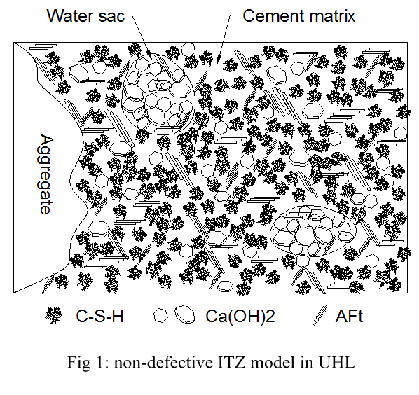
Recent Publications (if any-minimum 5)
- M.B. Ali, R. Saidur, Hossain M S. A review on emission analysis in cement industries[J]. Renewable and Sustainable Energy Reviews, 2011, 15: 10.
- Mehta P K. Durability of Concrete--Fifty Years of Progress?[J]. ACI Symposium Publication, 126.
- Mehta P K. Advancements in Concrete Technology[J]. Concrete International, 1999: 7.
- Sadowski Ł, Stefaniuk D. The effect of surface treatment on the microstructure of the skin of concrete[J]. Applied Surface Science, 2018, 427: 934-941.
- Shi Y, Shi Z M. Ultrasonic surface treatment for improving wind-blown sand erosion resistance of cementitious materials[J]. Wear, 2020.

Image: 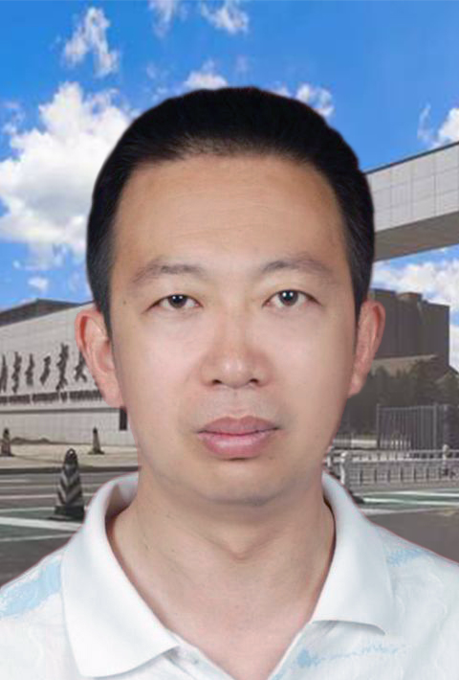
Biography (150 word limit)*
Shi Yong has his expertise in improving the durability of cementitious materials. He focus on to present a low cost and long-lasting method to improve the durability of cement mortar and concrete. Now he present the ultrasonic surface treatment(UST) in this paper after 7 years researchs, which has positive effect on durability performance of cementitious materials. It also has some advantages on absorption of solar radiation, it will be a promised method on Infrastructure engineering.
Email: shiyong@imut.edu.cn

Notes/Comments:

