Thermal characterization of phase change material for energy storage application
Gregory LARGILLER
Univ. Grenoble Alpes
CEA, LITEN, DTBH, LST
Grenoble, France
Gregory.largiller@cea.fr

Abstract (300 word limit)*
Thermal energy represents half of the primary energy used in Europe and is one of the main contributor of greenhouse gas emission. Integration of renewable thermal energy sources, such as biomass, solar thermal, geothermal or wasted heat is then a major stake for near future. Thermal Energy Storage (TES) is one of the key component that can help the development of renewable thermal energy in domains like urban heating network or industrial processes, allowing to smooth peaks of demand, to manage the balance with the supply and then to minimize the use of fossil energy. Most of the TES currently operated in the world are based on sensible heat by increasing and decreasing the temperature of a material such as water, thermal oil, molten salt, rock… The use of Phase Change Materials (PCM) as storage medium enable to reach higher energy density for a large temperature range (i.e. 30°C to 1 000 °C [1]). Current technologies use solid-liquid phase PCM as TES medium and reach energy densities from 100 MJ.m⁻³ for paraffin to 1 000 MJ.m⁻³ for salt hydrates. These systems show some drawbacks like the presence of a liquid phase which may imply leakage, undercooling or large volume variation of about 10 to 20%V/V upon phase transformation [2-4] which leads to mechanical stresses for the storage vessel. An alternative solution consists in using solid-solid PCM with about 5-10%V/V phase change variation [1,5], the later could even be used as structural material of the TES systems [6-8]. This study proposes to investigate and compare the thermal behavior of a classical solid-liquid paraffin and solid-solid PCM. Materials have been analyzed by calorimetry, then characterized into a thermal bench composed of two thermal loops and a heat exchanger with metallic fins. Latent heat, energy density and thermal conductivity are compared.

Image (If available)
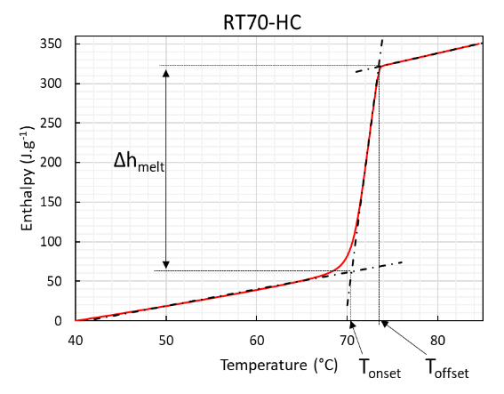
Specific heat of the RT70-HC (calorimetry)
Recent Publications (if any-minimum 5)
[1] A. Fallahi, G. Guldentops, M. Tao, S. Granados-Focil, et S. Van Dessel, « Review on solid-solid phase change materials for thermal energy storage: Molecular structure and thermal properties », Appl. Therm. Eng., vol. 127, p. 1427‑1441, dec. 2017.
[2] L. F. Cabeza, A. Castell, C. Barreneche, A. de Gracia, et A. I. Fernández, « Materials used as PCM in thermal energy storage in buildings: A review », Renew. Sustain. Energy Rev., vol. 15, no 3, p. 1675‑1695, avr. 2011.
[3] P. Arce, M. Medrano, A. Gil, E. Oró, et L. F. Cabeza, « Overview of thermal energy storage (TES) potential energy savings and climate change mitigation in Spain and Europe », Appl. Energy, vol. 88, no 8, p. 2764‑2774, août 2011.
[4] M. M. Kenisarin et K. M. Kenisarina, « Form-stable phase change materials for thermal energy storage », Renew. Sustain. Energy Rev., vol. 16, no 4, p. 1999‑2040, mai 2012.
[5] J. Font, J. Muntasell, et E. Cesari, « Plastic crystals: Dilatometric and thermobarometric complementary studies », Mater. Res. Bull., vol. 30, no 7, p. 839‑844, juill. 1995.
[6] W. F. Gao, W. X. Lin, T. Liu, et M. Li, « An experimental study on the application of polyalcohol solid-solid phase change materials in solar drying with cross-corrugated solar air collectors », présenté à IOP Conference Series: Earth and Environmental Science, 2017, vol. 93.
[7] M. Barrio, J. Font, D. O. López, J. Muntasell, et J. L. Tamarit, « Floor radiant system with heat storage by a solid-solid phase transition material », Sol. Energy Mater. Sol. Cells, vol. 27, no 2, p. 127‑133, juill. 1992.
[8] M. Kuta et T. M. Wójcik, « Phase change materials in energy sector - applications and material requirements », EPJ Web Conf., vol. 92, p. 02043, 2015.

Image: 
Biography (150 word limit)*
Gregory LARGILLER has been developing an expertise in the field of materials and processes. After a PhD dealing with powder metallurgy and simulation for industrial issues, he oriented himself to the development of materials for energy and joined the French Institute of Renewable Energies (CEA-Liten). His work deals now with the choice, modification and characterization of materials for thermal energy recovery as well as their implementation into technologies. He investigates heat storage for concentrated solar power (CSP), district heating (DH) and waste heat recovery.
Email: gregory.largiller@cea.fr

Notes/Comments:

