Preparation and performance of carbon dot stabilized copper sulphide/carbon nanotubes hybrid composite as supercapacitor electrode materials
Tingkai Zhao, Northwestern Polytechnical University, China
Xin Zhao, Northwestern Polytechnical University, China

Abstract (300 word limit)*
Carbon dot stabilized copper sulphide/carbon nanotube (CD@CuS/CNT) hybrid composite was synthesized by a simple one-pot hydrothermal reaction at 180℃ using copper sulphate and sodium thiosulphate as Cu and S sources. The microstructures and morphologies of hybrid composites were characterized by X-ray diffraction (XRD), Raman spectroscopy (Raman), scanning electron microscope (SEM) and transmission electron microscope (TEM). Moreover, a high-performance asymmetric supercapacitor device was assembled to improve the electrochemical performance of CuS as well as carbon based supercapacitors1. The CD@CuS/CNT hybrid composite exhibited a maximum specific capacitance of 736.1F•g-1 at the current density of 1A•g-1. Furthermore, the CD@CuS/CNT hybrid composite showed good cycling stability with more than 92% capacitance retention after 5000 cycles. These excellent results suggested that CD@CuS/CNT hybrid composite has promising application potential for supercapacitors2.

Image (If available)
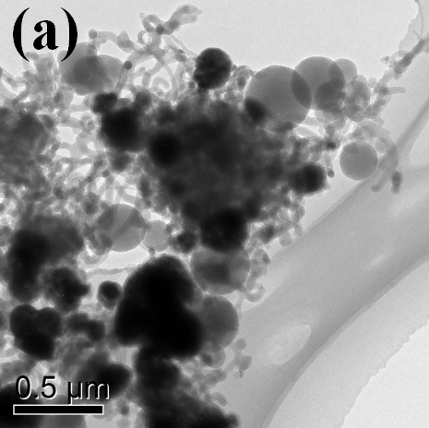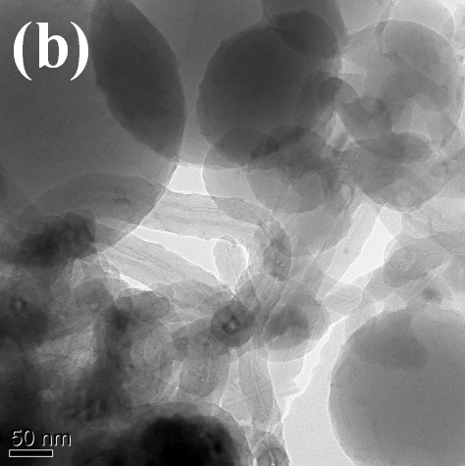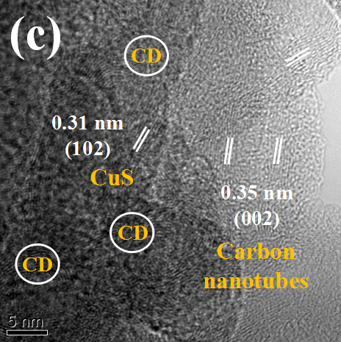
Fig. 1 (a,b) TEM, and (c,d) HRTEM images of CD@CuS-CNTs
Recent Publications (if any-minimum 5)
- L. Dong, et al, J. Mater. Chem. A, 4, 4659 (2016).
- T. Zhao, et al, Comp. Part B, 150, 60(2018).

Image: 
Biography (150 word limit)*
Dr. Tingkai Zhao is currently working as a full professor in School of Materials Science and Engineering of Northwestern Polytechnical University (NPU) and has accomplished his PhD degree from Xi’an Jiaotong University (XJTU) in 2005, China. He has visited Northwestern University (Evanston, USA) and University of Oxford (Oxford, UK) as a visiting scholar. As a director of NPU-NCP Joint International Research Center on Advanced Nanomaterials & Defects Engineering, the vice-director of Shaanxi Engineering Laboratory for Graphene New Carbon Materials & Applications. His research group mainly investigates the synthesis, structure and performance of advanced carbon materials such as carbon nanotubes (especially amorphous carbon nanotubes), graphene, flexible graphite, 2D nanomaterials, MXene and their applications in composites, energy conversion (solar cell, supercapacitor and Li-ion batteries), smart device and biosensors. He has published 2 kooks, 15 Chinese Invention patents and more than 110 academic articles on SCI journals, and also obtained more than 25 Awards and Honors such as the first prize of Shaanxi Science and Technology Awards in 2013 etc., and 4 times scientific reports in《China Science Daily》newspapers for his research achievements. And he has also been elected as a commissioner of Shaanxi Society of Nano science & Technology and Xi’an Society of Nano science & Technology.
Email: ztk-xjtu@163.com

Notes/Comments:

