Ceramic-based thermoelectric materials processed by laser

N.M. Ferreira, i3N, Physics Department, Department of Materials and Ceramic Engineering, Universidade de Aveiro, Portugal

M.A. Madre, ICMA (CSIC-Universidad de Zaragoza), C/Maria de Luna 3, 50018 Zaragoza, Spain
A. Sotelo, ICMA (CSIC-Universidad de Zaragoza), C/Maria de Luna 3, 50018 Zaragoza, Spain
A.V Kovalevsky, Aveiro Institute of Materials, Department of Materials and Ceramic Engineering, Universidade de Aveiro, Portugal
F.M. Costa, i3N, Physics Department, Universidade de Aveiro, Portugal

Abstract (300 word limit)

Today a particular interest is given to the oxide-based thermoelectric materials, due to enhanced thermal and redox stability, attractive properties at high temperature, together with the absence of toxicity, and natural abundance of the constituent compounds. The objective of this work is to assess the possibilities for processing oxide thermoelectrics through laser floating zone (LFZ) method, including identification of the appropriate treatment conditions and main structural and microstructural factors affecting the thermoelectric performance. Known that Nb- and La-substituted calcium manganite-based materials possesses promising thermoelectric properties, they were selected as a model system. Detailed structural (XRD) and microstructural (SEM/EDS) studies were performed for the samples grown at various pulling rates. The results on electrical conductivity, Seebeck coefficient and thermal conductivity indicate that high thermoelectric performance can be triggered by laser processing. Effects of pulling rate, dopants nature and thermal treatment to the fibres on that properties are discussed, suggesting that careful optimization of the laser treatment conditions is necessary, when seeking high thermoelectric performance in oxides by LFZ processing.

Image
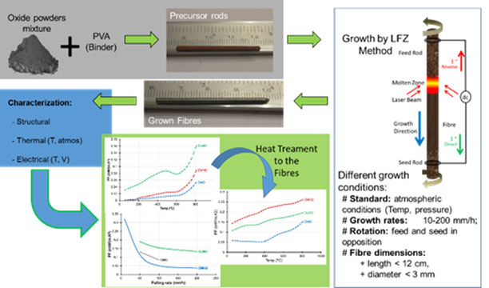

Recent Publications
- N.M. Ferreira, F.M. Costa, A.V. Kovalevsky, M.A. Madre, M.A. Torres, J.C. Diez, A. Sotelo, New environmentally friendly Ba-Fe-O thermoelectric material by flexible laser floating zone processing, Scripta Materialia 145 (2018) 54–57, doi:10.1016/j.scriptamat.2017.10.011
- N. M. Ferreira, M. C. Ferro, A. R. Sarabando, A. Ribeiro, A. Davarpanah, V. Amaral, M. A. Madre, A. V. Kovalevsky, M. A. Torres, F. M. Costa, A. Sotelo, Improvement of thermoelectric properties of Ca0.9Gd0.1MnO3 by powder engineering through K2CO3 additions, Journal of Materials Science 54 (2018) 3252–3261, doi:10.1007/s10853-018-3058-x
- Kovalevsky, A.V., Aguirre, M.H., Populoh, S., Patrício, S.G., Ferreira, N.M., Mikhalev, S.M., Fagg, D.P., Weidenkaff, A., Frade, J.R., Designing strontium titanate-based thermoelectrics: insight into defect chemistry mechanisms (2017) Journal of Materials Chemistry A, 5 (8), pp. 3909-3922, DOI: 10.1039/c6ta09860f
- A. Sotelo, F.M. Costa, N.M. Ferreira, A. Kovalevsky, M.C. Ferro, V.S. Amaral, J.S. Amaral, S. Rasekh, M.A. Torres, M.A. Madre, J.C. Diez. 'Tailoring Ca3Co4O9 microstructure and performances using a transient liquid phase sintering additive', J. Eur. Ceram. Soc. 36 (2016) 1025.
- M. A. Madre, F. M. Costa, N. M. Ferreira, S. I. R. Costa, Sh. Rasekh, M. A. Torres, J. C. Diez, V. S. Amaral, J. S. Amaral, A. Sotelo, High thermoelectric performance in Bi2-xPbxBa2Co2Ox promoted by directional growth and annealing, Journal of the European Ceramic Society 36 (2016) 67-74, DOI: 10.1016/j.jeurceramsoc.2015.09.034;
- Sh. Rasekh, F.M. Costa, N.M. Ferreira, M.A. Torres, M.A. Madre, J.C. Diez, A. Sotelo, Use of laser technology to produce high thermoelectric performances in Bi2Sr2Co1.8Ox, Materials and Design 75 (2015) 143–148, doi: 10.1016/j.matdes.2015.03.005;
- M.A. Madre, F.M. Costa, N.M. Ferreira, A. Sotelo, M.A. Torres, G. Constantinescu, Sh. Rasekh, J.C. Diez, Preparation of high-performance Ca3Co4O9 thermoelectric ceramics produced by a new two-step method, Journal of the European Ceramic Society 33 (2013) 1747–1754, DOI:10.1016/j.jeurceramsoc.2013.01.029
- N.M. Ferreira, Sh. Rasekh, F.M. Costa, M.A. Madre, A. Sotelo, J.C. Diez, M. A. Torres, New method to improve the grain alignment and performance of thermoelectric ceramics, Materials Letters (2012), 144-147, DOI: 10.1016/j.matlet.2012.05.131
- N. M. Ferreira, Sh. Rasek, J. S. Fernandes, F. M. Costa, M. A. Madre, J. C. Diez, A. Sotelo; Electrical Polarization Effect on Bi2Ca2Co1.7Ox thermoelectrics grown by laser floating zone; Microscopy and Microanalysis, 18 (2012) 93-94, DOI: 10.1017/S1431927612013128
.

Biography
Nuno Ferreira, is a PhD in Physics Engineering (2014), currently is a researcher at i3N, Physics Department at University of Aveiro, Portugal. He had participated in several R&D projects on material science. He have experience researcher in study and development of ceramics-based materials, prepared through conventional methods (melting, solid stated), with particular focus on laser processing (crystal growth – LFZ and surface sintering/modification). Present sample characterization skills include various techniques such as, electrical conductivity and magnetic properties of various oxide materials. Current focus materials: thermoelectrics, ferroelectrics and glass matrices doped with transition metals and rare earth for energy storage and conversion applications. Main expertise is related to structural, magnetic and electrical properties of materials prepared by laser processing.
Email: nmferreira@ua.pt

Notes/Comments:

