Discrete Zn, Co bimetallic sites supported on N doped carbon for high performance oxygen reduction reaction catalysis
Yufeng Zhao¹, Ziyang Lu², Hongguan Li²,
¹Institute of Sustainable Energy/College of Science, Shanghai University, Shanghai, 200444, P. R. China.
²Key Laboratory of Applied Chemistry in Hebei Province,Yanshan University, Qinhuangdao 066004, China

Abstract
A new design of discrete Zn, Co bimetallic sites supported on N doped carbon was fabricated through a competitive complexation stretegy (Figure 1) .[1] Aberration-corrected atomic-resolution high-angle annular dark field scanning transmission electron microscopy (HAADF-STEM) measurements combined with X-ray absorption fine structure (XAFS) reveals the existence and the structure of the Zn-Co bimetallic sites. This Zn-Co dual atom catalysts exhibit significantly improved oxygen reduction catalytic activity compared to single atom catalysts in both acid and alkaline conditions. DFT calculations reveal that the enhanced catalytic activity can attributed to the significantly elongated O-O bond length (from 1.23 Å to 1.42 Å), and thus facilitates the cleavage of O-O bond at the ZnCoN6(OH) sites, showing a theoretical overpotential of 0.335V during ORR process (Figure 2). In-situ XAS study demonstrate that Co serves as the active center during the catalysis. Further more, a highly active sulfur (S)-modified Zn,Co-Nx-C-Sy ORR catalyst is also developed. [2] Besides the elongated O-O band length, the S doping can further modify the charges around Zn,Co active center, and strengthen the interaction with oxygenated species by decreasing the free energy changes of *O2 + e- + H2O→*OOH + OH- step. The as prepared catalysts show promising potential in practical applications in both fuel cell and Zn-air batteries. Particularly, the H2/O2 fuel cell tests based on the Zn-Co atomic pair presents a peak power density of 705 mW cm-2 along with excellent stability.

Image
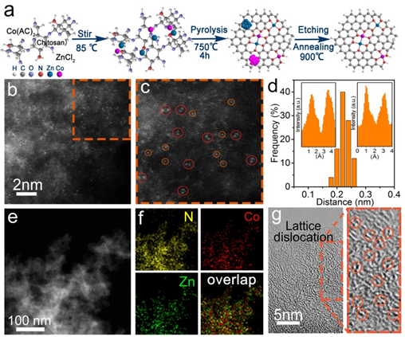
Figure 1. (a) Schematic illustration of the formation of Zn/CoN-C. Aberration-corrected HAADF-STEM image (b) and enlarged images (c) of the Zn/CoN-C. In (c), some of bimetallic Zn/Co sites are highlighted by larger red circles, and some of single Co/Zn atoms highlighted by smaller orange circles. (d) Statistical Zn-Co distance in the observed diatomic pairs, in which the two insets are intensity profiles obtained on two bimetallic Co/Zn sites. HAADF-STEM image (e) and corresponding element maps (f), showing the distribution of N, Zn, and Co. (g) HR-TEM of Zn/CoN-C, in which some lattice distortions are highlighted by orange circles.

Recent Publications
- Ziyang Lu, Bo Wang, Yongfeng Hu, Wei Liu, Yufeng Zhao, Ruoou Yang, Zhiping Li, Jun Luo, Bin Chi, Zheng Jiang, Minsi Li, Shichun Mu, Shijun Liao, Jiujun Zhang, Xueliang Sun, Isolated Zn-Co Atomic Pair for Highly Active and Durable Oxygen Reduction, Angewandte Chemie International Edition, 2019, 58 (9), 2622-2626
- Dexin Liu, Bo Wang, Hongguan Li, Shifei Huang, Qingjie Wang, Jing Wang, Minmin Liu, Jiujun Zhang, Yufeng Zhao, Distinguished Zn,Co-Nx-C-Sy Active Sites Confined in Dentric Carbon for Highly Efficient Oxygen Reduction Reaction and Flexible Zn-Air Batteries, Nano Energy, 2019, 58, 277-28
- Yang Yu, Shifei Huang, Bo Wang, Da Tie, Qingjie Wang, Yanglong Hou, Yufeng Zhao, Achieving high-energy full-cell lithium-storage performance by coupling high-capacity V2O3 with low-potential Ni2P anode, ACS Applied Materials & Interfaces, 2019, 11, 19-25.
- Ziyang Lu, Qinghua Liang, Bo Wang, Ying Tao, Yufeng Zhao, Wei Lv, Donghai Liu, Chen Zhang, Zhe Weng, Jiachen Liang, Huan Li, Quan-Hong Yang, Graphitic carbon nitride induced micro-electric field for dendrite-free lithium metal anodes, Advanced Energy Materials, 2019, 9, 1803186.
- Shifei Huang, Zhiping Li, Bo Wang, Jiujun Zhang, Zhangquan Peng, Ruijuan Qi, Jing Wang, Yufeng Zhao, N-doping and defective nanographitic domain coupled hard carbon nanoshells for high performance lithium/sodium storage, Advanced Functional Materials, 2018, 28, 1706294.


Biography
Dr. Yufeng Zhao is currently a professor in Yanshan University, vice-director of the Key Laboratory of Applied Chemistry in Hebei Province. She is also a review editor of Frontiers in Energy Storage, and the editor board member of Nano Advances. Dr. Zhao received her BS (2000) and MS (2003) degree in Materials Science and Engineering from Tianjin University, China, and her Ph.D. (2006) degree from Nanyang Technological University, Singapore. Afterwards, she worked in Deakin University, Australia (2006-2008) and Phillips University Marburg, Germany (2008-2009) as a research scientist. She joined Yanshan University since 2010, and she was also a visiting professor in the NUANCE Center of Northwestern University (2014-2015). Her current research focuses on the development of advanced energy materials for supercapacitors, sodium-ion batteries and electrocatalysts, with particular interest in 2D transition metal compounds and nano-carbon materials. She has published over 80 peer-reviewed papers on international journals including Nat Commun, Angew Chemie, Adv Func Mater, Nano Energy, etc.

Email: yufengzhao@ysu.edu.cn; yufengzhao@shu.edu.cn

Notes/Comments:

