Architecture and Interface Design for Ultrahigh Conductivity Graphene/Copper Composites
Ding-Bang Xiong, Mu Cao, Di Zhang, State Key Laboratory of Metal Matrix Composites, Shanghai Jiao Tong University, Shanghai 200240, China

Abstract
Recently, tailoring properties by architecture design that changes the spatial distribution of reinforcement in matrix at micro-/nano-scale without changing constituents has attracted intensive attention in the community of composite. Natural biological materials are characterized by combining simple constituents into a wide variety of composites with a maximum of control over architecture on many length scales, exhibiting a remarkable range of mechanical and functional properties. Understanding the role that multilevel architectures play in controlling properties of natural materials may serve as inspirations for architecture design in composites. Metals can be strengthened by adding hard reinforcements, but such strategy usually compromises ductility and toughness as well as electrical/thermal conductivity. In past few years, a bioinspired strategy has been applied to surmount the dilemma in our research. By assembling copper nanoflakes cladded with graphene, graphene/copper matrix composites with a natural nacre inspired nanolaminated architecture have been prepared. Owing to a combined effect from the bioinspired nanolaminated architecture and improved interface bonding, a tradeoff has been made between mechanical strength and ductility as well as electrical/thermal conductivity in graphene/copper matrix composites. The bioinspired nanolaminated architecture enhances the mechanical strengthening and electrical/thermal conducting efficiencies of two-dimensional graphene by alignment of graphene that orient to maximize performance for required loading and carrier transporting conditions, and toughening by crack deflection. The strategy sheds light on the development of structural-multifunctional integrated composites.

Image
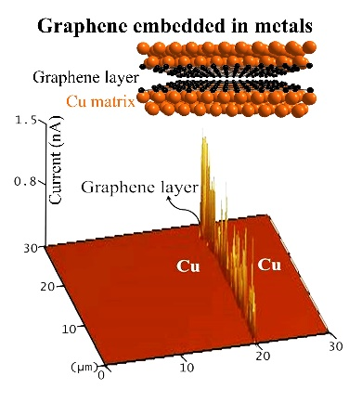

Recent Publications
- M. Cao, D.B. Xiong, L. Yang, S.S. Li, Y.Q. Xie, Q. Guo, Z.Q. Li, H. Adams, J.J. Gu, T.X. Fang, X.H. Zhang, D. Zhang, Ultrahigh electrical conductivity of graphene embedded in metals, Advanced Functional Materials, 2019, 1806792.
- M. Cao, D.B. Xiong, Z.Q. Tan, G. Ji, B. Amin-Ahmadi, Q. Guo, G.L. Fan, C.P. Guo, Z.Q Li, D. Zhang, Aligning graphene in bulk copper: Nacre-inspired nanolaminated architecture coupled with in-situ processing for enhanced mechanical properties and high electrical conductivity, Carbon, 2017, 117, 65-74.
- M. Zhao, D.B. Xiong, Z.Q. Tan, G.L. Fan, Q. Guo, C.P. Guo, Z.Q. Li, D. Zhang, Lateral size effect of graphene on mechanical properties of aluminum matrix nanolaminated composites, Scripta Mater., 2017, 139, 44-48.
- D.B. Xiong, M. Cao, Q. Guo, Z.Q. Tan, G.L. Fan, Z.Q. Li, D. Zhang, High content reduced graphene oxide reinforced copper with a bioinspired nano-laminated structure and large recoverable deformation ability, Scientific Reports, 2016, 6, 33801.
- D.B. Xiong, M. Cao, Q. Guo, Z.Q. Tan, G.L. Fan, Z.Q. Li, D. Zhang, Graphene-and-Copper Artificial Nacre Fabricated by a Preform Impregnation Process: Bioinspired Strategy for Strengthening-Toughening of Metal Matrix Composite, ACS Nano, 2015, 9, 6934-6943.


Biography
Ding-Bang Xiong is an associate professor in the State Key Lab of Metal Matrix Composites, in Shanghai Jiao Tong University, China since 2012. He received his Ph.D degree in material physics and chemistry from Shanghai Institute of Ceramics in 2007. Between 2007-2010, he carried out his postdoctoral research as Alexander von Humboldt fellow in Marburg University, Germany, and between 2010-2012, he did collaboration research in Kyoto University supported by the Japan Society for the Promotion of Science. Her current research focuses on fabrication and properties of metal matrix composite materials.
Email: xiongdingbang@sjtu.edu.cn

Notes/Comments:

