Nanointerfacial Regions Enhanced by Gel Polymer Electrolyte-Accessible Electrodes for High-Performance Flexible Energy Storages
Eun Seok Song, Sung-Kon Kim*
Department of Chemical engineering
Chonbuk national university, Korea (South)

Abstract (300 word limit)
More compact and increasingly capable of generating higher power densities and higher level of efficiency are needed for powertrain platform designs. In the aspects of rational cell configuration, many efforts are being directed towards the development of lightweight and flexible/wearable energy storage devices that can meet power and energy demands in spatial-limited applications such as energy back-up systems, portable electronics, wearable electronics, and electric vehicles. In terms of manufacturing, safety, and reliability for flexible energy storages, solid-state materials as both separator and electrolyte are preferred instead of only use of liquid electrolytes such as aqueous, organic electrolytes, and ionic liquids. Gel or polymer electrolytes can act as both separator and electrolytes and strongly hold electrolytes with polymer matrix, thus precluding the leakage of liquid electrolytes. However, there are challenges associated with the wettability at the electrolyte/electrode interface and the ionic conductivity of the polymer-based electrolytes due to the rather thick electrolyte layer.
Here, a good formation of the interfacial region between electrode and electrolyte, particularly solid-state electrolyte, is significant for high-performance energy storages. Here we synthesize solid gel polymer electrolytes (GPEs) consisting of poly(ethylene glycol) methyl ether methacrylate (PEGMA) and trimethylolpropane ethoxylate triacrylate (ETPTA) with a lithium salt solution (1M LiPF₆ EC/DMC) by UV irradiation. Ionic conductivity and mechanical strength are changed by varying the composition of PEGMA and ETPTA as well as the content of lithium salt solution in the polymer. The GPEs with high ionic conductivity (~10⁻³ S/cm) is impregnated into carbon nanomaterials-based electrodes which can enhance electrolyte-accessible surface area of electrodes. While the GPEs with relatively large mechanical stability and small ionic conductivity (~10⁻⁴ S/cm) can be used as both separator and electrolyte, providing flexible solid-state energy storage devices. This strategy holds significant promise as a platform to design high-performance carbon nanomaterial-based electrodes for energy storages.

Image

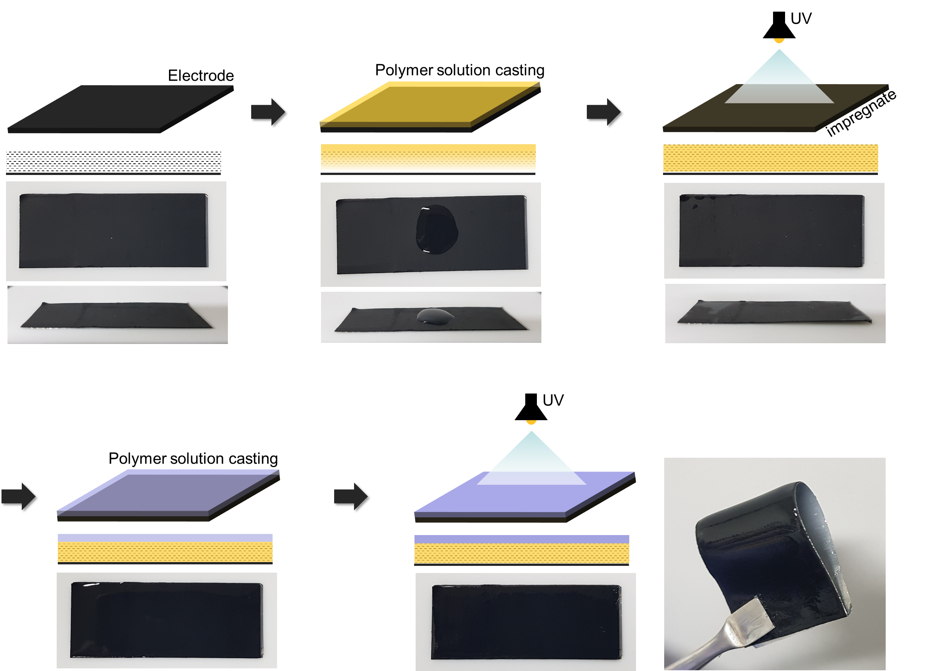

Fig. Process flow for the fabrication of flexible solid-state energy storage using electrolyte-impregnable method.

Recent Publications (minimum 5)
- Jun Woo Jeon,† Jae Hee Han,† Sung-Kon Kim,† Dong-Gyun Kim, Yong Seok Kim, Dong Hack Suh, Young Taik Hong, Tae-Ho Kim, Byoung Gak Kim, “Intrinsically Microporous Polymer-Based Hierarchical Nanostructuring of Electrodes via Nonsolvent-Induced Phase Separation for High-Performance Supercapacitors”, Journal of Materials Chemistry A, 2018, 6(19), 8909-8915.
- Jaewon Choi, Yoon Myung, Sung-Kon Kim*, "Flexible Sodium-Ion Battery Anodes Using Indium Sulfide-Based Nanohybrid Paper Electrodes", Applied Surface Science, 2019, 467-468, 1040-1045.
- Junpyo Lee, Jaewon Choi, Daye Kang, Yoon Myung, Sang Moon Lee, Hae Jin Kim, Yoon-Joo Ko, Sung-Kon Kim*, Seung Uk Son*, “Thin and Small N-doped Carbon Boxes Obtained from Microporous Organic Networks and Their Excellent Energy Storage Performance at High Current Densities in Coin Cell Supercapacitors”, ACS Sustainable Chemistry & Engineering, 2018, 6(3), 3525-3532
- Sung-Kon Kim,† Hyung-Jun Koo,† Jinyun Liu, Paul V. Braun, “Flexible and Wearable Fiber Micro-Supercapacitors Based on Carbon Nanotube-Agarose Gel Composite Electrodes”, ACS Applied Materials & Interfaces, 2017, 9(23), 19925-19933
- Sung-Kon Kim, Jiung Cho, Jeffrey S. Moore, Ho Seok Park, Paul V. Braun, “High-Performance Mesostructured Organic Hybrid Pseudocapacitor Electrodes”, Advanced Functional Materials, 2016, 26(6), 903-910

 M.S Eun Seok Song
Eun Seok Song is the master student of Chemical Engineering at Chonbuk National University. Mr. Song is working on the synthesis of ion-conducting polymers and the fabrication of solid-state electrolytes for energy storages such as rechargeable batteries and supercapacitors.

Email: ryon.3121@gmail.com

 Prof. Sung-Kon Kim
Prof. Sung-Kon Kim is the assistant professor of Chemical Engineering at Chonbuk National University. Prof. Kim received his BS in Polymer Science and Engineering from Chungnam National University in 2006, and his MS and PhD in Chemical and Biological Engineering from Seoul National University in 2008 and 2012, respectively. Following a postdoctoral appointment at the Department of Material Science and Engineering of University of Illinois at Urbana-Champaign, he joined the faculty at Chonbuk National University in 2017. His current research program focuses on developing soft materials for energy storage and conversion.

Email: skkim@jbnu.ac.kr

Notes/Comments:

