Three-Dimensionally Surface-Engineered Carbon Fiber Electrodes for Flexible and Wearable Micro-Supercapacitors
Jisu Kim, M.S, CHONBUK National University, Republic of Korea
Sung-Kon Kim, Prof. CHONBUK National University, Republic of Korea

Abstract (300 word limit)
Fiber micro-supercapacitors (mSCs) are of promising energy storages as they can offer good mechanical flexibility, providing a path for direct integration into textiles with other electronic components with various sets of shapes and sizes. Although the energy density of mSCs remains unsatisfactory, compared to that of rechargeable batteries, they exhibit provide long cycle lives and high peak powers, which show a potential for applications such as on-chip energy storage with high power demands. In addition, fiber mSCs give a particular opportunity for applications in which their form-factor flexibility is needed over secondary batteries, for example, portable electronics, roll-up displays, smart skins, and wearable electronics. Herein, the nanostructure is formed on the surface of carbon fibers commercially available by depositing multi-walled carbon nanotubes on a polystyrene colloidal crystal template. Fiber mSCs are fabricated by twisting two surface-engineered fiber electrodes with a help of polymer electrolytes. The resulting fiber mSCs provide good flexibility and reliable power output due to good transport paths for both ions and electrons, enabling a high rate performance. The 3D nanostructured surface of carbon fiber electrodes offers large surface area, leading to exceptional energy density.

Image

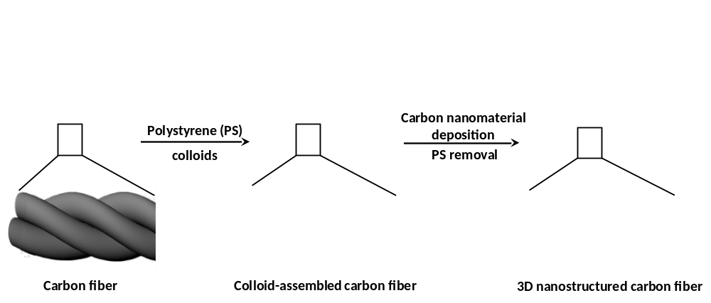

Recent Publications (minimum 5)
- Sung-Kon Kim,† Yun Ki Kim,† Hyun Joo Lee, Sang Bok Lee, Ho Seok Park, “Superior Pseudocapacitive Behavior of Confined Lignin Nanocrystals for Renewable Energy-Storage Materials”, ChemSusChem, 2014, 7(4), 1094-1101.
- Sung-Kon Kim, Hyung-Jun Koo, Aeri Lee, Paul V. Braun, “Selective Wetting-Induced Micro-Electrode Patterning for Flexible Micro-Supercapacitors”, Advanced Materials, 2014, 26(30), 5108-5112.
- Sung-Kon Kim,† Hyung-Jun Koo,† Jinyun Liu, Paul V. Braun, “Flexible and Wearable Fiber Micro-Supercapacitors Based on Carbon Nanotube-Agarose Gel Composite Electrodes”, ACS Applied Materials & Interfaces, 2017, 9(23), 19925-19933.
- Jaewon Choi, Minho Yang, Sung-Kon Kim*, “Pseudocapacitive Organic Catechol Derivative-Functionalized Three-Dimensional Graphene Aerogel Hybrid Electrodes for High-Performance Supercapacitors”, Applied Surface Science, 2017, 422, 316-320.
- Jun Woo Jeon,† Jae Hee Han,† Sung-Kon Kim,† Dong-Gyun Kim, Yong Seok Kim, Dong Hack Suh, Young Taik Hong, Tae-Ho Kim, Byoung Gak Kim, “Intrinsically Microporous Polymer-Based Hierarchical Nanostructuring of Electrodes via Nonsolvent-Induced Phase Separation for High-Performance Supercapacitors”, Journal of Materials Chemistry A, 2018, 6(19), 8909-8915.

 M.S. Jisu Kim
Jisu Kim is MS student of Chemical Engineering at Chonbuk National University. She is studying on the colloids and carbon nanomaterials for energy storages. Particularly, her research focuses on wearable and flexible micro-supercapacitors.

Email: okjisu@naver.com

 Prof. Sung-Kon Kim
Prof. Sung-Kon Kim is the assistant professor of Chemical Engineering at Chonbuk National University. Prof. Kim received his BS in Polymer Science and Engineering from Chungnam National University in 2006, and his MS and PhD in Chemical and Biological Engineering from Seoul National University in 2008 and 2012, respectively. Following a postdoctoral appointment at the Department of Material Science and Engineering of University of Illinois at Urbana-Champaign, he joined the faculty at Chonbuk National University in 2017. His current research program focuses on developing soft materials for energy storage and conversion.

Email: skkim@jbnu.ac.kr

Notes/Comments:

