The ZnO based Nanostructured Anode Materials for Energy Conversion Applications @ LTSOFC
Ghazanfar Abbas,
Department of Physics, COMSATS University Islamabad, Lahore Campus, Lahore-54000, Pakistan

Abstract
1. Introduction – Solid oxide fuel cells have got a countless consideration for the researchers in the field of energy conversion technologies due to their fuel flexibility and higher efficiency. Nanostructured materials have produced a great interest of researchers due to their vast applications in the field of chemistry, biotechnology, physics, medical science and material engineering etc. [1]. Now a day, the scientists attract their attention toward the nanomaterials for their use in energy conversion devices to overcome the energy crisis. Fuel cell is one of them which can fulfil energy demands [2]. In a fuel cell device the chemical energy of fuel was converted into the electrical energy. It was composed of three components anode, electrolyte and a cathode. Among all other categories of fuel cells, solid oxide fuel cells (SOFC) were preferably used due to its reliability, flexibility of fuel, good efficiency, modularity, low emissions and environment friendliness [4-5].
2. Experimental - In the present research investigation, two types of ZnO based anode materials with compositions Al0.1Mn0.1Zn0.8O (AMZ) and Al0.1Mn0.1Ni0.1Zn0.7O (AMNZ) were synthesized by solid state reaction. The phase confirmation and surface morphology of the synthesized materials were confirmed by the X-Ray diffraction and scanning electron microscopic analysis, respectively. Electrical properties of the materials were also measured for energy applications.
3. Results and Discussion - The Scherer’s formula was applied to elucidate the particle sizes of proposed materials and found to be 52 and 61nm for AMZ and AMNZ, respectively. The maximum conductivity of AMZ and AMNZ was found to be 4.4 and 5.2 S/cm, respectively. The values of activation energy calculated by Arrhenius plot were 0.21 and 0.25ev for AMZ and AMNZ, respectively. The fabricated materials showed both ionic and electronic conducting behaviour as confirmed by electrochemical impedance measurements. The AMNZ composition has higher value of open circuit voltage (1.01V) and power density (535mW/cm2) in hydrogen atmosphere as compared to AMZ at 550oC indicating that the AMNZ can be used as promising anode material at low temperature for fuel cell applications. The results of measurements have been shown in figure 1
Conclusions - All these characterization results shows that material is suitable for anode candidates in LT-SOFC and can be considered the new potential candidate as conventional one.

Figure 1

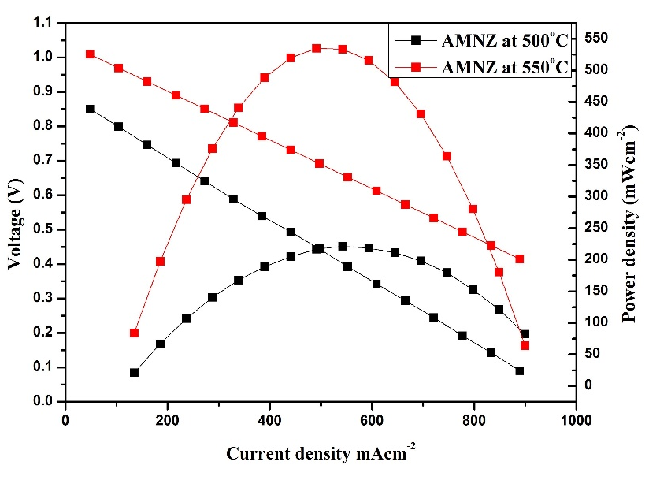

Recent Publications
- Ghazanfar Abbas, M. Ashfaq Ahmad, Rizwan Raza, M. Hammad Aziz, M. Ajmal Khan, Fida Hussain, Tauqir A. Sherazi, “High performance zinc based cathode for low temperature solid oxide fuel cell” Materials Letters, Vol. 238(March); 2019: 179-182 I.F. = 2.7
- Rida Batool, Rohama Gill, Faizah Altaf, M. Ashfaq Ahmad, Rizwan Raza, M. Ajmal Khan, Fida Hussain, Ghazanfar Abbas*, “Structural and electrochemical study of Ba_{0.15}Cu_{0.15}Ni_{0.10}Zn_{0.60} oxide anode for low temperature solid oxide fuel cell” Journal of Alloys and Compounds Vol. 780(April); 2019: 653-659. I.F. =3.779
- Faizah Altaf, Rida Batool, Rohama Gill, Ghazanfar Abbas*, “Proton conductivity and methanol permeability study of polymer electrolyte membranes with range of functionalized clay content for fuel cell application” European Polymer Journal Vol. 110(January); 2019: 1155-167. I.F. = 3.741
- Fida Hussain, Ghazanfar Abbas, M. Ashfaq Ahmad, Rizwan Raza, Zohaib Ur Rehman, Saleem Mumtaz, M. Akbar, Raja Ali Riaz, Saad Dilshad, “Comparative electrochemical investigation of zinc based nano-composite anode materials for solid oxide fuel cell” Ceramics International Vol. 45(1); 2019: 1077-1083. I.F. = 3.057
- M. Kaleem Ullah, Rizwan Raza, M.I. Asghar, Amjad Ali, Asia Rafique, Ghazanfar Abbas, Muhammad Ashfaq Ahmad, Imran Hanif, Muhammad Akbar, P.D. Lund, “Tri-doped ceria (M0.2Ce0.8O2-d, M¼ Sm0.1, Ca0.05, Gd0.05) electrolyte forhydrogen and ethanol-based fuel cell”. Journal of Alloys and Compound Vol. 773(1); 2019: 548-554. I.F =3.779


Biography (150 word limit)
Dr. Ghazanfar Abbas has completed his Ph.D. in 2013 in the field of Nanocomposite Materials for Energy Conversion Applications (Solid Oxide Fuel Cells). Currently, he is working as Assistant Professor in the Department of Physics, COMSATS University Islamabad, Lahore Campus, Lahore-54000, Pakistan and involved in teaching graduate undergraduate classes. I have joined Clean Energy Reseach Lab and orking in the field of fuel cell technology with nano-engineering technique. I have a professional skill to synthesize the materials by different techniques; solid state reaction, co-precipitation, sol-gel, wet-chemical root and auto-clave techniques and well known knowledge of XRD, EDX, SEM, TEM, and TGA analysis. I have been working to measure the electronic/ionic conductivities of the materials and fuel cell performance of three layers (anode/electrolyte/cathode) which includes the measurement of open circuit voltage (OCV), current density and power density at various temperature from 400-600ºC.

Email: mian_ghazanfar@hotmail.com

Notes/Comments:

Presenting Author Details:
Full Name: Dr. Ghazanfar Abbas
Email: mian_ghazanfar@hotmail.com
Session Name: Hydrogen Energy and Fuel Cell Technology
Category: ORAL Presentation

