DFT simulations applied to multiferroic materials
Sergio R. de Lazaro, State University of Ponta Grossa, Brazil Renan A. P. Ribeiro, State University of Ponta Grossa, Brazil Luis H. S. Lacerda, State University of Ponta Grossa, Brazil
Juan Andrés, CDMF, Brazil
Elson Longo, CDMF, Brazil

Abstract
Nowadays, superficial process is very important for chemical reactions, optical, electrical and magnetic properties. Ab-initio simulations are very specific for molecular structure, electronic density, spin, charge and others quantum information. Surface models have been developed to clarify and understand the electronic nature and properties; the Density Functional Theory (DFT) is one of more applied quantum descriptions used in surface science in molecular structure. Multiferroic materials have been researched because of its structure to represent a material with two or more properties. One special case is the electro-magnetic coupling in R3 and R3c structures as bulk as superficial dimensions can be contribute significantly to develop transdutors and spintronic devices. Our experience in simulate multiferroic materials is presented in analysis of electronic structure directed to electronic levels and spin location from magnetic cations. However, a particular phenomena is described in literature as the possibility to localize spin density in Ti atom became it a Ti³⁺ specie, which is very important to understand the intermetallic connection in materials with two cations, more specifically one magnetic cation and other non-magnetic cation. Such spin localization indicates band-gap reduction and spin channels from magnetic induction in a non-magnetic cation.

Image

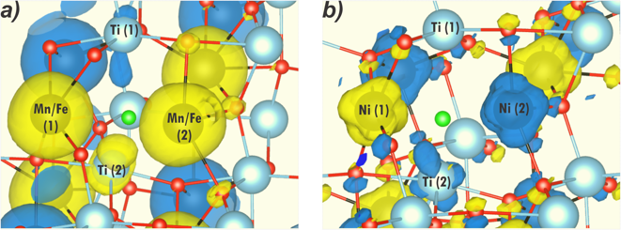

Figure 1: Spin density distribution closer to the oxygen vacancy site showing ferromagnetic ordering for MnTiO₃ and FeTiO₃ (a) and antiferromagnetic ground state for NiTiO₃ (b). Yellow and blue isosurfaces correspond to the spin-up and spin-down populations, respectively.

Recent Publications (minimum 5)
- Ribeiro RAP, Andrés J, Longo E, Lazaro SR (2018) Magnetism and multiferroic properties at MnTiO3 surfaces: a DFT study. Applied Surface Science 452:463-472.
- Da Silveira Lacerda LH, de Lazaro SR (2018) Multiferroism and magnetic ordering in new NiBO3 (B = Ti, Ge, Zr, Sn, Hf and Pb) materials: a DFT study. Journal of Magnetism and Magnetic Materials 465:412-420.
- Lacerda LHS, de Lazaro, SR (2018) Improvement of multiferroic property and change of magnetic ordering in new ANiO3 (A = Ti, Ge, Zr, Sn, Hf and Pb). Computational Materials Science 153:228-234.
- Ribeiro RP, Longo E, Andrés J, de Lazaro SR (2018) A DFT investigation of the role of oxygen vacancies on the structural, electronic and magnetic properties of ATiO3 (A = Mn, Fe, Ni) multiferroic materials. Physical Chemistry Chemical Physics. In press
- Jurelo AR, Ribeiro RAP, de Lazaro SR, Monteiro JFHL (2018) Structural, vibrational and electronic properties of the superconductor CuxTiSe2: theoretical and experimental insights. Physical Chemistry Chemical Physics 20 27011-27018.

 Biography
Sergio Ricardo de Lazaro has him expertise in DFT simulations applied in chemistry of materials in bulk and surface dimensions to improve electronic, magnetic and structural properties. He is professor in State University of Ponta Grossa since 2006, he created the chemical simulation group in department of Chemistry. He has participated as referee in many scientific journals and has 54 manuscripts published in reputed journals.
Email: srlazaro@uepg.br

Notes/Comments:

