TEM Studies of Epitaxial Oxide Films for Advanced All-Solid Li-ion Batteries
Leonid A. Bendersky1, Haiyan Tan2, K. Kamala Bharathi3, Saya Takeuchi1 and Aaron C. Johnston-Peck1
1 Material Measurement Laboratory, National Institute of Standards and Technology (NIST), Gaithersburg, MD 20899, USA; leoben@nist.gov
2 Thermo Fisher Scientific, 5350 NE Dawson Creek Drive, Hillsboro, Oregon 97124, USA
3 Department of Physics and Nanotechnology, SRM University, Research Institute, Kattankulathur, Chennai 603203, India

Abstract
Besides being of technological interest, thin films of different battery components, especially active cathode materials, can be utilized for fundamental studies of the processes that govern the battery’s properties. Cathodes utilized in commercial lithium batteries are complex systems consisting of a polycrystalline active material in the form of a powder mixed with conductive carbon and a binding material. A simple system with no additives is desirable for use in the investigation of interfacial reactions, especially for local microstructural studies by transmission electron microscopy (TEM). Such systems, when synthesized in the form of a thin film, especially as a single (or pseudo-single) crystal epitaxial film, can provide powerful insight into the processes occurring on a well-described two-dimensional interface, as well as the film interior. In our recent works we successfully utilized LiCoO₂ epitaxial films to study details of structural changes during electrochemical cycling. In the work presented here the similar approach was extended to other important cathode systems, as well as for studying some solid electrolytes.

Image
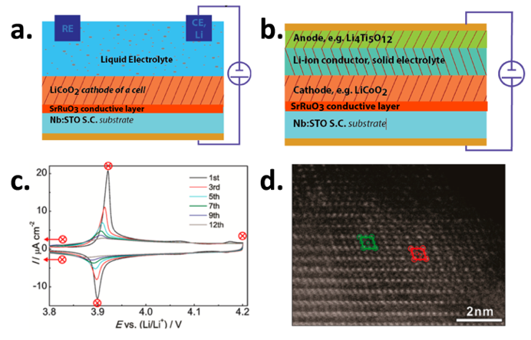

Fig. 1 (a,b) Schematic drawings of studied thin-film configurations; (c) Cyclic voltammograms of LiCoO₂/SRO/STO configuration; (d) Structural changes in the LiCoO₂ film seen by HAADF-STEM.

Recent Publications
- Bendersky LA, Tan H, Bharathi KK, Li ZP, Johnston-Peck AC (2017) Using epitaxial films to study fundamental properties of cathode materials for modern Li-ion batteries. Crystals, 7(5):127-143
- Johnston-Peck AC, Takeuchi S, Bharathi KK, Herzing AA, Bendersky LA (2018) Local degradation pathways in lithium-rich manganese-nickel-cobalt-oxide epitaxial thin films. Journal of Materials Science, 53(2):1365-1379
- Bendersky LA, Shen H, Young KH (2016) Crystallographic Alignment between C14 and bcc Phases in a Multi-phase Metal Hydride Alloys. Batteries, 2(3):22
- Young KH., Ng K, Bendersky LA (2016) A Technical Report of the Robust Affordable Next Generation Energy Storage System-BASF Program. Batteries, 2:2
5. Tan H, Takeuchi S, Bharathi KK, Takeuchi I, Bendersky LA (2016) Microscopy study of structural evolution in epitaxial LiCoO₂ cathode films during electrochemical cycling. ACS Appl. Mater. Interfaces, 8:6727–6735

 Biography
Leonid A. Bendersky is a research scientist at Materials Science and Engineering Laboratory of National Institute of Standards and Technology (NIST). He received his PhD degree in materials science from the Technion, Israel in 1982. From 1983 he has been with NIST working on a variety of advanced materials and technologies including rapid solidification, quasicrystals, structural intermetallics, functional oxides, hydrogen storage, Li-ion batteries. His research is focused on applying advanced transmission electron microscopy and crystallography to understand structural phase transitions and relation between properties and strutures. He is the author of over 200 publications.

Email: leoben@nist.gov

