Advances in Room Temperature Fluoride-Ion Batteries

Palanivel.Molaiyan@ttu.ee¹, I. Mohammad¹, Raiker.Witter@ttu.ee^{1,2}

¹School of Information Technologies Tallinn University of Technology, Tallinn, EST
²Institute of Nanotechnology, Karlsruhe Institute of Technology (KIT), Karlsruhe, GER

Abstract:
All-solid-state secondary batteries employing solid electrolytes are potentially more stable and safer than conventional batteries. At present, investigations and improvements of the ionic conductivities of solid electrolytes are attracting great attention. Here, we discuss the creation of defects (vacancy or point defects) in Pb_{x-1}Sn_{x}F₂, Ba_{x-1}Sn_{x}F_{2,} CaF₂, and (interstitial defect) Sm_{1-x}Ca_{x}F_{3-x} systems. Also, we discuss the introduction of additional surface defects to enhance conductivities at grain boundaries and nano-particle surfaces. Our samples were prepared by high-energy planetary ball-milling. Structural, morphology and conductive properties of the synthesized electrolytes were examined. Crystal structure, crystal/particle sizes and local molecular environment were examined with X-ray diffraction (XRD), high-resolution Field Emission Scanning Electron Microscope (FESEM) and Nuclear Magnetic Resonance (NMR) studies. At room temperature, the ionic conductivities of the systems were obtained to be between 10⁻³ to 10⁻⁵ S/cm. Finally, based on these solid-state electrolytes, different Fluoride Ion Batteries (FIB) at room temperature performance (RT-FIB) were prepared and electrochemical cycling behavior studies carried out.

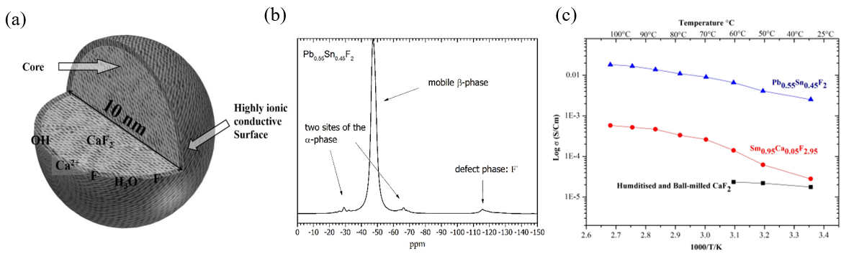
Fig 1. (a) Core CaF₂ Solid-state electrolyte prepared with humidisation. (b) NMR reflexation of Pb_{0.55}Ca_{0.45}F₂. (c) Ionic conductivity of different solid-state electrolytes like CaF₂, Pb_{0.55}Ca_{0.45}F₂, and Sm_{0.95}Ca_{0.05}F_{2.95}.

References
- Raiker Witter, Palanivel Molaiyan, Mohammad Irshad, Suresh Kumar,; " A method for manufacturing a nanoparticle material and a fluoride ion battery", Tallinna Tehnikaülikool; US62/326,802; 05.04.2018.
- Raiker Witter, Suresh Kumar, Palanivel Molaiyan, Mohammad Irshad; "A method for manufacture of fluoride ion battery", Tallinna Tehnikaülikool; US62/326,802; 24.04.2016.
- P. Molaiyan, M. Irshad and R. Witter, "Defect Enhanced CaF₂ Solid-State Electrolyte for Fluoride Ion Batteries". (2018)
- P. Molaiyan, M. Irshad and R. Witter, "High Ion Conductive Solid Electrolyte Composite Material: Sm_{1- x}Ca_{x}F_{3-x} for Fluoride Ion Batteries". (2018)
- Mohammad, I., Raiker Witter, Maximilian Fichtner, M. Anji Reddy, “Synthesis of Fast Fluoride-Ion-Conductive Fluorite-Type Ba_{1–x}Sb_{x}F_{2+x} (0.1 ≤ x ≤ 0.4): A Potential Solid Electrolyte for Fluoride-Ion Batteries. ACS Applied Materials & Interfaces”, 2018.

Biography:
I am Palanivel Molaiyan from Tamilnadu, India and obtained my master in Materials Science (2010) at PSG College of Technology, India.
During a three years perioud in the industrial sector I worked as a technician and application scientist at Hind High Vacuum Co Pvt Ltd, Bangalore, India.
Currently, I am pursuing Ph.D. in science (2014-2018) at Tallinn University of Technology, Tallinn, Estonia. My research topic is fluoride-ion based batteries using solid-state electrolytes under the supervision of Prof. (Associate) Dr. Raiker Witter, TUT, Estonia and KIT, Germany.
My research expertise is in materials science and electrochemistry, especially working on new solid-state electrolytes based on rare earth and alkali fluoride materials for the development of room temperature fluoride-ion based batteries.
Email: Palanivel.Molaiyan@ttu.ee & palaniii_phys87@yahoo.co.in and Raiker.Witter@ttu.ee

