Recent progressive of two-dimensional materials for terahertz detection
Lin Wang*, Xiaoshuang Chen, Wei Lu
ªState key Laboratory ofInfrared Physics, Shanghai Institute of Technical Physics, Chinese Academy of Sciences, 500 Yu Tian Road,
Shanghai, Shanghai 200083, China
^{b}Synergetic Innovation Center of Quantum Information & Quantum Physics, University of Science and Technology of China, Hefei, Anhui 230026, China
*Email: wanglin@mail.sitp.ac.cn

Abstract (300 word limit)

Recent years, layered van der Waals crystals consist of individual atomic planes weakly coupled by vdW interaction have attract great interests due to their intriguing physical properties, such as superconductivity, high carrier mobility, topologically protected surface states and among many others. An ambitious practical goal is to exploit planes of vdW crystals as building blocks of more complex optoelectronic application, especially in the terahertz band. The pursuit of two-dimensional materials for terahertz detection is promoted by the unique properties beyond traditional system, such as good CMOS-compatibility, easy for fabrication and fast response. Especially, graphene can support terahertz plasmon which can lead to enhanced THz absorption. Graphene-based terahertz detectors rely on the photothermoelectric and self-mixing effects[1] both of these effects depends on the near-field or the decay of plasmons. Also, other two-dimensional materials such as black phosphorus, topological insulator exhibit exotic THz optoelectronic properties, such as anisotropic band structure in black phosphorus (BP), interplay between surface states and bulk states such as in Bi₂Se₃ exhibiting the unique THz spectral profile[2][3]. Initial characterization has demonstrated the excellent interaction between THz photons and two dimensional materials. However, convent absorbed photons into electricity with high efficiency is still a big challenge. In typically, self-mixing process for direct detection require materials with both high mobility and moderated bandgap, and is usually wipe out/disrupted by the coexisting mechanism such as thermoelectric process. In this work, we present a new route toward manipulation of hot electrons within high mobility materials such as BP and graphene. Due their moderated bandgap, the hot electrons in atomic plane can be extensively excited and randomized. The unilateral flow of excess hot electrons can be facilitated by exploring the both the electromagnetic engineering and electrostatic tuning. Intriguingly, the hot electrons effect change the resistance via nonequilitrum carrier diffusion, leading to the high photoelectric gain under electrical bias. The present results and the novel hot electron mechanism allow for realistic exploitation of two-dimensional materials for large area, fast imaging.
Keywords: Terahertz, Two-dimensional Materials, Detection

Image

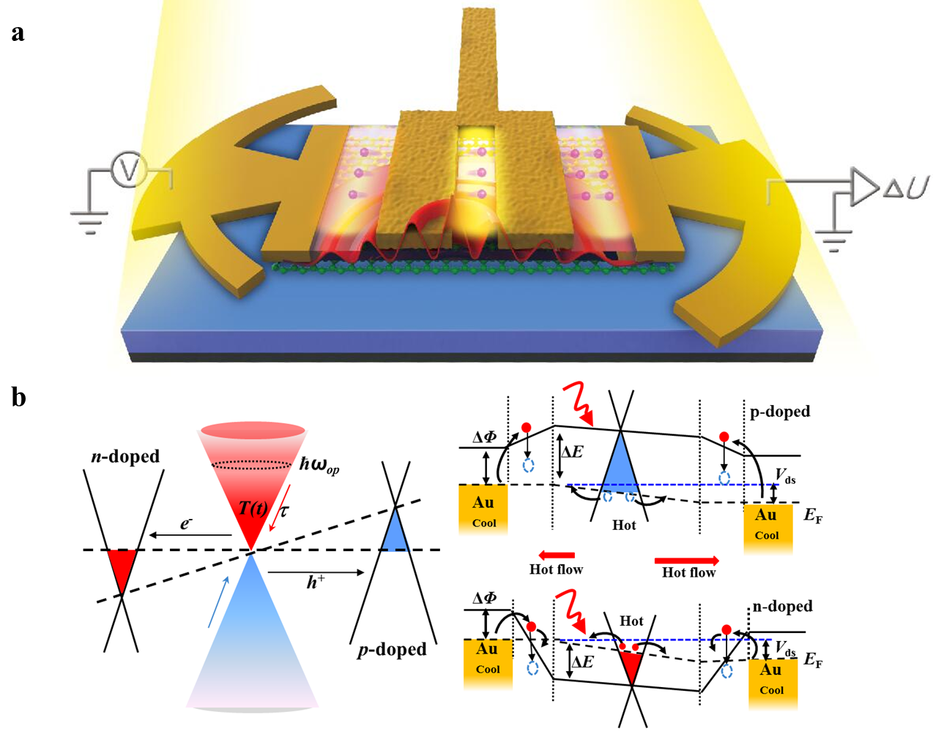

Recent Publications
[1]L. Vicarelli, M. S. Vitiello, D. Coquillat, A. Lombardo, A. C. Ferrari, W. Knap, M. Polini, V. Pellegrini, A. Tredicucci. Graphene field-effect transistors as room-temperature terahertz detectors. Nature Materials, 11, 865-871 (2012).
[2] Lin Wang, Changlong Liu, Xiaoshuang Chen, Jing Zhou, Weida Hu, Xiaofang Wang, Jinhua Li, Weiwei Tang, Anqi Yu, Shao-Wei Wang. Toward Sensitive Room-temperature Broadband Detection from Infrared to Terahertz with Antenna-Integrated Black Phosphorus Photoconductor. Adv. Fun. Mat. 27, 1604414(2017).
[3] Changlong Liu, Lin Wang*, Xiaoshuang Chen, Jing Zhou, Weida Hu, Xinran Wang, Jinhua Li, Zhiming Huang, Wei Zhou, Weiwei Tang, Gangyi Xu, Shao-Wei Wang, Wei Lu, Room-temperature photoconduction assisted by hot-carriers in graphene for sub-terahertz detection. Carbon, 130, 233-240 (2018).
[4]Weiwei Tang, Antonio Politano, Cheng Guo, Wanlong Guo, Changlong Liu, Lin Wang, Xiaoshuang Chen, Wei Lu. Ultra-sensitive room-temperature terahertz direct detection based on bismuth selenide topological insulator. Adv. Fun. Mat. 10.1002/adfm.201801786 (2018).
[5]Changlong Liu, Lin Wang, Xiaoshuang Chen, Jing Zhou, Weiwei Tang, Wanlong Guo, Jin Wang, Wei Lu. Nanoscale, 10, 5852-5858 (2018).

Lin Wang was currently associate professor in Shanghai Institute of Technical Physics, Chinese Academy of Science.. He has been awarded many prizes including special prize of president scholarship for distinguished postgraduate student. Outstanding achievement award in Shanghai. He has authored or coauthored more than 40 technical journal papers and delievered more than 10 invited conference presentations, seving as a journal peer-reviewer in Adv. Fun. Mat. ACS Nano, APL etc.
His current research interests include plasma wave detection of terahertz/Infrared radiation using graphene and III-V, Plasmonic Nanomaterials and Metamaterials devices, graphene-like two-dimensional optoelectronics.
Email: wanglin@mail.sitp.ac.cn

Notes/Comments:

