Towards Sensitive Terahertz Detection via Thermoelectric Manipulation in Graphene Transistors

Gang Chen
Chinese Academy of Sciences, Shanghai Institute of Technical Physics, State Key Lab for Infrared Physics, 500 Yutian Rd. Shanghai 200083, China

Abstract (300 word limit)
vGraphene has been highly sought-after as a potential candidate for hot electron terahertz (THz) detection benefiting from its strong photon absorption, fast carrier relaxation and weak electron-phonon coupling. Nevertheless so far graphene based thermoelectric THz photodetection is still hindered by the low responsivity owing to the relatively low photo-electric effeciency. In this work, we provide a straightforward strategy for the enhanced THz detection based on an antenna-coupled CVD graphene transistors with the introduction of symmetric paired fingers. This design enables switchable photodetection modes by controlling of the interaction between the THz field and free hot carriers in graphene channel through different contacting configurations. Hence a novel "Bias field effect" can be activated which leads to a drastic enhancement in THz detection ability with responsivity up to 280V/W and Johnson-noise limited minimum noise-equivalent power (NEP) of 100 pW/Hz^{0.5} at room temperature. The mechanism of the enhancement of the photoelectric gain is attributed to the thermophotovoltaic instead of the plasma self-mixing effects, Our results offer a promising alternative route to scalable, wafer-level production of high performance graphene detectors.

Image

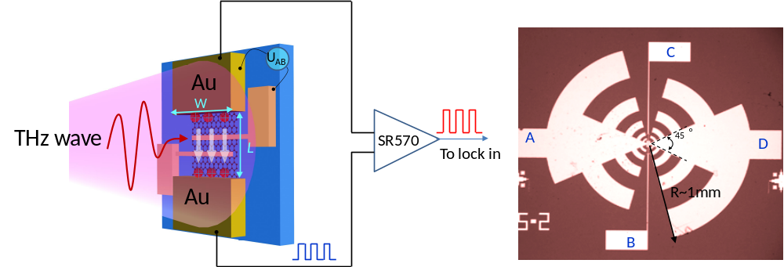

Recent Publications (minimum 5)
- Liu D, et al. (2018) Efficient Raman Enhancement on High-Quality Ultra-Clean Graphene Quantum Dots Produced by a Quasi-Equilibrium Plasma-Enhanced Chemical Vapor Deposition. Nature Communications 9:193
- Liu C, et al. (2018) Towards Sensitive Terahertz Detection via Thermoelectric Manipulation in Graphene Transistors. NPG Asia Materials DOI:10.1038/s41427-018-0032-7
- Du L, et al. (2018) Thickness-controlled direct growth of nanographene and nanographite film on non-catalytic substrates. Nanotechnology 29:215711
- Sun F, et al. (2018) Optical waveguide of buckled CdS nanowires modulated by strain engineering. ACS Photonics 5:746-751
- Du L, et al. (2017) Formation of Self-Connected Si0.8Ge0.2Lateral Nanowires and Pyramids on Rib-Patterned Si(1 1 10) Substrate. Nanoscale Research Lett. 12:70
- Meng K, et al. (2016) Two-Dimensional Organic-Inorganic Hybrid Perovskite Photonic Films. Nano Letters 16:4166

 Biography (150 word limit)
Gang Chen has his expertise in growth of semiconductor materials and the fabrication of optoelectronic devices. He received his PhD on condensed matter physics from Fudan University, Shanghai, China in 2002. Then he had been working at the Institute of Solid State Physics in Johannes Kepler University, Linz, Austria for ten years on the MBE growth of SiGe based nanostructures and their application in the optoelectronics. Now he is a professor in Chinese Academy of Sciences, Shanghai Institute of Technical Physics. He has published more than 60 research papers in peer-reviewed journals. His main research interest are on the field of the fabrication low dimensional Carbon allotrope and their application on ultra broad photodetection.
Email:gchen@mail.sitp.ac.cn

