The modeling of selected mechanical properties of plastic materials under influence of complex external load state
Dariusz KURPISZ, Poznan University of TechnologyPhD,Poland,
Maciej OBST, Poznan University of Technology PhD, Poland

Abstract

One of the most important and widely used materials are plastic materials. Hence, the knowledge on the behaviour and especially mechanical properties of this type of materials, plays an important role in their strength assessment. Very important is here the practical possibility of the prediction of material behaviour under the influence of complex load state, where useful and very important are the strain energy based methods of mechanical properties modelling of material. Such type of approach to the modelling were used among others in [4] and [5].
In the current paper basing on phenomenological approach and interpretation of mechanical experimental characteristics, the strain energy model of plastic material under complex load state in range of elastic deformations, will be introduced. The strain energy density function which is a density of the work of stress components$σ_{i}(t)$ for $i=1,2,3,$ along deformation path $C:ε_{i}(t)$ for $i=1,2,3$(see Fig.1), defined in the form:

$$W\left(ε_{1},ε_{2},ε_{3}\right)=\int{\sum_{i=1}^{3}{σ_{i}}}dε_{i}=\int_{0}^{1}{\sum_{i=1}^{3}{σ_{i}\left(t\right){ε^{'}}_{i}\left(t\right)}}dt,$$

will be applied for determination of material stability assumption due to the possibility of the appearing of plastic flow.
All theoretical investigations will be illustrated on the example of two types of plastics materials in three-axial state of stress.

Image
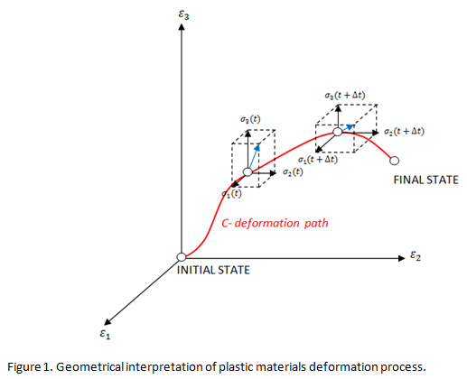
Recent Publications

- Li Q, M, (2001) Strain energy density failure criterion. International Journal of Solids and Structures 38: 6997-7013.
- Valavala PK (2008) Multiscale constitutive modeling of polymer materials, Dissertation, Michigan Technological University
- W YJ, Li J, Faria R (2006) An energy release rate-based plastic-damage model for concrete. International Journal of Solids and Structures 43:583-612.
- Wegner T, Kurpisz D (2013) Phenomenological modeling of mechanical properties of metal foam. Journal of Theoretical and Applied Mechanics51:203-214.
- Wegner T, Kurpisz D (2017) An Energy-Based Method in Phenomenological Description of Mechanical Properties of Nonlinear Materials under Plane Stress. Journal of Theoretical and Applied Mechanics 55:129-139.

Biography
Dariusz Kurpisz is a scientific worker at the Poznan University of Technology. His scientific interests includes mathematical modeling of physical process both for materials as well for more complicated structures. One of the most important tools in his work are phenomenological approach and energy method of modeling based on experimental approach and the strain energy density function.
Email: dariusz.kurpisz@put.poznan.pl

Notes/Comments:

