Polyacetylene: Myth, Reality and a Way Forward.
Bruce S. Hudson, PhD, Syracuse University, USA

Abstract (300 word limit)
Statement of the Problem: Polyacetylene, the simplest and oldest conducting polymer, has never been made in a form that permits rigorous determination of its structure. Trans polyacetylene will have two equivalent potential energy minima. It has been assumed that this results in bond length alternation. It is, however, very likely that the zero-point energy is above the Peierls barrier. Experimental studies that purport to show bond alternation have been reviewed and shown to be compromised by experimental inconsistencies or by the presence of finite chain polyenes. This situation has been reviewed in an open paper. http://www.mdpi.com/1996-1944/11/2/242/pdf A method for preparation of high molecular weight polyacetylene with fully extended chains that are prevented from reacting with neighboring chains by photochemical polymerization of a reactive guest molecules in urea inclusion complexes (UICs) is then discussed. The structural chemistry of these UIC materials will be reviewed. Our current projects involve guest species diiodobutadiene or diiodohexatriene. The loss of iodine atoms during the elimination polymerization is monitored by weight loss. The polyacetylene chains form in UIC channels as fully extended chains that are parallel with a separation of 0.82 nm in a hexagonal lattice. The diene and triene guest species differ in crystal morphology with the triene presenting with hexagonal needles. Raman spectroscopy used to monitor the formation of polyene chains suffers loos of intensity when the chains are very long. The final material is characterized by vibrational inelastic neutron scattering using VISION at the Oak Ridge National Laboratory. Our ultimate objective is to measure electrical conduction of polyacetylene in urea inclusion compounds along the c-axis of the hexagonal channel. The strong bonding of carbons atoms suggests that this material may be a superconductor at room temperature due to the lack of thermally populated phonons. Methods for the formation of closed loop structures are being considered.

Image
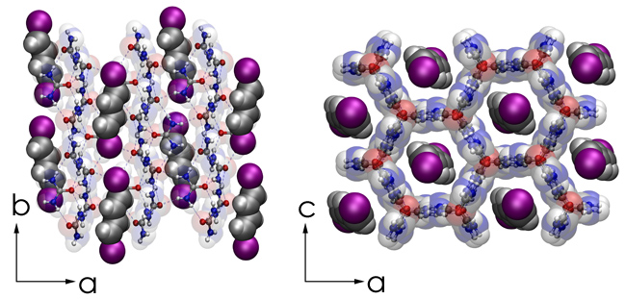
Recent Publications (minimum 5)
() Hudson, B. S. Polyacetylene: Myth & Reality, Materials, 2018, 11, 242; doi:10.3390/ma11020242.
(2) Hudson, B. S.; Allis, D. G. Bond alternation in infinite periodic polyacetylene: Dynamical treatment of the anharmonic potential. J. Molec. Struct. 2013, 1032, 78-82.
(3) Harris, K. D. M.; Palmer, B. A.; Edwards-Gau, G. R. Reactions in Solid-State Inclusion Compounds. In Supramolecular Chemistry: From Molecules to Nanomaterials; Gale, P., Steed, J., Eds.; John Wiley & Sons, Ltd.: Chichester, UK, 2012; Volume 4, pp. 1589–12.
(4) Dinca, S. A.; Allis, D. G.; Lashua, A. F.; Sponsler, M. B.; Hudson, B. S. Insulated Polyacetylene Chains in an Inclusion Complex by Photopolymerization. In Crystal Engineering―Design, New Materials and Application, Proceedings of the 2015 Material Research Society Symposium MM; Parkin, S. Ed.; Cambridge University Press, 2015; Volume 1799, p. 7.
(5) Lashua, A. F.; Smith, T. M.; Hu, H.; Wei, L.; Allis, D. G.; Sponsler, M. B.; Hudson, B. S. Commensurate Urea Inclusion Crystals with the Guest (E,E)‑1,4-Diiodo-1,3-Butadiene. Cryst. Growth Des. 2013, 13, 3852-3855.
(6) Marti-Rujas, J.; Desmedt, A.; Harris, K. D. M.; Guillaume, F. Bidirectional Transport of Guest Molecules through the Nanoporous Tunnel Structure of a Solid Inclusion Compound. J. Phys. Chem. C 2009, 113, 736–743.
(7) Hudson, B. S., Oriented n-alkanes in Urea-d4 Inclusion Complexes for Inelastic Neutron Scattering Vibrational Studies, Molecular Crystals and Liquid Crystals 2001, 356, 423-432.Harper C (2009)

 Biography (150 word limit)
Bruce S. Hudson received his Bachelors and Masters degrees in biophysical chemistry from the California Institute of Technology in Pasadena, California and his PhD degree in Physical Chemistry from Harvard University where he worked for Bryan E. Kohler on the peculiar electronic spectroscopy of linear conjugated polyenes. As part of his PhD thesis he proposed that the lowest excited electronic state of linear polyenes has the same symmetry as the ground electronic state involving doubly excited configurations. It is the merging of this excited state with the ground state for very long linear polyenes that gives rise to the double minimum potential of polyacetylene. He is a fellow of the American Physical Society
Email: bshudson@syr.edu

Notes/Comments:

