Soft-templated ordered/disordered bimodal mesoporous carbon from mixture ratio of the phenolic resin and mesophase pitch

Jae-Yeon Yang, Korea Institute of Carbon Convergence Technology, Jeonju 54852, Republic of Korea
Byoung-Suhk Kim, Organic Materials & Fiber Engineering, Chonbuk National University, Jeonju 54896, Republic of Korea
Min-Kang Seo, Korea Institute of Carbon Convergence Technology, Jeonju 54852, Republic of Korea

Abstract
Ordered mesoporous carbonaceous materials (OMC) have recently been studied extensively due to their potential applications, such as sorption, catalysis, energy storage, and electrochemistry. Generally, OMC with various structures has been successfully prepared with hard and soft-template methods. However, the key drawback of the hard-template method is the extra steps required to prepare the scaffolds and the sacrificial use of the surfactant templates as well as the scaffolds. The high-cost and fussy synthesis may sorely limit their applications. While in the soft-template method, amphiphilic surfactant molecules, such as block copolymers, which is denoted as a soft-template method based on the principle of liquid-crystal templating, is expected to be more flexible in generating OMC.
In this work, ordered and disordered mesoporous carbons were prepared by an organic-organic self-assembly method with the mixture ratio of phenolic resin and petroleum based-mesophase pitch as starting materials, amphiphilic tricopolymers F127 as a soft-template, HCL as a catalyst, and distilled water as a solvent. Mesoporous carbons were synthesized by a low-temperature and were carbonized at a low temperature. Their surface, structural, and textural properties were investigated using Brunauer-Emmett-Teller (BET) method, adsorption branches of isotherms using BJH method, transmission electron microscopy (TEM), X-ray diffraction (XRD), small angle X-ray scattering (SAXS), potentiometric titration, and thermal analyses. The electrochemical measurements were performed with an electrochemical analyzer system. SEM and TEM images of mesoporous carbons obtained by varying the blend ratios of pitches were shown in Figure 1. OMC exhibited the typical stripe-like and hexagonally arranged, consistent with a high-quality hexagonal p6mm mesostructure which was good in agreement with the value calculated from the SAXS data(Figure 2).

Image

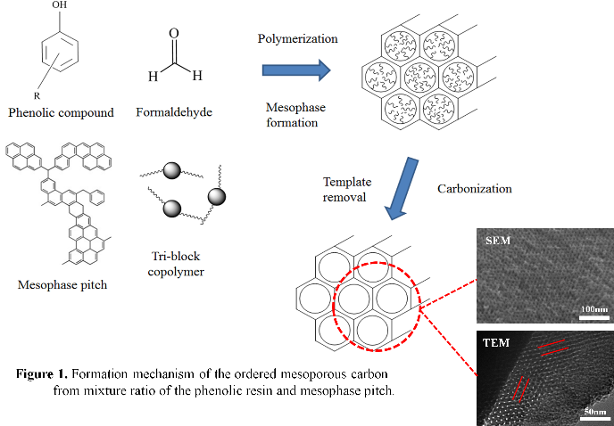

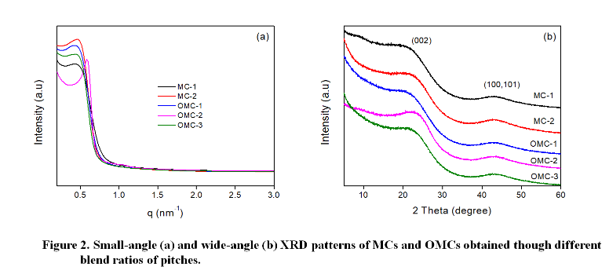

Recent Publications

 Biography
Jaeyeon Yang has his expertise in fabrication of the carbon-based fuel cells, carbon fiber reinforced polymer or carbon fiber reinforced plastic. Also, his research expertise includes carbon materials, carbon fibers, and carbon fiber papers.

Email: yangjy1026@gmail.com

