Influence of Electrodeposited Polypyrrole Layer on the Capacitive Performance of Hybrid NiCo₂O₄/Carbon Fiber Paper Composites

Tae-Hoon Ko, Department of Organic Materials & Fiber Engineering, Chonbuk National University, Jeonju 54896, Republic of Korea
Min-Kang Seo, Korea institute of Carbon Convergence Technology, Jeonju 54852, Republic of Korea.
Hak-Yong Kim, Department of BIN Convergence Technology, Chonbuk National University, Jeonju 54896, Republic of Korea
Byoung-Suhk Kim, Department of Organic Materials & Fiber Engineering, Chonbuk National University, Jeonju 54896, Republic of Korea

Abstract
Recently, electrochemical capacitors have been carried out with emphasis on the development of hybrid electroactive electrode materials, based on metal oxide, carbon materials and conducting polymers. The hybrid NiCo₂O₄ modified carbon fiber paper (NiCo₂O₄/CFP) composites with different electrodeposited times of polypyrrole (PPy) layers were prepared by two-step process. At first, NiCo₂O₄ was prepared by low temperature hydrothemal method. Secondly, PPy layer were coated onto the NiCo₂O₄/CFP composites by using electrochemical deposition method. The potential sweeping between –0.2 to 1.0 V at a scan rate of 50 mV/s was performed for various potential sweeping cycles (0, 5, 10, 15 and 20) in 0.5 M KCl solution in the presence of pyrrole monomer. SEM images clearly indicated that the NiCo₂O₄ nanoneedles were uniformly grown over the CFP. Further, PPy layer was uniformly deposited over the NiCo₂O₄/CFP composites. In the present work, we have fabricated various hybrid NiCo₂O₄/CFP composite electrodes with different electrodeposited PPy layers, and the effects of electrodeposited PPy layer were investigated. The as-prepared NiCo₂O₄/CFP composite electrodes with PPy layer electrodeposited for 15 cycles (NiCo₂O₄-PPy15/CFP) showed good electrochemical performance. Further, NiCo₂O₄-PPy/CFP composite electrode was successfully utilized for solid-state high performance supercapacitor applications. It showed high capacitance value with high energy and power density as well as high rate capability, which were evaluated from galvanostatic charge-discharge and electrochemical impedance spectroscopy.

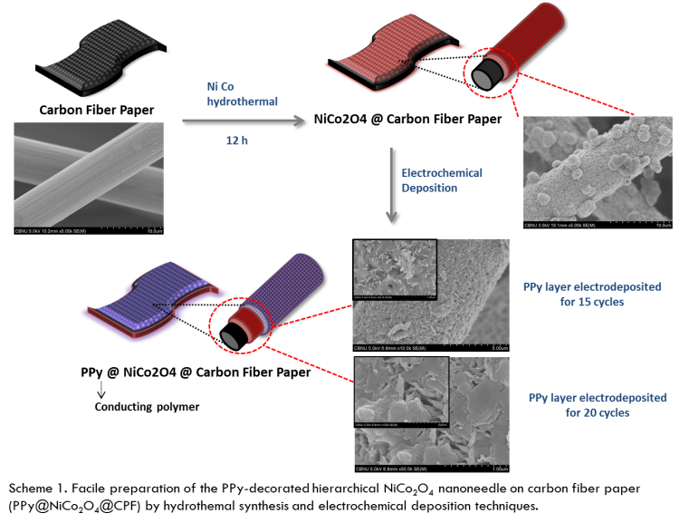
Recent Publications
- Ko TH, Devarayan K, Seo MK, Kim HY, Kim BS (2016) Facile Synthesis of Core/Shell-like NiCo₂O₄-Decorated MWCNTs and its Excellent Electrocatalytic Activity for Methanol Oxidation. Scientific reports. 6:20313_1-20313_9.
- Ko TH, Radhakrishnan S, Choi WK, Seo MK, Kim BS (2016) Core/shell-like NiCo₂O₄-decorated MWCNT hybrids prepared by a dry synthesis technique and its supercapacitor applications. Materials Letters. 166:105-109.
- Ko TH, Radhakrishnan S, Seo MK, Khil MS, Kim HY, Kim BS (2017) A green and scalable dry synthesis of NiCo₂O₄/graphene nanohybrids for high-performance supercapacitor and enzymeless glucose biosensor applications. Journal of Alloys and Compounds. 696:193-200.
- Ko TH, Lei D, Balasubramaniam S, Seo MK, Chung YS, Kim HY, Kim BS (2017) Polypyrrole-Decorated Hierarchical NiCo₂O₄ Nanoneedles/Carbon Fiber Papers for Flexible High-Performance Supercapacitor Applications. Electrochimica Acta. 247: 524-534.
- Kim WJ, Ko TH, Seo MK, Chung YS, Kim HY, Kim BS (2018) Engineered carbon fiber papers as flexible binder-free electrodes for high-performance capacitive energy storage. Journal of Industrial and Engineering Chemistry, in press.



Biography
Taehoon Ko has his expertise in fabrication of the high-performance nanocomposite supercapacitors, fuel cells, and electrocatalysts. His research expertise includes carbon nanotubes, carbon fiber papers, nanostructured metal oxides, and hierarchical nanocomposites.
Email: Taehoon222@naver.com
Notes/Comments:

