Combinedoxidation of methane to synthesis gas
Dossumov K., Doctor of chemical science, professor, al-Farabi Kazakh National University, Center of Physical and Chemical Methods of Research and Analysis, Almaty, Kazakhstan
Yergaziyeva G., candidate of chemical science, The Institute of Combustion Problems, Almaty, Kazakhstan
Myltykbayeva L., PhD, The Institute of Combustion Problems, Almaty, Kazakhstan
Telbayeva M., PhD-student, The Institute of Combustion Problems, Almaty, Kazakhstan

Abstract
Biogas is a promising source of hydrocarbons capable of providing the current and future needs of mankind for energy and hydrocarbon feedstocks [1]. The main components of biogas obtained in anaerobic bioreactors are methane and carbon dioxide, as impurities can contain carbon monoxide and oxygen [2]. Biogas obtained in this way can be converted to synthesis gas by dry (CH₄ + CO₂) or steam reforming (CH₄ + H₂O) using appropriate catalysts [3-5]. In the present work, a modified nickel catalyst supported on alumina was used as catalysts for the combined oxidation of methane. Experiments on testing the efficiency of catalysts were carried out on an automated flow catalytic unit (PKU-1). The reaction products were identified chromatographically on a device of "CHROMOS GC-1000"
The figure shows the results of the effect of promoting additions of lanthanum (La₂O₃), molybdenum (MoO₃) and cerium (CeO₂) oxides on the catalytic activity of the nickel catalyst in the combined methane oxidation reaction involving oxygen, carbon dioxide and water vapor, under process conditions: CH₄: CO₂ : O₂: H₂O = 2: 2: 1: 0.5, Tr = 850° C and W = 1000 h⁻¹. As can be seen from the figure, the promotion of nickel catalyst with cerium, lanthanum or molybdenum oxides results in an increase in the activity and selectivity of nickel catalyst. The highest activity and selectivity of the nickel catalyst is observed when oxides of cerium and molybdenum are promoted. On the promoted 3% NiO-1% MoO₃ / Al₂O₃ catalyst, the selectivity for hydrogen was 66%, for carbon monoxide 47%. At the same time, the concentration of H₂ reaches 52 vol. %, CO up to 33.9 vol. % and methane conversion 95%. For a catalyst of 3% NiO-1% CeO₂/Al₂O₃, the selectivity for hydrogen is 50% and for carbon monoxide 60%. In this case, the concentration of H₂ obtained reaches 41 vol.%, CO up to 42.8 vol.% and methane conversion 98%.
Thus, the activity and selectivity of oxide-supported nickel-containing catalysts promoted by MoO₃, CeO₂ and La₂O₃ oxides during methane reforming into synthesis gas was tested. It is determined that the promotion of nickel catalyst with cerium or molybdenum oxides leads to an increase in the selectivity and activity of the catalysts for the desired products.

Figure – Selectivity and activity of catalysts in the methane reforming reaction
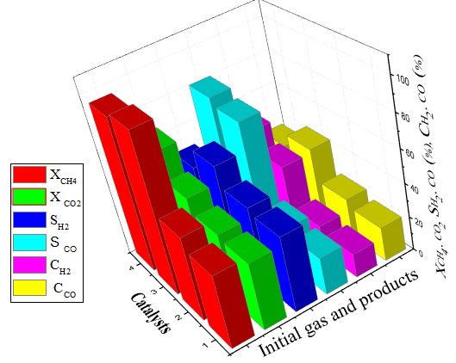
1 - 3%NiO/Al₂O₃; 2- 3%NiO–1%La₂O₃/Al₂O₃; 3 - 3%NiO–1%СеО₂/Al₂O₃; 4 - 3 % NiO –1%MoO₃/-Al₂O₃

Recent Publications
- Davide Papurello, Andrea Lanzini (2014) Biogas from the organic fraction of municipal solid waste: Dealing with contaminants for a solid oxide fuel cell energy generator. Waste Management 34:2047–2056
- Ashvin L. Karemore (2016) On the dry and mixed reforming of methane over Ni/Al₂O₃-Influence of reaction variables on syngas production. International J Hydrogen Energy 41:22963-22975.
- Karam Jabbour, Pascale Massiani (2017) Ordered mesoporous “one-pot” synthesized Ni-Mg(Ca)-Al₂O₃ as effective and remarkably stable catalysts for combined steam and dry reforming of methane. Applied Catalysis B: Environmental 201:527–542.
- Nian Zhang, Xin Chen (2017) Catalytic performance of Ni catalyst for steam methane reforming in a micro-channel reactor at high pressure. Chemical Engineering & Processing: Process Intensification 118:19–25.
- Daegak Kim, JongHyun Jeon (2017) Effective suppression of deactivation by utilizing Ni-doped ordered mesoporous alumina-supported catalysts for the production of hydrogen and CO gas mixture from methane. International J Hydrogen Energy 42:24744-24756.

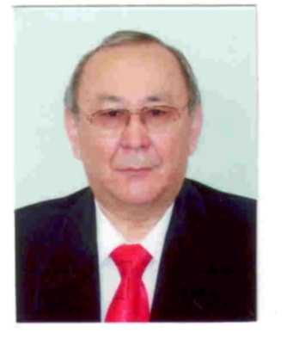
Dossumov Kusman was born in Semipalatinsk, Republic of Kazakstan on February 27, 1950. Since 1972 he got the high education diploma of al-Farabi Kazakh National University (KazNU), chemistry, Almaty, Kazakhstan. In 1996 he got the doctor of chemical science and in 2000, he has been a professor of chemistry.

In 1972-1995 years he was Junior Science Researcher, Senior Science Researcher, then Leading Science Researcher of the Institute of Organic Catalysis & Electrochemistry NAS RK. During 1995-2007 years he was Deputy Director then in 2007-2010 - General Director of D.V. Sokolsky Institute of Organic Catalysis & Electrochemistry Ministry of Education & Science Republic of Kazakhstan. In 2011-2017 he was first deputy director of the Center of Physical and Chemical Methods of Research and Analysis al-Farabi KazNU, Almaty, Kazakhstan. His current research interests are catalysis, petro –gas chemistry and ecology. dossumov50@mail.ru

