Characterization of Air Plasma Sprayed Al PO4 and Laser Sealed ZrO2-MgO Coatings on Ni-Base Supper Alloys of Aero Engine
I-ABSTRACT
Aerospace gas turbine engines are designed and operates at temperature very close to their melting points. So current strategies for performance improvements are centered on (thermal barrier coatings) TBCs.
II- AIM AND SCOPE OF THE PRESENT WORK
This project was designed to obtain a better understanding of the pore morphologies, the surface microstructure, surface densification, phase structures mechanical characteristic, chemical structure, and thermo-physical properties of ceramic coatings in a high temperature corrosive environment and to help designers of advanced aero, industrial and marine gas turbine engines in the area of TBCs. Whilst in aero engines ceramic coatings are primarily temperatures as a means of increasing life.
III – REVIEW
TBCs are often applied to metallic super alloys to extend the temperature regime in which a component can operate (1 - 6). A common failure mechanism of TBCs on thermal cycling is delamination of the ceramic just above the bond coat ceramic interface due to high local stresses and that thermal expansion mismatch between the substrate and ceramic layer is a significant contributor to these stresses (7 - 11) to reduce these stresses three layer system incorporating intermediate layer of graded material between the bond coat and ceramic have been tried while these three layer coating have proved promising for diesel application (12).
CHEMICAL ENERGY SOURCE
ELECTRIC ENERGY SOURCE
If continues energy
If low energy
If discontinues energy
If high energy
HVof (High velocity Oxy-Fuel flame spraying)

0
Wire arc spraying
D-GUN method spraying
Plasma spraying
Principle Diagram of the Energy Source Shows the different thermal spraying techniques divided by their principle energy sources.
IV - PLAN OF WORK
An ideal coating would exhibit a high uniform, well controlled distribution of pores and micro cracks to both decrease thermal conductivity and allow thermal expansion and contraction without exfoliation. At the same time, the coating must be sealed against penetration of corrosive liquids by a high density surface layer. Two approaches, surface densification by heat treatment and impregnation by thermo - chemical methods have been investigated in this work.
V- EXPERIMENTAL ANALYSIS
PLASMA - TECHNIK AG M - 1000 apparatus for plasma and auxiliary equipment for the spraying of aerospace components. It comprise : powder source (PT - 800), control console (M - 1000), plasma torch (F4), feed unit (TWIN - 10), water cooler system (T -powder 500) and holding device for the work piece in addition to dust separator (MK - 9) and wet separator (NA - 100). Figure (1)., gives a schematic diagram of the apparatus.
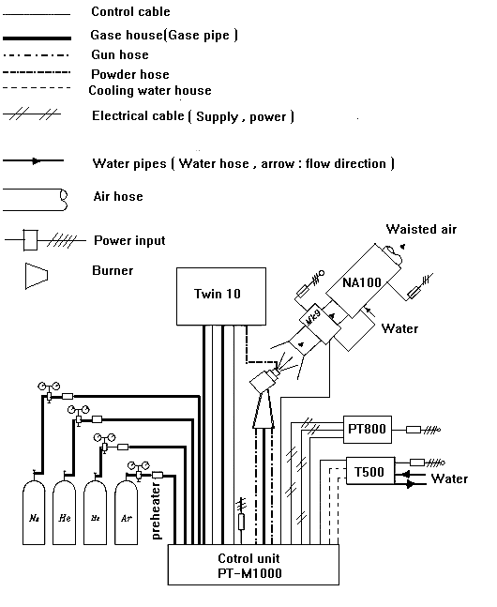
Samples cut out of Nickel base super alloy Ni-Cr 20 Ti Al of DIN designation number is corresponding to 2.4631) of 1.4 mm thickness have been subjected to investigations. First, Ni - 5wt % Al (AMDRY, 956) alloy (bond coat) of 0.4 mm to 0.6 mm thickness and then, Zro2 - 20wt % Mg O (AMDRY 333) (top coat) of 0.5 mm to 0.8 mm thickness have been deposited by air plasma spraying method upon their surface.
5-1 spraying material investigation:
The most important powder parameters are grain size described, in ASTM standard B. 214- 86 using mesh designation number also, in DIN standard DIN 32529 using number to describe the grain size), internal porosity (correlated with apparent density and flow ability (described, in ASTM standard B. 329- 76 and B 213- 83. receptivity).

EDX (Electron Diffraction X- ray) was used in chemical analysis.
XRD (X- Ray Diffraction) was used in phase identification and quantitative phase analysis studies.
5-2 Surface investigation:
The Vickers Hardness (HV3) was determined using ASTM E- 384 - 73 standard.
The Tensile bond strength measurement using ASTM 633 - 96 or DIN 50160 standard.
Porosity were tested with (MIP).
EDX and XRD were used in chemical and phas identification.
The corrosion behavior of specimens was determined using AUTOLAP PGSTAT 30 show in figure (2).
Thermal conductivity, λ, was calculated from thermal diffusivity , α , with laser flash apparatus (Theta Industries Inc., Part Washington, NY , USA), specific heat, cp. With DSC 404 C, and density of the free standing coating specimen.
Λ = α * Cp * ρ
TEC were carried out by dilatometer (Adamel Lhomargy SAS, model DI - 24, France).
TCR test was studied in a thermal cycling facility illustrated in figure (3) and table (1).

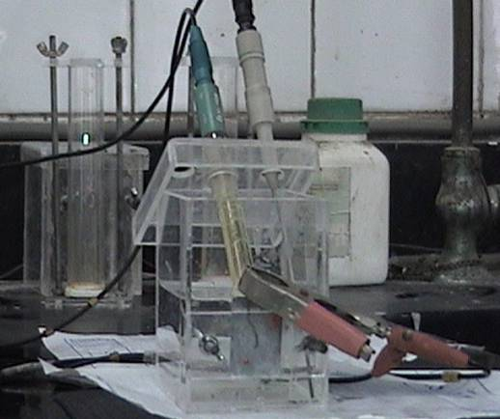
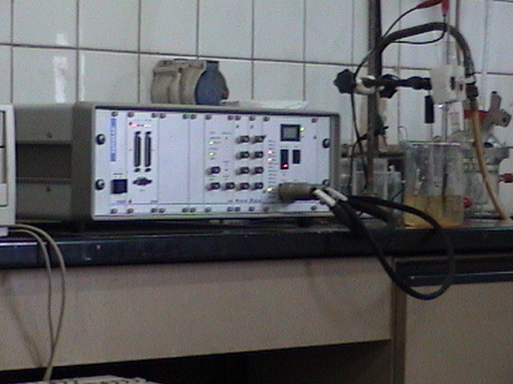


AUTOLAP PGSTAT 30 | corrosion cell
Figure (2): Photograph of AUTOLAP PGSTAT 30
And corrosion cell

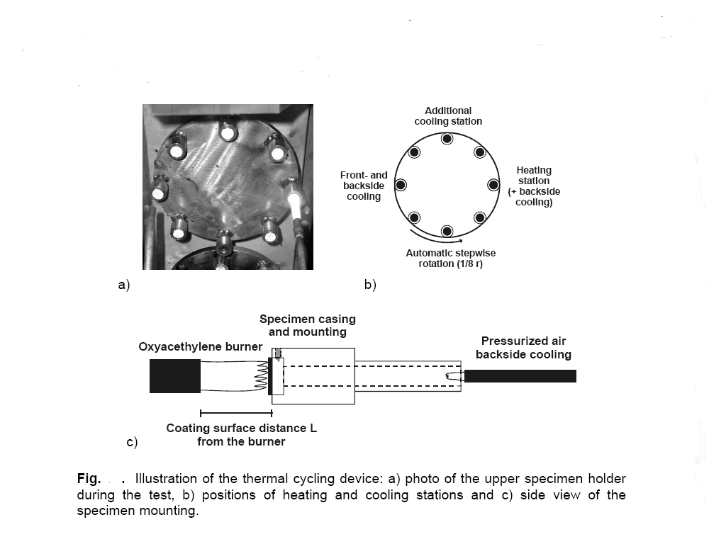
Fig (3). Illustration of the thermal cycling device, a) photo of the super specimen holder during test, b) position of heating and cooling stations and C) side view of the specimen mounting.
Table (1). Thermal cycling test parameter:
Parameter | Test
Coating burner distance (mm) | 50
Coating maximum temperature C⁰ | 1200
Coating minimum temperature C⁰ | 250 ± 50
Heating time (sec) | 20
Total cycle number | 500
VI RESULT AND DISCUSSION
6-1 Influence Of The Plasma Spray Parameter:
On Coating Performance:
The effect of plasma spray parameters on coating performance, plasma voltage versus H₂ - content % and Metallographic / Image analysis of sprayed Ni - Al bond coat and ZrO2 – Mg O topcoat with different spray parameters are show in tables
(2, 3) and Figure (4, 5), and Figure (6, 7) receptivity.
Table (2): The effect of the plasma gas on the coating performance of Ni - Al bond coat, at plasma current = 450 A, injector angle = 90o, substrate temperature = 140 ºC, and injection distance = 130 mm
Specimen No | Plasma gas flow rate (L/min) |  | H₂- content  (%) | Plasma voltage  (V) | Hardness  (HV₃) | Tensile bond strength  (M. Pa) | Porosity  (%) | Thickness  (μ. m)
Specimen No | Ar | H₂
S₀ | 47 | 9.5 | 20.2 | 68 | 190 | 35 | 2 | 250
S₁ | 47 | 8.6 | 18.2 | 60 | 150 | 30 | 6 | 160
Specimen No. | Plasma gas flow rate (L/min) |  | H₂- Content  (%) | plasma voltage  (V) | Hardness  (HV₃) | Tensile bond strength  (M. Pa) | Corrosion rate  (m. p. y) | Porosity  (%) | Thickness  (μ. m)
Specimen No. | Ar | H₂
/S₀ | 47 | 13 | 27.6 | 72 | 200 | 22 | 0.0683 | 9.8 | 230
/S₁ | 47 | 0 | 0 | 27 | 115 | 12 | 0.99135 | 18.9 | 155
Table (3): The effect of the plasma gas on the coating performance of Zr. O₂-Mg O top coat at plasma current = 630 A, injection angle = 90°, substrate temperature = 150°C, and spraying distance = 90mm.
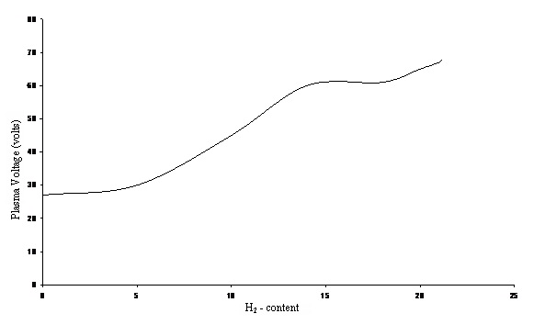
Figure (4): Effect of H₂ - content % on plasma voltage (plasma voltage versus H₂ - content %): Total flow rate = 56.5 L / min, I = 450 for Ni - Al bond coat.
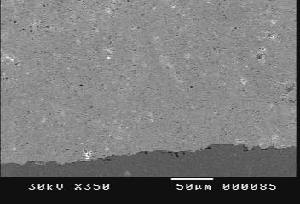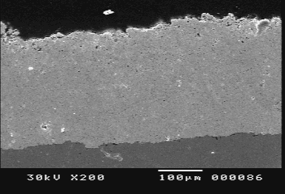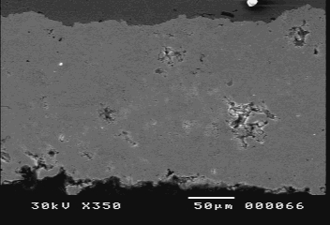
S₀ | S₀ | S₁
Fig. (5): Back scattered SEM image for cross section view of (Ni- 5wt% - Al bond coat) coatings sprayed with the optimum conditions (S₀ , Nickel - Aluminum (bon coat) coating sprayed with the optimum condition. ), with decreasing of the H₂-gas flow rate (S₁ , H₂ - Content 18.2% plasma voltage 60V porosity percentage 6%).
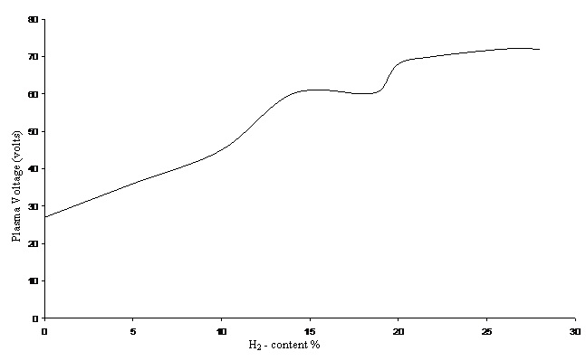
Figure (6): Effect of H₂-content % on plasma voltage, (plasma voltage versus H₂-content): Total flow rate = 60 L/min, I = 630A for zirconia (top coat) coating.
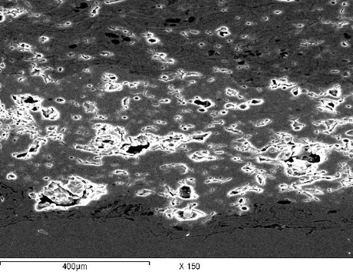
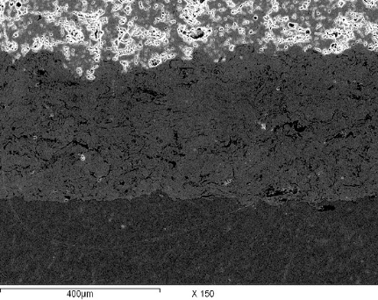

X-150  (Sub) + (Ni - Al) + (ZrO₂-MgO)  (/So) | X - 150  (ZrO₂ - MgO) + (Ni-Al)  Pure Ar (no H₂), plasma voltages 27.6 V  (/S1)
Figure (7): Back scattered SEM image for cross-section view of zirconia (top coat) coatings on Nickel-Aluminum (bond coat) sprayed with the optimum conditions (/So), without H2-gas flow rate (/S1)

6-2 Advanced Processing Approaches for Producing TBCs of High Quality Performance
6.2.1 Pretreatment of substrate:
The average surface roughness was able to be increased from 10μm (by using shut blasting method) up to 20 μ . m (by using NTA with applying LPPS).
Figure (8) and table (4) shows installation on LPPS and NTA process parameter.
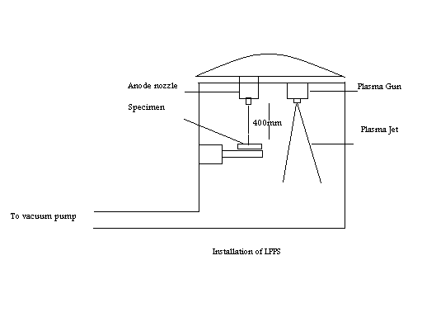
Figure (8): Installation of LPPS

Table (4): NTA process parameter on the surface of specimens (Ni-super alloy substrate).
Plasma generating gas | Pressure of plasma | Distance between gun and specimen  (mm) | Duration of NTA processing  (Sec) | NTA Electric current  (A) | Surface roughness  (μm) | Improved tensile bond strength (MPa)
Ar + 15 vol % H₂ | 25 | 500 | 0.1 - 2 | 35A | 20 + 2 | 65

6.2.2 Post - spray treatment procedure:
6.2.2.1 Heat treatment:
An example of the furnace annealing of T.TBCs can be illustrated in table (5).
The effect of sintering on ZrO2 - MgO top coating is illustrated in SEM micrographs, Fig (9), by remaining strings of fine pores and closed crack at splate boundaries.
Table (5): The effect of the Furnace treatment on the coating performance of T TBCs.

Sprayed Material Type | Furnace treatment |  |  | Property improved
Sprayed Material Type | Temperature (C⁰) | Time  (h) | Atmosphere | Porosity  (%) |  | Density  (gm./cc) |  | Young's Modulus  (G. Pa) |  | Tensile bond strength on coated substrate (M Pa)
 |  |  |  | Before | After | Before | After | Before | After | Before | After
Ni-5wt% Al bond coat sprayed on Ni-substrate | 1150 | 2 | Vacuum | ---- | ---- | 7.50 | 7.51 | 190 | 200 | 65 | 80
Ni-5wt% Al bond coat sprayed on Ni-substrate | 800 | 24
65 wt% ZrO₂MgO plus 35wt% Ni- Al intermediate coat sprayed on the bond coat | 800 | 4 | Air | ---- | ---- | 5.51 | 5.66 | 91 | 135 | 37 | 54
ZrO₂-20wt % MgO top coat sprayed on the intermediate | 1150 | 4 | Air | 9.8 | 5.8 | 4.23 | 4.48 | 62 | 69 | 33 | 48

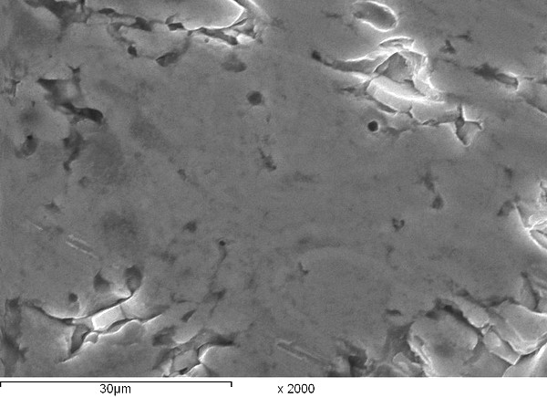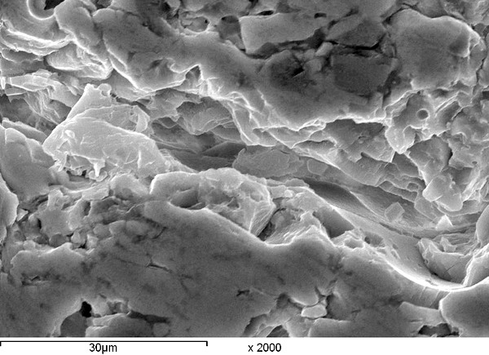
X: 2000  Annealed ZrO2-MgO top coat sprayed with the optimum conditions | X: 2000  ZrO₂ - MgO top coat  Sprayed with the optimum conditions
Figure (9): SEM micrographs of annealed and not annealed TBCS which are thermally sprayed at the same optimum conditions illustrating the sintering of the ZrO₂ - MgO top coat structure, string of the fine pores and closed cracks at splat boundaries for annealed coating.
6-2.2.2 Surface densification:
The Zr O₂ – Mg O coating were sealed with either Al (OH)₂ - 85% H₃PO₄ solution at 300 ⁰C for 4 hours or pulsed NAG Laser has radiation wave length of 1064 nm.
The high magnification SEM micrographs in figure (10) showed no visible reaction layer in the coating / sealant interface. But the quantitative XRD analysis in table (6) , For AlPO₄ sealing showed a clear ZrP₂O₇ peaks with phase transition due to the following reaction.

For laser sealing showed grain refining without phase transition due to the localization nature of laser.
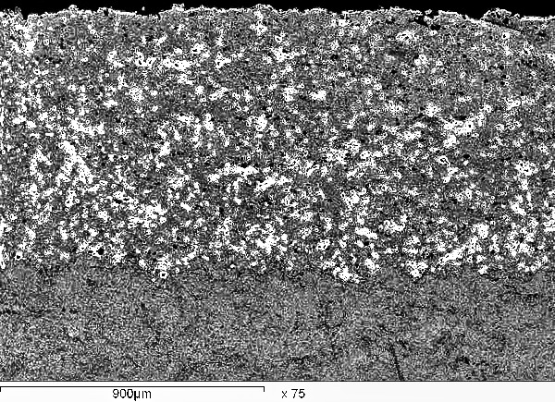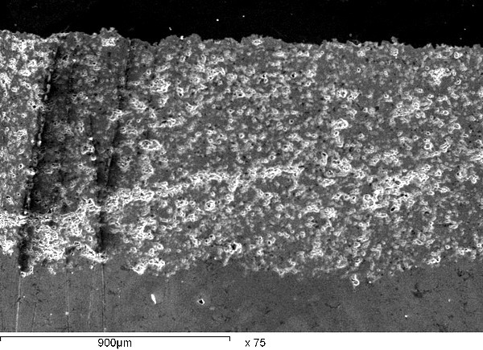
X: 75  Reference coating  (a) | X: 75  Aluminum phosphate sealed (penetration of Aluminum phosphate sealant into the ZrO₂ - MgO₂ top coat)  (b)
Figure (10): Optical micrographs of (a) reference coating, (b) modified Al PO₄ coating based TTBCs.
Table (6): EDX result of Al PO₄ sealed ZrO₂ - MgO coatings.
Position of analysis | Compound wt % |  |  |  |  | Element wt %
Position of analysis | ZrO₂ | MgO | Al PO₄ | Zr P₂O₇ | Al₂O₃ | Zr | Mg | Al | P | O
Outer the coating cracks | 78.2 | 21.8 | __ | __ | __ | 60.9 | 13.1 | __ | __ | 25.9
Inner the coating cracks | 77.9 | 21.8 | 0.05 | 0.12 | 0.13 | 60.7 | 9.3 | 2 | 1.8 | 26.2
6-3 Thermal expansion of thermal cycling and calculated thermal conductivity corresponding to the measured porosity:
TEC of the mixed of ceramic (65 wt % ZrO₂ - MgO) with alloy (35 wt % Ni Al) intermediate coating was about (12 × 10⁻⁶ K⁻¹) which is close to that of substrate (18 × 10⁻⁶ K⁻¹), bond coat (14.9 × 10⁻⁶ K⁻¹) and top coat (9.5 × 10⁻⁶ K⁻¹), this lead to reduce the generation of residueal stress.
Coating failure by thermal cycles depends on the applied stress.
SEM after different cycles are presented in figure (11).
Pure Zirconia (not stabilized Zirconia) coating was damage after 280 cycles showed visible delamination and craking. Reference (not modified) double layer coatings was showed a horizontal and vertical crack after laser (or Al PO₄) sealed ZrO₂ - MgO topcoat did not show any change and resisted more than 500 cycles, the coating peeled of near the bond coat after 950 cycles.
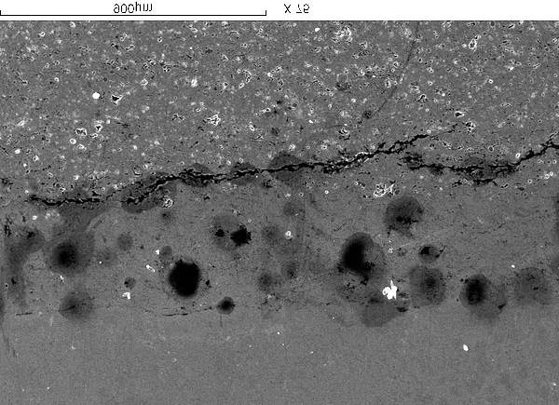
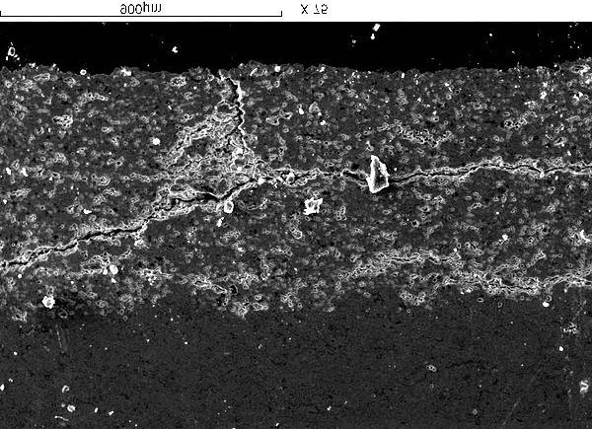
The Calculation of thethermal conductivity λ (T) corresponding to the measured porosity results are present in table (7).
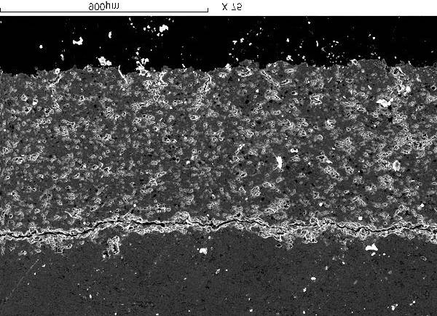
X-75  Reference coating  after 500 cycles  (A | X-75  Reference coating  after 400 cycles  (B) | X-75  Non stabilized ZaO₂  after 280 cycles  (C)

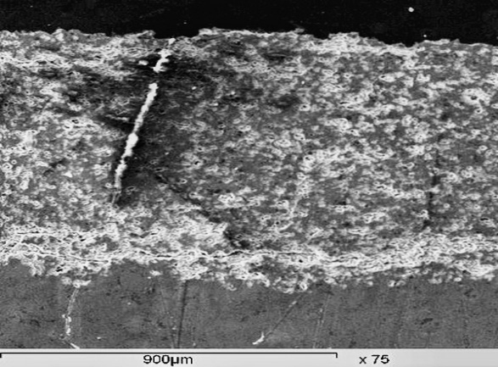
X-75  AlPO₄ sealed ZrO₂ - MgO  (D) | X-75  AlPO₄ sealed ZrO₂ - MgO  after 500 cycles  (E)

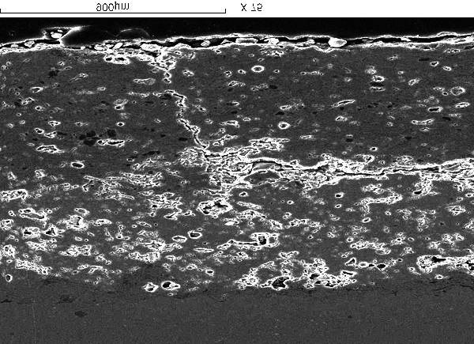
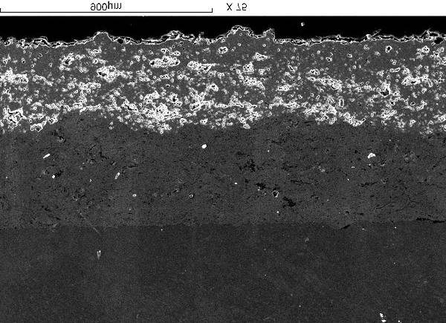
X-75  Laser sealed ZrO₂ – MgO  (F) | X-75  Laser sealed ZrO₂ - MgO  after 500 cycles  (G)

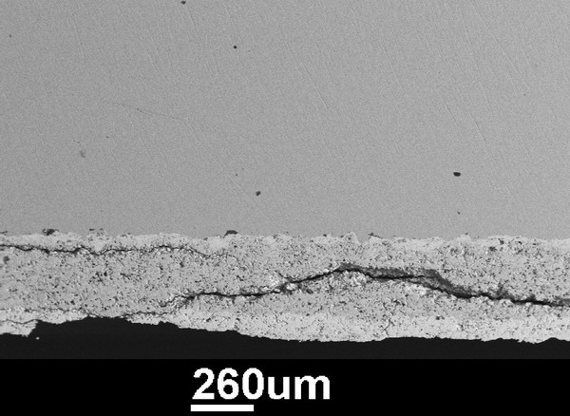
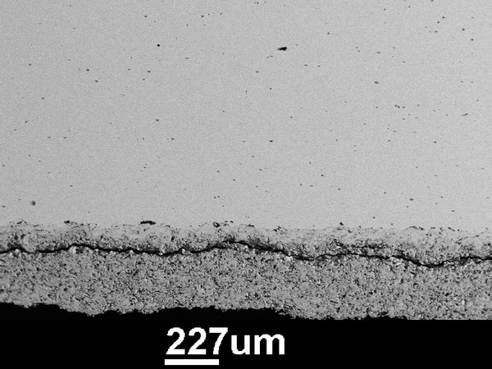
X-35  Modified coating of AlPO₄ sealed  ZrO₂ -MgO after 950 cycles  (Triple Coating)  (H) | X-35  Modified coating of laser sealed ZrO₂ - MgO after 950 cycles  (Triple Coating)  (I)

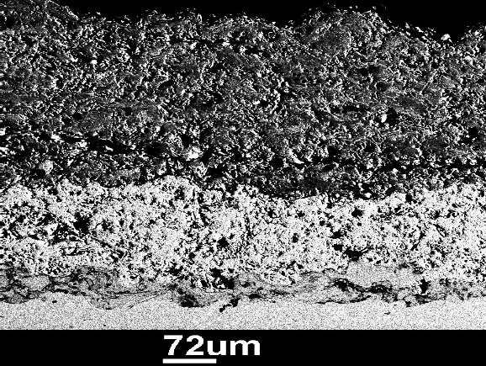
Triple coating after 500 cycles
(K)
Figure (11): Optical microstructure (SEM) of undamaged coatings and damage coatings after 280, 400, 500 and 950 cycles.

Table (7): Calculated thermal conductivity, λ (T) results for reference material was used in λ (T) calculations also for modified coatings corresponding to the measured porosity.
Coating layer type deposited on Ni substrate using APS technique | Porosity (δ)  % | Density  (ρ)  Kg/m³ | Specific heat (Cp)  J/Kg/K | Thermal diffusivity  α * 10⁻⁷ m²/S | Thermal conductivity  λ = ρC_{p}α  W/mK | Temperature  C° | Phase structure
Ni - base - suepr allay  Din (2.4631) | 0.1 | 8900 | 444  580  635  647 | 190  130  150  160 | 75  66  84.7  92.1 | 300  700  1000  1300 | c-Ni
Ni - 5wt % Al bond coat | 2 | 7500 | 450  530  560  585 | 40  41.5  43  34 | 9  10.2  13  15 | 300  700  1000  1300 | c-Ni
ZrO₂ - 20 wt% MgO | 9.8 | 4280 | 614  640  657  660 | 2.85  7.5  7.8  8.85 | 0.75  2  2.2  2.5 | 300  700  1000  1300 | t-ZrO₂ and c-MgO
Aluminum phosphate sealed ZrO₂ - 20 wt%  MgO to coat  (modified coating) | 2.9 | 4380 | 625  675  680  684 | 4.3  9.1  10.4  12.7 | 1.2  2.7  3.1  3.8 | 300  700  1000  1300 | t-ZrO₂ and c-MgO
Laser sealed ZrO2-  20 wt% MgO top coat (modified coating) | 3.9 | 4350 | 634  650  655  667 | 2.9  7.4  8.4  8.7 | 0.8  2.1  2.4  2.55 | 300  700  1000  1300 | t-ZrO₂ and c-MgO

6-4 Modified corrosion resistance and corresponding Vickers Hardness investigations.
The electromagnetic parameters derived from linear polarization on experiment and the corresponding Vickers hardness for blank, reference, and modified specimens with the same spray conditions are present in table (8).
Table (8): The electromechanically parameters. Corrosion potential E_{corr}, corrosion current I_{corr}, polarization resistance R_{P}, and corrosion rate C_{R} derived from linear polarization experiments and the corresponding hardness (HV₃) for blank specimen, reference and modified coatings with the same spray conditions.
Specimen Type | E_{corr}  (v) | R_{p}  ohm. Cm²*10³ | I_{corr} μA/Cm² | Corrosion rate (mpy) | Efficiency % | Hardness HV₃
Ni-base super alloy substrate | -0.297 | 8.416 | 3.2906 | 0.97832 | __ | 180
ZrO₂ - MgO reference coating | -0.237 | 185.8 | 0.22988 | 0.06834 | 93.01 | 200
Aluminum - Phosphate sealed ZrO₂ - MgO  Modified coating | -0.318 | 83.3 | 0.1802 | 0.053 | 94.5 | 200
Laser - sealed ZrO₂ - MgO modified coating | -0.165 | 2899 | 0.01678 | 0.004 | 99.5 | 247

VII CONCLUSION
Plasma spraying has great advantage over the known galvanizing process in cases where it can be used to coat electrically non- conductive surface with metal.
The deviation of plasma spray parameters from the optimum condition lead to the fine microstructure coating became lower in quality i.e. increase of porosity, voids (pull - out effect), un-melted phase, and delamination.
The strengthening in phosphate sealing result from two different mechanism, chemical bonding and adhesive binding. Due to chemical reaction and formation of condensed aluminum phosphates in the structure defects of the coating.
The sealed top-coat in a few microns (50μm 100μm) were highly density and grain refined with the exception of some closed pores formed in the laser sealing process.
Phosphate sealed coating showed excellent wear resistance, 80% lower weight losses than the reference coatings.
Laser sealed coating was even more micro hardness and more abrasion resistance than the phosphate sealed coating, only a minor part of the melted top layer was worn away.
FUTURE WORK IN TBCs
TBCs, need further development work, both in production technology and characterization Erosion - corrosion resistant, TBCs are needed to prevent overheating of metal part in engines and heat exchangers, for which both coating formulation and deposition methods are needed.

Thicker Zirconia coatings and more strain - tolerant coatings are needed for combustion Zones of aero gas turbine engines.

Repair of joining techniques for coating materials are always in need of further research. Some turbine blades in service have been re - coated several times, showing the importance of this aspect.
VIII Reference
1) P.J. Meyer and D. Hawley: in Thermal Spray Coatings: Properties, Processes and Applications, T.F. Bernecki, ed., ASM International, Materials Park, OH, USA, 1991, p. 29- 38.
2) A. Freslon, "Plasma Spraying at Controlled Temperature and atmosphere" in Thermal Spray Science and Technology, C.C. Berndt and S. Sampath, eds., ASM International, Materials park, OH, USA, 1995, p. 57 - 63.
3) T. Lewis, L. Sokol, and E. Hanna, "Optimization of Gator- gard Applied Chromium Carbide- Ni Cr Aly Composite Overlays for Maximum Solid Particle Erosion Resistance, in Thermal Spray", Advances in Coatings Technology, D.L. Houck, ed ASM International, Materials Park, OH, USA, 1988, p. 149- 155.
4) T. Morischita, "Coatings by 250 kW Plasma Jet Spray System.' Plasma Technik 2nd Symp., S. Blum- Sandmeier, H. Eschnauer, P. Huber, and A.R. Nicoll., eds., Plasma Technik Wohlen, Wholen, CH, 1991, vol. 1, p. 137 - 45.
5) T.C. Mc Geary and J.M. Koffshey, "Engineering Applications for Flame Plating", Met. Progr., 1965, Jan., p. 80- 86.
6) M.L: Thrope and H.J. Richter, "A Pragmatic Analysis and Comparison of HVOF process", J. Thermal Spray Technol., 1992, vol. 1 (2), p. 161- 70.
7) Smith, G.D. and J.A.E. Bell, "Thermal Barrier Coating of Incoloy Alloy 909", Proceedings of the 1989 Spring TMS Meeting, las Vegas Nevada.
8) Hillery , R.V., B.H. Pilsner, R.L Mcknight, T.S. Cook and M.S. Hartle, "Thermal Barrier coating life predication Model Development. Final Report" NASA CR - 180807 (1988).
9) Miller, R.A. and C.E. Lowell "Failure Mechanisms of thermal Bareier Coatings Exposed to Elevated Temperatures", This Solid Films, 95, pp. 265- 273 (1982)
10) Miller, R.A., "Current Status of thermal Barrier Coatings- An Overview "Surface and Coatings Technology, 30, pp. 1- 11 (1987).
11) Stecura, S., "Two - layer thermal - Barrier Systems for Ni - Al - Mo Alloy and effects of Alloy Thermal Expansion on System life" Amer. Ceramic Soc. Bull., 61 (2), pp. 256- 262 (1982)
12) Novak, R.C., A. P. Matarese and R.P. Huston, "Development of Thermal Barrier coatings for Diesel Applications", Thermal Spray Technology, ASM International, pp. 273- 281 (1989).

