Fast optical response time and high contrast ratio after dispersion of fluorescent dye into the nematic liquid crystal
Govind Pathak^{a*}, Atul Srivastavaª and Rajiv Manoharª
ªLiquid Crystal Research Lab, Department of Physics, University of Lucknow, Lucknow-226007, India
*E-Mail: govindpathak001@gmail.com

Abstract

Fluorescent dye Benzo 2,1,3 thiadiazole has been dispersed into the pure nematic liquid crystal (NLC) 1550C which is consisted of 4’-(trans,trans-4-alkylbicyclohexyl)carbonates and 4’-(4-(trans,trans-4-alkyl)-4-cyanobicyclohexane, with in three different concentration in the present investigation. Electro-optical and dielectric parameters have been investigated here. In this work response time has been measured by Optical Switching Method and found to be decreased after the dispersion of fluorescent dye into the pure NLC 1550C. This fast optical response time measurement is the main finding of the present investigation. Rotational viscosity has also been calculated here and found to be decreased for dispersed system as compare to pure NLC. Polarizing Optical Microscope (POM) images have also been taken in the current study which shows that alignment as well as contrast has been improved after the dispersion of fluorescent dye. Contrast Ratio (CR) has also been measured here by applying a square wave and found to be increased for the dispersed system. This is also a promising result of this investigation. The outcome of present investigation may be very useful in the liquid crystal displays (LCDs) and other devices which requires fast response time.
Keywords: Nematic liquid crystal; Fluorescent dye; Response time, Contrast ratio.
Image
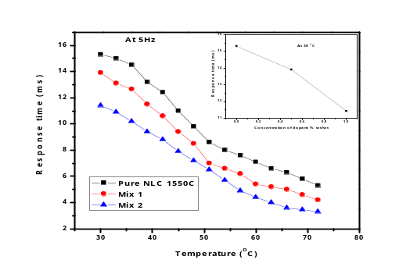
Figure 1. Variation of Response time with respect to temperature for pure NLC and dispersed system.

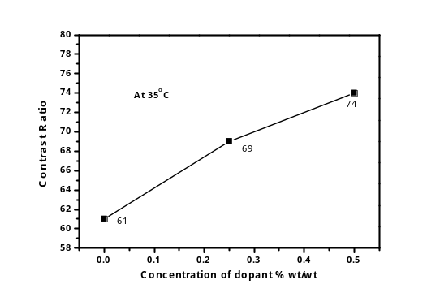
Figure 2. Variation of Contrast Ratio with respect to concentration of dopants.

Recent Publications
1. Pathak G, Pandey S, Katiyar R, Srivastava A, Dabrowski R, Garbat K, Manohar R (2017) Analysis of photoluminescence, UV absorbance, optical band gap and threshold voltage of TiO2 nanoparticles dispersed in high birefringence nematic liquid crystal towards its application in display and photovoltaic devices, Journal of Luminescence. 192:33-39.
2. Pandey S, Vimal T, Singh DP, Gupta SK, Pathak G, Katiyar R, Manohar R (2016) Core/shell quantum dots in ferroelectric liquid crystals matrix: effect of spontaneous polarisation coupling with dopant, Liq.Cryst. 43:980-993.
3. G. Pathak, R. Katiyar, K. Agrahari, A. Srivastava, R. Dabrowski, K. Garbat, R. Manohar. Analysis of birefringence property of three different nematic liquid crystalsdispersed with TiO₂ nanoparticles, Opto-Electronics Review, 26 (2017), 11-18.
4. Agrahari K, Pathak G, Katiyar R, Yadav G, Vimal T, Pandey S, Singh DP, Gupta SK, Manohar R (2017) Effect of Cd1−xZnxS/ZnS core/shell quantum dot on the optical response and relaxation behaviour of ferroelectric liquid crystal, Molecular Crystals And Liquid Crystals 1-11.
5. Vimal T, Pandey S, Gupta SK, Singh DP, Agrahari K, Pathak G, Kumar S, Tripathi PK, Manohar R, (2017) Manifestation of strong magneto-electric dipolar coupling in ferromagnetic nanoparticles-FLC composite: evaluation of time-dependent memory effect, Liquid Crystal 1-11.
 Biography: Govind Pathak is doing his Ph.D form the Department of Physics, University of Lucknow, India since 2014. Govind Pathak has his expertise in the field of Liquid Crystalline Materials. He has published several research articles in reputed journals and also presented his work in several conferences in India. His work is based on the measurement of Electro-optical and Optical parameters of the Nematic and Ferroelectric Liquid Crystals dispersed with different dopants, like Nanoparticles and dyes. He has a research experience in achievement of fast optical response time, enhancement of Contrast ratio and high birefringence in the liquid crystal. He is also working on the newly synthesized Twist-Bend Nematic phase of liquid crystal. His investigation on the LC material may be very useful in the Liquid Crystal Displays (LCDs) and many more industries that produce such type of devices which requires fast optical response, good contrast and high birefringence. Email: govindpathak001@gmail.com

