Elucidating the role of Sn-substitution and Pb-Vc in regulating stability and carrier concentration in CH₃NH₃Pb_{1−X−Y}Sn_{X}Vc_{Y}I₃
Saswata Bhattacharya, PhD, Department of Physics, Indian Institute of Technology Delhi, Hauz Khas, New Delhi-110016, India

Abstract (300 word limit)

Inorganic-organic perovskites, CH₃NH₃PbI₃ in particular, have recently drawn significant attention in improving solar cell’s performance due to their long diffusion length, high carrier mobility, suitable optical band gaps, and strong absorption of light. However, the presence of Pb has rendered its usage in developing non-toxic lead-free devices. Therefore, reducing the extent of Pb by substituting a suitable alternative metal (e.g. Sn, Ge, Sr, etc.) in the perovskite has become extremely important. Moreover, inclusion of Sn in the perovskite network (i.e. CH₃NH₃Pb_{1−x}Sn_{x}I₃) can reduce the optical band gap. This enables the perovskite to absorb all visible lights of the solar spectrum along with some ultraviolet to near-infrared photons (up to 1.1 eV). Therefore, digging deep into the atomistic insights and electronic structure of Sn based perovskites has become profoundly important for designing efficient energy harvesting materials. In this talk, I shall address the role of Sn-substitution and Pb-vacancy (Vc) in regulating stability and carrier concentration of CH₃NH₃Pb_{1−X−Y}Sn_{X}Vc_{Y}I₃ using state-of-the-art density functional theory (DFT). The finite temperature effect is duly included in our theoretical calculations involving lattice thermal vibration at a given temperature. We find that at low temperature the system prefers Pb-Vc and the most stable configuration does not prefer any Pb at 50% Sn concentration. However, the Pb-Vcs become unfavourable above 250K due to the reduced linearity of I-Sn-I bonds. For n-type host the Sn substitution is more preferable than Pb-Vc formation, while for p-type host the trend is exactly opposite. The charge states of both substituted Sn and Pb-Vc are found to be dependent on the Sn concentration, which in turn alters the perovskite’s property from n-type to p-type beyond 50% Sn substitution. All our theoretical explanations, that were hitherto unknown, are perfectly in agreement with previously available experimental-observations.
Image
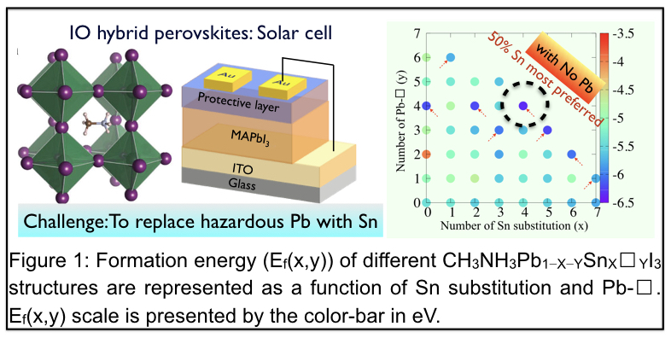
Recent Publications (minimum 5)
- S. Bhattacharya, D. Berger, K. Reuter, L. Ghiringhelli, S. Levchenko “Theoretical evidence for unexpected O-rich phases at corners of MgO surfaces” Phys. Rev. Materials Rapid Commun. (Press).
- D. Sarker, S. Bhattacharya, P. Srivastava, S. Ghosh "Triggering of spin-flipping-modulated exchange bias in FeCo nanoparticles by electronic excitation" Sci. Rep. 6, 39292 (2016).
- A. Bhattacharya, S. Bhattacharya "Unraveling the role of vacancies in the potentially promising thermoelectric clathrates
Ba₈Zn_{x}Ge_{46−x−y}▢_{y}" Phys. Rev. B 94, 094305 (2016).
- S. Bhattacharya, B. H. Sonin, C. J. Jumonville, L. M. Ghiringhelli, N. Marom "Computational Design of Nanoclusters by Property-Based Genetic Algorithms: Tuning the Electronic Properties of (TiO₂)_{n} Clusters" Phys. Rev. B 91, 241115(R) (2015).
- S. Bhattacharya, S. V. Levchenko, L. M. Ghiringhelli, M. Scheffler "Stability and Metastability of Clusters in a Reactive Atmosphere: Theoretical Evidence for Unexpected Stoichiometries of Mg_{M}O_{x}" Phys. Rev. Lett. 111, 135501 (2013).

 Biography (150 word limit)
Saswata Bhattacharya aims at developing theoretical methods that allow in understanding general rules of a given problem in materials science. He solves the problem by including electronic correlation effects by combining density functional theory (DFT) with quantum chemistry methods (eg. HF, MP2, CCSD). In order to capture the effect at finite temperature and pressure, he employs the ab initio thermodynamics and beyond approaches. Over the last ten years, he works in inter-disciplinary areas of condensed matter physics with broad research interest in first principles based simulation of designing new materials and understanding their properties using state-of-the-art DFT. His research group at Indian Institute of Technology Delhi is involved in predicting properties of materials by integrating different level of theories and validates their prediction using the highest level of theoretical approaches within DFT or by comparing with experimental data. Most of the materials they design have significant impact in materials science.
Email: saswata@physics.iitd.ac.in

Notes/Comments:

