An energy-efficient single-pane “green window” via the photothermal effect of chlorophyll thin film coatings
Yuan Zhao, Donglu Shi*
University of Cincinnati, USA

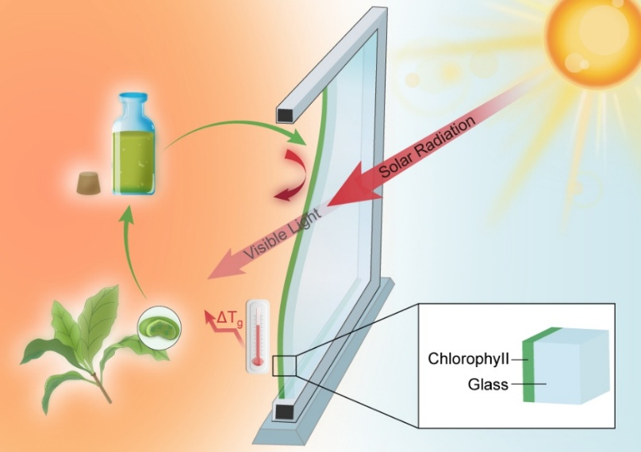
Abstract

To prevent heat loss through windows in cold climates, the conventional methods mainly rely on low-e coatings and thermal insulating materials on double-pane windows. In this study, naturally occurring chlorophyll is utilized as a thin film coating on glass (also known as “Green Window” for its natural and green appearance) and demonstrates applicability to significantly reduce thermal loss, thus improving energy savings. Chlorophyll exhibits a unique optical characteristic with strong absorptions in the blue-violet and NIR regions while remaining highly transmissive in much of the visible region. This unique property allows, on one hand, simulated solar energy, in the non-visible region, to be converted to heat by chlorophyll through the so-called photothermal effect. Only slight heating due to the photothermal effect on the window surface is required to significantly reduce the U-factor (related to thermal loss). On the other hand, the chlorophyll coating density required to generate this temperature rise by thin film deposition on glass retains high light transmittance attributable to minimum absorption in the visible range. This concept lifts the dependence on insulating materials making single-pane windows highly possible. Chlorophyll synthesis, thin film deposition, optical characterization, photothermal effect, and energy performance quantification are carried out in this study with engineering considerations in window designs.
Image

Fig. 1. Schematic of Chl-coated “Green Window”.
Recent Publications
- Targeting and Regulating of an Oncogene via Nanovector Delivery of MicroRNA using Patient-Derived Tumor Xenografts. Theranostics, 2017, 7(3), 677-693.
- Photothermal Effect on Fe₃O₄ Nanoparticles Irradiated by White-Light for Energy-Efficient Window Applications. Solar Energy Materials and Solar Cells, 2017, 161, 247–254.
- In situ synthesis of graphene oxide/gold nanorods theranostic hybrids for efficient tumor computed tomography imaging and photothermal therapy. Nano Research, 2017, 10(1), 37-48.
- Biomarkerless targeting and photothermal cancer cell killing by surface-electrically-charged superparamagnetic Fe3O4 composite nanoparticles. Nanoscale, 2017, 9, 1457-1465.
- Green Synthesis of Sub-10 nm Gadolinium-Based Nanoparticles for Sparkling Kidneys, Tumor, and Angiogenesis of Tumor-Bearing Mice in Magnetic Resonance Imaging. Advanced Healthcare Materials, 2017, 9, 1457-1465.


Biography
Donglu Shi is currently the Chair and Graduate Director of the Materials Science and Engineering Program and a Graduate School Fellow at the University of Cincinnati.
Donglu Shi has so far published 280 refereed SCI journal publications including Physical Review Letters, Nature, ACS Nano, and Advanced Materials, with an h-index of 47. He has edited 12 books in superconductivity, functional thin films, nanomaterials, biomaterials, tissue engineering, and nano biomedicine (World Scientific, Pergamon Press, Springer-Verlag). He holds seven US patents in electronic materials. He is currently the Editor-in-Chief of Nano LIFE, and Associate Editor of Materials Science & Engineering: C, and J. of Nanomaterials. Donglu Shi has been elected as a Graduate Fellow at the University of Cincinnati in 2016. He has received the SIGMA XI Research Recognition Award, Distinguished Researcher Award, and Neil Wandmecher Teaching Award.
Donglu Shi’s main interests include nanostructure design, nano biomedicine, nanophotonics, and magnetism.
Email: donglu.shi@uc.edu

