Promising oxyborates for solid-oxide fuel cell applications

Olivier JOUBERT, Professor, CNRS-IMN, France

Abstract (300 word limit)

The research on solid oxide fuel cell (H⁺ or O²⁻ SOFC) is based on both the synthesis of new materials and the design process of the cell. The main advantage of SOFC is that they can work under hydrocarbon fuel at temperature higher than ≈700°C. In the current SOFC systems, the most widely used electrolyte is YSZ which is inexpensive and shows an acceptable conductivity level. But YSZ is very refractory and its major drawback is its reactivity during the sintering process with lanthanum- and strontium-based cathode materials, which leads to the formation of an insulating layer such as SrZrO₃ or La₂Zr₂O₇. There is also a great interest to find ceramic based fuel cells, for mobile application, working at low temperature (≈400°C). This can be achieved in H⁺-SOFC with a ceramic membrane showing a good proton conductivity level. The state of the art perovskite type Yttrium-doped BaCeO₃ (called BCY) shows a proton conductivity level above 1mS/cm at 400°C. But due to its high basicity, BCY tends to decompose, in this temperature domain, in air containing CO₂. Finding new electrolyte material is one of the issues. In this presentation, after a briefly state-of-the art concerning SOFC electrolyte, we will report on high-temperature proton and oxide ion conductivites in two new class of oxyborates, La₂₆O₂₇(BO₃)₈ and doped Ba₃Ti₃O6(BO₃)₂ compounds. Both samples were prepared by solid-state reaction and characterized using x-ray diffraction and electrochemical impedance spectroscopy. Quite high conductivity level, about 6.8×10^{–4} (Fig. 1) and 1.5×10^{–4} S/cm at 700°C in air were observed respectively. The transport properties can be understood in terms of the presence in high concentrations of oxygen and barium vacancies as well as oxygen interstitials as observed in hybrid density-functional defect calculations.
Image

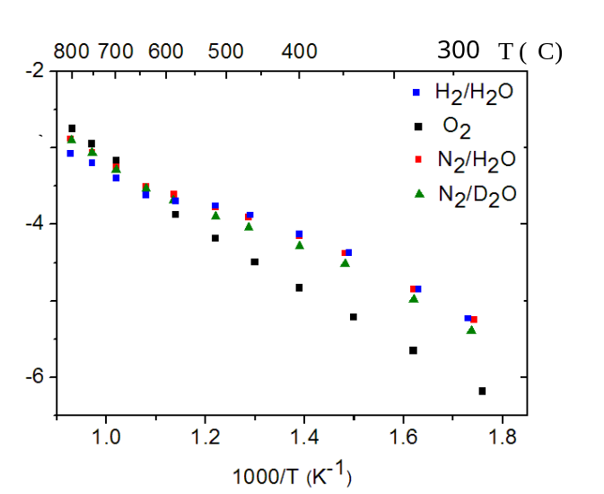
Figure 1 : Conductivity vs temperature of the oxyborate La₂₆O₂₇(BO₃)₈ under different atmospheres

Recent Publications (minimum 5)

1. Lebreton M, Delanoue B. Baron E, Ricoul F, Kerihuel A, Subrenat A, Joubert O, Le Gal La Salle A (2015) Effects of carbon monoxide, carbon dioxide, and methane on Nickel/Yttria-stabilized Zirconia-based Solid Oxide Fuel Cells performance for direct coupling with a gasifier, International Journal of Hydrogen Energy, 40 (32), 10231-10241.
2. Jarry A, Joubert O, Suard E, Zanotti J-M, Quarez E (2016) Location of deuterium sites at operating temperature from neutron diffraction of BaIn_{0.6}Ti_{0.2}Yb_{0.2}O_{2.6-n}(OH)_{2n}, an electrolyte for proton-solid oxide fuel cells, Phys.Chem.Chem.Phys., 18, 15751.
3. Quarez E, Noirault S., Caldes M-T, Joubert O. (2010) Water incorporation and proton conductivity in titanium substituted barium indate, Journal of Power Sources, 195 (4), 1136-1141
4. Noirault S, Célérier S, Joubert O, Caldes M-T, Piffard Y (2007) Incorporation of water and fast proton conduction in the inherently oxygen deficient compound La₂₆O₂₇(BO₃)₈. Adv. Mater., 19, 867–870
5. Doux J-M, Hoang K, Joubert O, Quarez E (2017) Oxygen Ion Transport and Effects of Doping in Ba₃Ti₃O₆(BO₃)₂, Chem. Mater. 29, 6425−6433.




Biography (150 word limit)
Olivier JOUBERT is professor at Nantes University and chairs the Fuel Cell group of "Institut des Matériaux Jean Rouxel" (CNRS-IMN). His major research interests concern new ceramic materials. He has participated to the development of novel ion and proton conductors as electrolyte for Solid Oxide Fuel Cell and electrolyser and also anode materials. He is co-author of 95 publications, 20 invited talks and 5 patents. Olivier Joubert is chairing the HySPàC research grouping which assembles all French academic research groups in the field of production and storage of hydrogen and also fuel cell and electrolysers, about 108 laboratories mainly from the CNRS and CEA. He is the main organizer of the IDHEA meetings held in Nantes in 2014 and 2016. O. Joubert is in charge of the expertise cell ERIMAT in Capacités SAS, a private subsidiary of the University of Nantes dedicated to the development of research, and provides assessment, advice to industries.
Email:Olivier.Joubert@cnrs-imn.fr

Notes/Comments:

