Effect of Universal Trimming on Electrical Characteristics of Polymer Thick Film Resistors

Rambabu Busi,Lakireddy Bali reddy College of Engineering, Mylavaram, A.P., INDIA
Y Srinivasa Rao,Andhra University,Visakhapatnam,A.P., INDIA
T.Satyanarayana,Lakireddy Bali reddy College of Engineering, Mylavaram, A.P., INDIA

Abstract:

Statement of the Problem: The purpose of this paper is to study high-voltage interactions in polymer thick-film resistors, namely, polyvinyl chloride (PVC)-Graphite thick-film resistors, and their applications in universal trimming of these resistors.
Methodology & Theoretical Orientation: The authors applied high voltages in the form of pulses and impulses of various pulse durations and with different amplitudes to polymer thick-film resistors and observed the variation of resistance of these resistors with high voltages.
Findings – The paper finds that high voltages can be used for trimming of polymer thick-film resistors in both directions, i.e. upwards and downwards. The practical implications of this paper is that one can trim the polymer thick-film resistors, namely, PVC–graphite thick-film resistors, in both directions, i.e. upwards and downwards, by using this method.
Originality/value – The value of the paper is in showing that high voltages can be used to trim downwards and also upwards in the case of polymer
thick film resistors. This type of trimming is called universal trimming, developed first time for polymer thick-film resistors.
Findings –When high voltage pulses are applied to a polymer thick film resistor with a particular resistivity either it is higher or lower one, it leads to increase in resistivity with shorter pulse duration of high voltage pulses and decreases in resistivity with longer pulse duration of the applied high voltage pulses. This clearly shows that there is a phenomenon similar to local heating which arises due to high voltage and leads to micro-welding between the particles and breaking of the conducting paths. Therefore, the authors looked for a mechanism with local heating which can lead to decrease or increase in resistance with the application of a voltage.
Conclusion & Significance:
This paper describes some investigations carried out on the universal trimming method of polymer thick film resistors using high voltages. It is reported that there is a reduction or increment in the resistance with the application of high voltage beyond a certain (threshold) value which depends up on the value of the voltage and the effective duration for which it is applied. By using this process, the polymer thick film resistor can be trimmed both upwards and downwards which leads to universal trimming of these resistors, just by changing the effective duration of the applied high voltage pulses.
Image

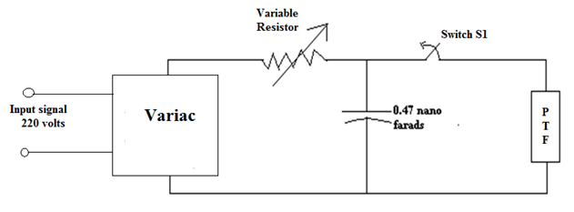
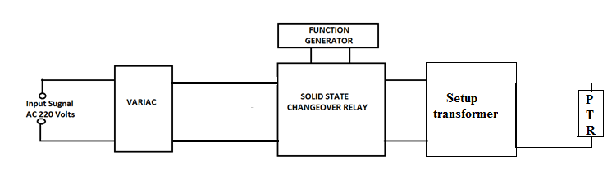

High Voltage Test Circuits used to apply High Voltage short and Long impulses to
Polymer Thick Film Resistors
Recent Publications (minimum5)

1. Y. S. Rao (2007) “Studies on electrical properties of polymer thick film resistors,” Microelectronics International, vol. 24,8–14.
2. Subrahmanium, K.V., et.al. (2014), “The effect of microwave
radiation on PVC-graphite thick film resistors”, Microelectronics
International, Vol. 31 No. 2, pp. 99-102.
3. Srinivasa Rao, Y. (2008), “Studies on temperature coefficient of
Polymer thick film resistors”, Microelectronics, Vol.25, pp.33-36.
4. Y. SrinivasaRao and M.Satyam, 1997. “The effect of high voltage
pulses on PVC-Graphite Thick film resistors”, The International
Journal of Microcircuits and Electronic Packaging, pp.51-56, vol.20.
5. R. P. Himmel.1971.” Thick Film Resistor Adjustment by High Voltage
Discharges” Proceedings of Electronic Component Conference (ECC),
IEEE,pp.504-512.



Biography(150 wordlimit)
Dr. Ram Babu. Busi received his Ph.D in Microelectronics in the Department of Instrument Technology from Andhra University in 2016 and M.Tech in Electrical and Instrumentation Engineering from the Punjab Technical University in 2007. At present, he is Professor in Lakireddy Bali Reddy College of Engineering (A), department of Electronics & Instrumentation Engineering, Mylavaram, A.P., India. He has more than 13 years of teaching and research experience and published more than 14 research papers in the International journals and presented few of them in the International Conferences. His present research focuses on MEMS and NEMS, Trimming and reliability studies of polymer Thick Film Resistors, Nano-biosensors and Spintronic logic devices using grapheme.
Email:rams1315@gmail.com

Notes/Comments:

