Insights into the Dynamic Interplay between Mobile Ions and
Photovoltaic Performance of Organometal Halide Perovskites

Byungwoo Park, Department of Materials Science and Engineering, Research Institute of Advanced Materials,
Seoul National University, South Korea

Abstract

Among various photovoltaic energy conversion systems, organometal halide perovskite (OHP) has gathered much attention over the past few years, as the OHP-based solar cells have demonstrated high power conversion efficiency (> 22%) and long-term stability. However, the mixed ionic/electronic conducting nature of OHPs allows the migration of mobile ionic species (vacancy and/or interstitial defects) during solar cell operation, which is pinpointed as the major cause of anomalous current-voltage (J-V) hysteresis. The timescales of ion diffusion span the range between sub-second to more than a minute, and are highly dependent on the types of ions and OHPs’ nanostructures. Such ion diffusion, in combination with electron-hole recombination, results in the complex time-dependent temporal evolution of photovoltage and photocurrent, emphasizing the importance of frequency- and time- dependent responses of solar cells to enable high photovoltaic performance.
Herein, the photovoltaic performance of solar cells based on (FAPbI₃)_{0.83}(MAPbBr₃)_{0.17} and Cs-doped one (FA stands for (NH₂)₂CH⁺, and MA for CH₃NH₃⁺) was addressed utilizing various analysis methods such as impedance spectroscopy, transient voltage and current measurements coupled with light/bias control (e.g., photovoltage rise, open-circuit voltage decay, photocurrent profile, etc.) to reveal the influence of mobile ions on the photovoltaic performance. The variations of OHPs’ properties in microscopic scale were rationally minimized (such as grain size, crystallographic orientation, crystallinity, etc.) by minimally changing the processing parameter (e.g., annealing time) to reduce their influences on the photovoltaic performance, thereby distinguishing the role of nanoscale defects. Nanoscopic analyses utilizing noise spectroscopy were conducted to comprehend the effects of mobile ions on the electronic traps and thereby the photocurrent behaviors. These analyses strongly suggest that the time-dependent photocurrent and/or photovoltage behavior are strongly correlated to the nanoscale ionic defects and their migrations, providing deeper understanding of the operation of OHP-based solar cells.

Image

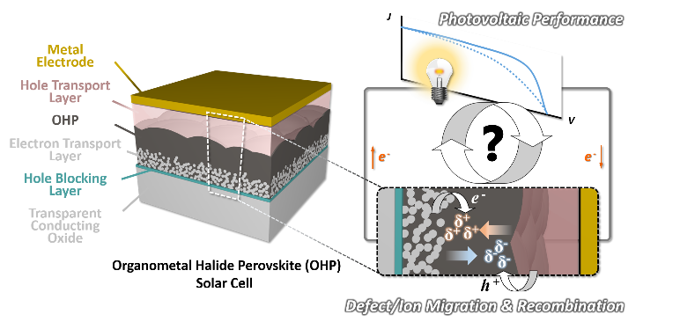
Impacts of mobile ion redistribution on
photovoltaic performance

Recent Publications

1. T. Hwang, B. Lee, J. Kim, S. Lee, B. Gil, A. J. Yun, and B. Park (2017) From Nanostructural Evolution to Dynamic Interplay of Constituents: Perspectives for Perovskite Solar Cells. Adv. Mater. (accepted).
2. S. Lee, J. C. Flanagan, B. Lee, T. Hwang, J. Kim, B. Gil, M. Shim, and B. Park (2017) Route to Improving Photovoltaics Based on CdSe/CdSe_{x}Te_{1-x} Type-II Heterojunction Nanorods: The Effect of Morphology and Cosensitization on Carrier Recombination and Transport. ACS Appl. Mater. Interfaces. 9:31931-31939.
3. J. Kang, J. Kim, S. Lee, S. Wi, C. Kim, S. Hyun, S. Nam, Y. Park, and B. Park (2017) Breathable Carbon-Free Electrode: Black TiO₂ with Hierarchically-Ordered Porous Structure for Stable Li-O₂ Battery. Adv. Energy Mater. 7:1700814. [Front Cover]
4. B. Lee, S. Lee, D. Cho, J. Kim, T. Hwang, K. H. Kim, S. Hong, T. Moon, and B. Park (2016) Evaluating the Optoelectronic Quality of Hybrid Perovskites by Conductive Atomic Force Microscopy with Noise Spectroscopy. ACS Appl. Mater. Interfaces. 8:30985-30991.
5. T. Hwang, D. Cho, J. Kim, J. Kim, S. Lee, B. Lee, K. H. Kim, S. Hong, C. Kim, and B. Park (2016) Investigation of Chlorine-Mediated Microstructural Evolution of CH₃NH₃PbI₃(Cl) Grains for High Optoelectronic Responses. Nano Energy 25:91-99.


Biography
Byungwoo Park received his Ph.D. degree in Applied Physics from Harvard University. He worked as a post doctor at IBM T. J. Watson Research Center and a research fellow at California Institute of Technology. He joined the School of Materials Science and Engineering at Georgia Institute of Technology as an Assistant Professor. He is currently a Professor in the Department of Materials Science and Engineering at Seoul National University since 1997. His current research interests include the development of nanoscale coating, novel nanocomposites, heterojunction nanorod and perovskite solar cells, Li-ion rechargeable batteries, and the growth kinetics of nanostructures.

byungwoo@snu.ac.kr http://bp.snu.ac.kr

Notes/Comments:

