Material Innovation in Solar Selective Absorber Coatings
Iman S El-Mahallawi, PhD, Cairo University; Adjunct Professor The British University in Egypt
Hanann Youssef, MSc Cairo University
Hussein Badr, BSc Cairo University

Abstract (300 word limit)
Statement of the Problem: Spectrally selective coatings are common in low and medium temperature solar applications ranging from water solar heating collectors to parabolic trough absorber tubes. They are also essential elements for achieving high efficiency in higher temperature applications such as Concentrating Solar Power (CSP) systems. The mid-temperature coatings are used for solar water and industrial heating applications, while the high temperature absorber coatings are used for thermal power plants. The commercialisation of solar selective absorbers necessities that the expensive oxide coatings are to be replaced by cheaper efficient materials, where the most feasible and practical deposition methods may be used. The material requirements will vary for low and high temperature applications.
Methodology & Theoretical Orientation: In this work, different solar selective absorber coatings are prepared by different methods and their optical absorbance is compared and assessed for solar selective absorbance applications. The materials assessed include natural materials, PVD deposited layers on metal substrates and nanoreinforced polymeric based composite material coatings. The characterisation methods included Spectrophotometery and Fourier transform spectroscopy (FTIR).
Findings:
For low temperature applications, it was shown that adding 1.5 and 2.5% nano-graphite particles to a commercial polymer based black coating causes an increase in the optical absorptance to values above 0.96 and a decrease in emittance to values below 0.35, where the highest absorptance and lowest emittance were obtained for 2.5% addition. CuO shows the highest absorbance amongst other natural materials, due to it's amorphous structure and it's black colour.
For high temperature applications, AlN was found to have higher absorptance at longer wavelength, whereas TiN has higher absorptance at short wavelength. A new material is proposed for high temperature applications.
Conclusion & Significance:
It has been shown that nano-reinforced polymers are good candidates for low temperature selective solar absorbers, while TiN and AlN are good candidates for high temperature applications.

Image
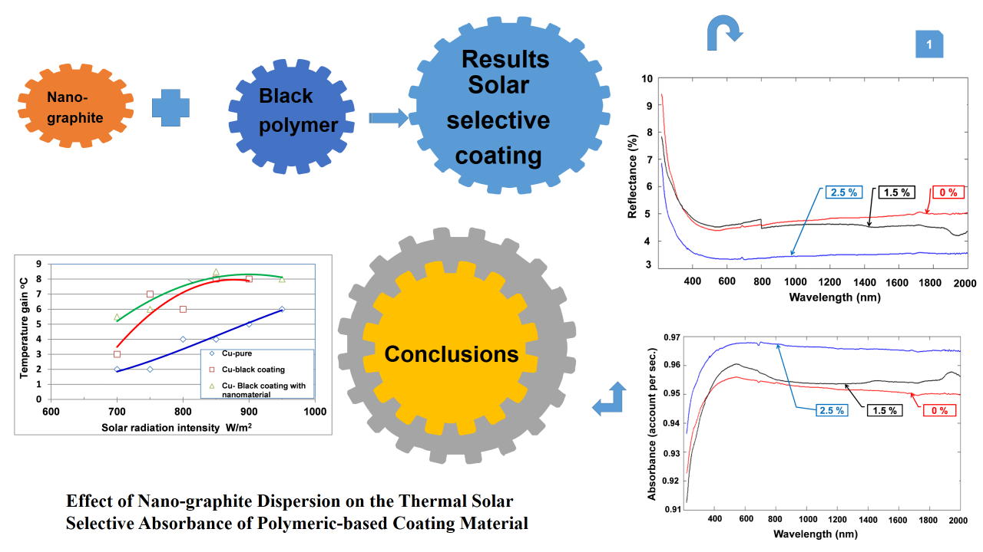
Recent Publications (minimum 5)
- Iman S. El-Mahallawi, Nadia H Rafat, Nagwa Khattab, Moetaz A. Nabil, Ahmed A. Abdel-Rehim, Sayed Akl, and Amr Mohsen; Economic Technical Solutions for Enhancing the Efficiency of Thermal Solar Systems, International Conference on Industry - Academia Collaboration, Fairmont Helipolis Hotel Cairo Egypt, IAC 3-5 March, 2014.
- Nevin Yahia, Iman S. El-Mahallawi, Ahmed A. Abdel-Rehima, Tarek Hatem, N. Khattab; Modelling and Experimentation of Thermal Flat Plate Solar Collector Design Parameters, Conference Proceedings, SusTEM2015, 7-8 July, 2015, Newcastle, UK.
- Hussein Badr, Mostafa Amr Youssef, Hebatullah Sayed Abd Elsalam, Mirna Abde Elrahman Mohamed, Mohamed Gamal El-Kholy, Iman El-Mahallawi, Ahmed Abdel-Rehim “Thermoelectric Behaviour of Polyvinyl Acetate/ CNT Composites”, Chapter TMS 2017 146th Annual Meeting & Exhibition Supplemental Proceedings Part of the series The Minerals, Metals & Materials Series pp 287-294, TMS, 2017.
- Iman S. El-Mahallawi, Ahmed A. Abdel-Rehim, N. Khattab, Nadia H Rafat, Hussein Badr; Effect of Nano-graphite Dispersion on the Thermal Solar Selective Absorbance of Polymeric-based Coating Material, TMS 2018, Arizona.
- The effect of substrate on NiTi IR layer thin film growth by RF magnetron sputtering for Solar Selective Absorbance; publication stage.

Biography (150 word limit)
Iman El-Mahalawi has her expertise in developing materials and manufacturing methods for different engineering applications. This includes design, manufacturing, testing, characterization and assessing the materials for each engineering application. She has more than 100 publications, 50 of which are cited in Scopus, on different materials engineering applications. Recently, she included energy harvesting in here interests and led research groups on topics related to solar energy and thermoelectric materials. Her current work aims at developing novel economic, ecofriendly and practically feasible materials to be manufactured by conventional and advanced production methods. This will create new pathways for developing energy harvesting materials and their commercialization. This approach is responsive to all stakeholders and will encourage social impact from research.
Email: saiman@eng1.cu.edu.eg; ielmahallawi@bue.edu.eg

Notes/Comments:

