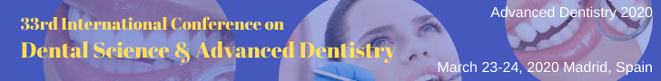
Letter of Invitation

Date: December 05, 2019

To,
Mr. Ahmed Mohamed Abdelrahman Ahmed Eldeed
Tanta University, Egypt
Ref No: ADMS011

OBJECT: Invitation Letter

Mr. Ahmed Mohamed Abdelrahman Ahmed Eldeed

Conference Series LLC Ltd cordially invites you as a delegate to the “33rd International Conference on Dental Science & Advanced Dentistry”, which is going to be held during March 23-24, 2019 Madrid, Spain. We welcome you to join us and share your knowledge and view on the theme “Advanced Dentistry for today’s lifestyle”. In this regard, on behalf of the Organizing Committee, we are pleased to welcome you to join us as a delegate.

The “33rd International Conference on Dental Science & Advanced Dentistry” initiated by Editors- Journal of Oral Health and Dental Management, Journal of Dentistry and Journal of Oral Hygiene & Health will offer you an unforgettable experience in exploring new opportunities.
Kindly consider this opportunity and share your experience
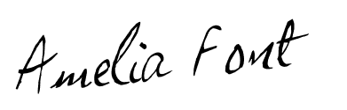
We look forward to see you in the glorious city of Madrid, Spain
For more details about Advanced Dentistry -2020, PS: https://advancedentistry.dentalcongress.com/
With our best wishes,

Amelia Font,
Program Manager
On Behalf of Organizing Committee
Conference Series LLC Ltd
47 Churchfield Road, London, UK, W3 6AY
Toll Free: 44-8000148923
Email Id: advanceddentistry@annualamericacongress.com

Disclaimer: This invitation is to attend Advanced Dentistry-2020 only

