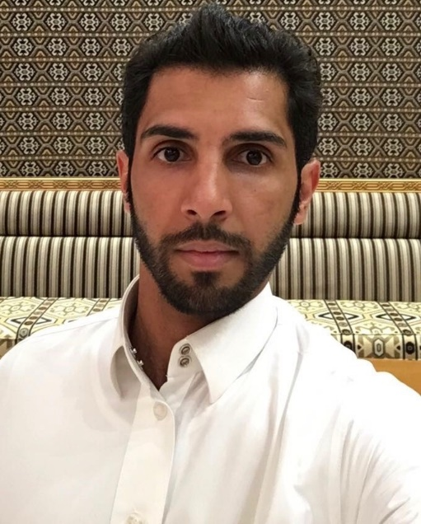

Full name: Abdullah Abdulqader Haqash
Internship at :Al-Farabi College for Dentistry and Nursing, Riyadh, Saudi Arabia.

This abstract is Under Supervision of Prof: Ahmed Elmarakby, Assis Prof at Restorative Dentistry Department, Al-Farabi College for Dentistry and Nursing, Riyadh, Saudi Arabia

Assessment of the Quality of Composite Resin Restorations

Abstract
Purpose: To evaluate the quality of the composite restorations. Material and Methods: A total of 246 composite restorations in 125 patients attending the Conservative Dentistry Clinics at the Faculty of Dentistry, University of Khartoum were examined. Both anterior and posterior composite restorations were included. California Dental Association Quality Evaluation System was used for the evaluation. Results: Fifty two percent of all restorations were found to be satisfactory, while the remaining 48% were not satisfactory. With regard to surface and colour criteria, colour mismatch within the range (34.8%) and slight surface roughness (26.6%) were the most common defects. The most frequent defects of the anatomical form were restoration overhang (26.8%). The majority of the restorations above 4 years old were of unacceptable anatomical form (66.7%), and their marginal integrity was less acceptable than more recent restorations (46.7%). Conclusions: Forty eight percent of the examined composite restorations needed to be replaced, and the unacceptable anatomic form was the main cause of failure of composite restorations. Keywords Composite Resin Restorations, Marginal Defect, Overhang Restoration, Colour Mismatch

Full name: Abdullah Abdulqader Haqash

Contact number :00966595940000

Twitter account:Dr_aah1992

Linked in account: Dr.aah

Category: poster presentation

