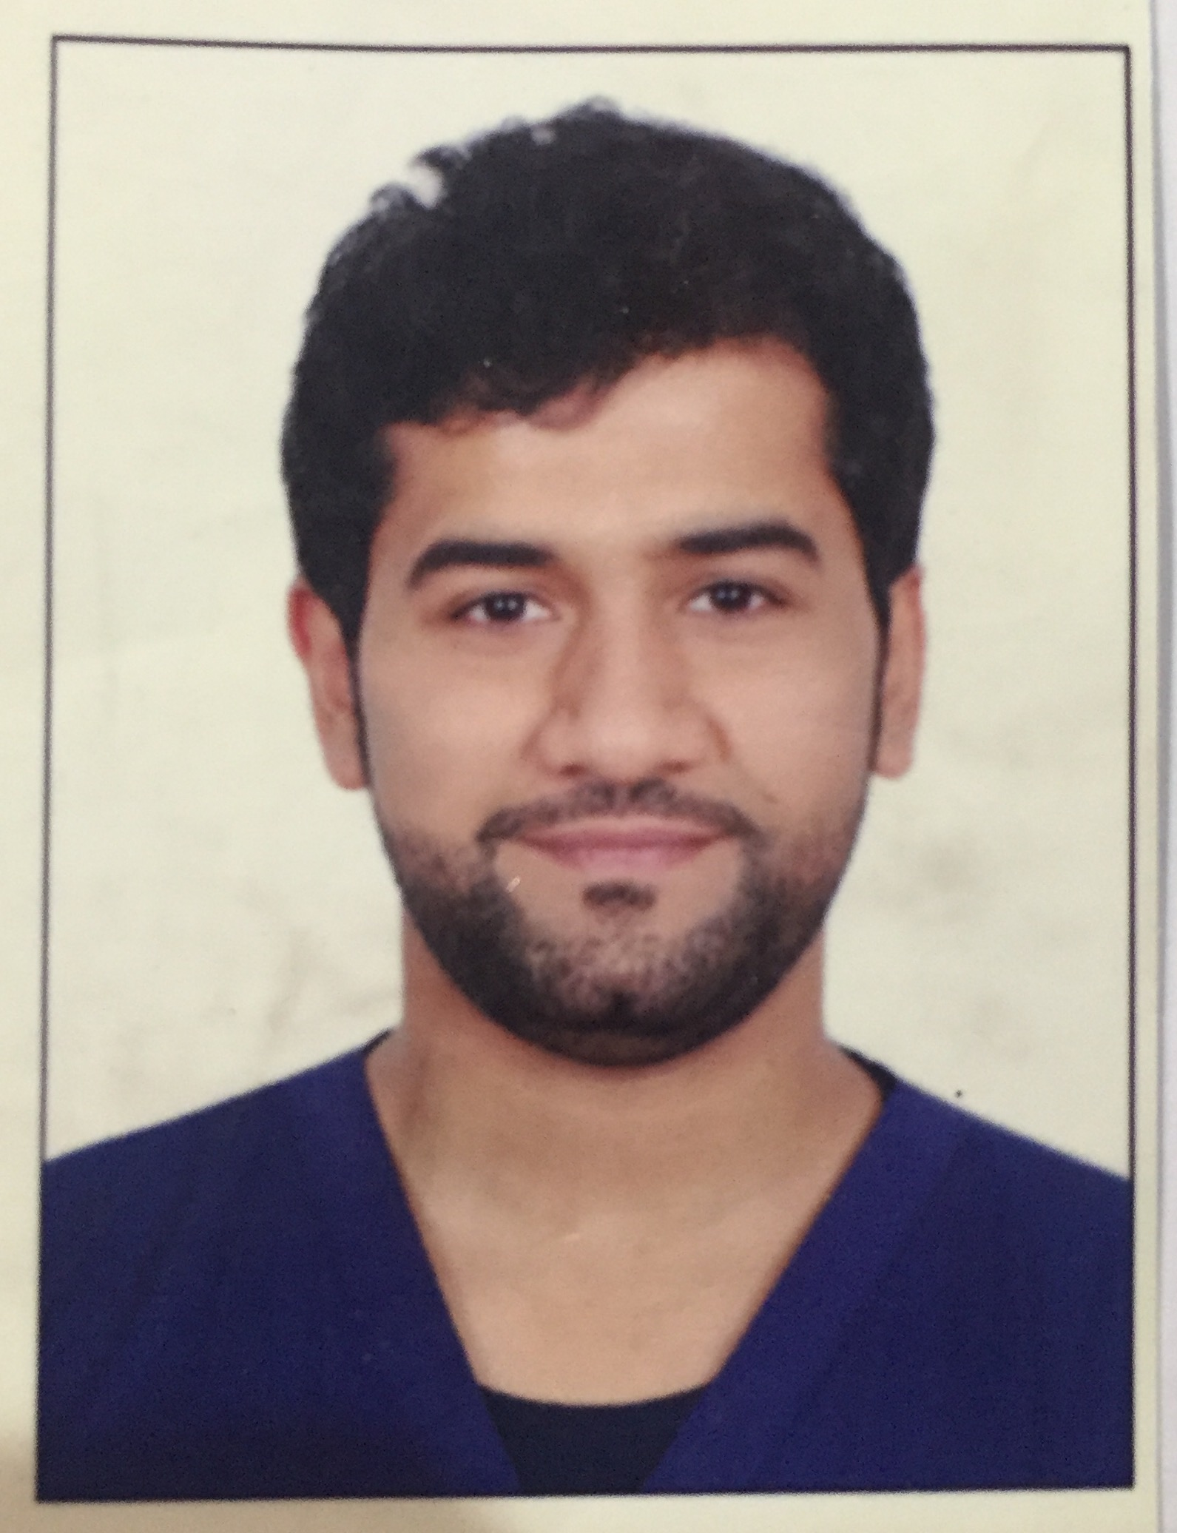

Full name: Abdulaziz Khaled Alnwaihel
Internship at :Al-Farabi College for Dentistry and Nursing, Riyadh, Saudi Arabia.

This abstract is Under Supervision of Prof: Ahmed Elmarakby, Assis Prof at Restorative Dentistry Department, Al-Farabi College for Dentistry and Nursing, Riyadh, Saudi Arabia

Microhardness of resin-based materials polymerized with LED and halogen curing units
ABSTRACT
The purpose of this study was to evaluate the microhardness of resin-based materials polymerized with a LED (light-emitting diode) light-curing unit (LCU) and a halogen LCU. Twenty cylindrical specimens (3.0 mm in diameter and 2.0 mm high) were prepared for each tested material (Z100, Definite and Dyract). Specimens were light-cured with two LCUs (Ultraled and Curing Light 2500) for either 40 or 60 s on their top surfaces. Hardness was measured on top and bottom surfaces of each specimen. Statistical analysis was done by ANOVA and Tukey's test (p<0.05). There was no significant difference in hardness between LED LCU and halogen LCU for Z100 and Dyract on top surface. Conversely, lower hardness was recorded when Definite was light-cured with the LED LCU than with the halogen lamp. On bottom surface, hardness was significantly lower for all materials light-cured with LED LCU. Z100 was harder than Dyract and Definite regardless of the light curing unit. There was no significant difference in hardness between the exposure times on top surface. Higher hardness was obtained when the materials were light-cured for 60 s on bottom surface. The tested LED was not able to produce the same microhardness of resin-based materials as the halogen LCU.
Key Words: microhardness, composite, light emitting diodes (LED).
Full name: Abdulaziz Khaled Alnwaihel

Contact number: 00966561777980

Twitter account : Abdulaziz656

Linked account:

Session name number:

Category : poster presentation

