Bichectomy: a small and simple intraoral surgical procedure with great facial results.
Simone de Lucas, Dental Surgery, post-graduate Implantology, Coordinator of post-graduate in Dental marketing management, teacher of post-graduate in Bichectomy- Brazil.

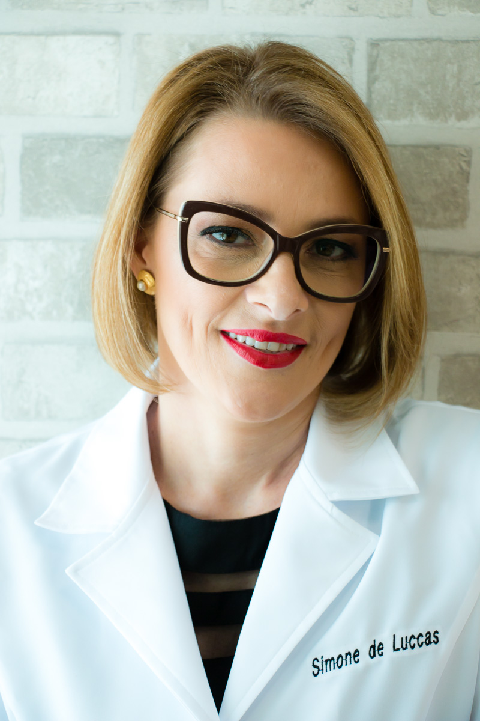
Recent Publications
Lucas de, Simone. “Look that ! – bichectomy” – 19. Ago.16 https://www.facebook.com/priscila.sabino.376/videos/vb.100003076180595/1004701519642378/?type=2&theater
Lucas de, Simone. “bichectomy , the truth” – 30. Nov. 16 https://youtu.be/hCjjzl9xPXs
Lucas de, Simone. Você Bonita “Myths and truths about bichectomy” - 12. Jan. 17 https://www.youtube./watch?v=A4lWmHoa_r8
Lucas de, Simone – “Deoxycholic acid injection for reduction of submental fat and bichectomy” – 13. Fev. 17 https://www.youtube.com/watch?v=Hpu2H3dm978

Abstract
Nowadays Bichectomy is the esthetic facial procedure most frequently performed surgery in countries like Brazil, USA,Japan, Venezuela and Mexico.
The procedure described had been around since 1980, the technique became very popular thanks to social media.
This technique consists of the intraoral elimination of an encapsulated adipose tissue (Bichat’s fat pad). It is located within the face between two muscles. When it is removed, the effect is discreet, yet provides the desired “The Blush Mark”.
This procedure is for both men and women, even with ideal weight present and have existing big cheeks and round face. The intention is lengthen, outline, and establish facial contours providing gains on self-esteem.
Bichectomy is also indicated to treat facial asymmetries and for patients that bite the inside of their cheeks.
In facial harmonization, the bichectomy is value procedure, since it provides as marked and dominant mandible, as well as powerful and sensual impression, which are highly valued characteristics.
Dr. Lucas will address the following topics:
How happens the facial aging signs
who are ideal patients for Bichectomy
She will show the final results, as well as the success techniques used for more than 150 patients in Brazil.
In addition, Dr. Lucas will discuss topics like accidents, complications, risks, and occurrences.
Dr. Lucas will answer questions about treatments, medical and therapeutic protocol, and post-operation.

Biography (150 word limit)
Dr Simone de Lucas is a Doctor of Dental Surgery, graduated in dentistry school for 23 years for Universidade de Mogi das Cruzes (UMC- SP, Brazil). She is member of the Brazilian society of Botulinum Facial Implants and Member of Brazilian Academy of Orolfacial Aesthetics. Dr Simone is national reference in Bichectomy.
Post-graduate courses in Butolinicum toxin; Facial fillers and Bichectomy in carried out fresh human cadavers (Miami Anatomical Reserch Center- MARC, Miami US).Also post-graduate in Brazil in Implantology; Oral and Maxilo hospital monitoring; Bichectomy; Butolinicum toxin and Fillers; Laser; Venipuncture and Derma Roller with application of Platelet Rich Fibrin (PRF) for Skin Rejuvenation and Dental marketing management.
Currently she teaches Bichectomy in Instituto Brasileiro de Odontologia e Pesquisa (IBOP), Faculdade do Centro Oeste Pinelli Henriques (FACOPH).

Email: simonedelucasodonto@gmail.com

