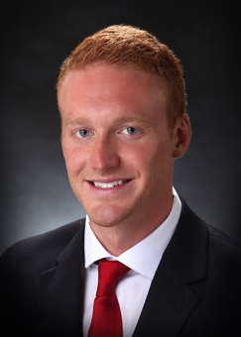

Electromyography and 3-Dimensional Kinematics to Assess Body Posture in Dental Students

Patrick D. Zawadski, Albert J. Threlkeld, Jennifer J. Bagwell, Martha E. Nunn, Sonia M. Sanchez, Jennifer A. Hasslen
Creighton University School of Dentistry, NE 68178, USA

Seated posture in dentistry is an important area, which has received little attention. Poor postural seated positions have been long documented to cause musculoskeletal disorders (MSDs). Back pain, in particular, is common and has been recorded as occurring on average in over 50% of dentists and dental hygienists. Recent studies have suggested that negative consequences of bad posture can be identified as early as undergraduate dental education. With a well-documented prevalence of MSDs in dentists, hygienists and dental students, it should be no surprise that posture and ergonomics demands more attention. Based on this knowledge we used Electromyography (EMG) and 3-Dimensional Kinematics to assess posture in dental students while standing (baseline) or sitting at a standard or ergonomic operator chair. Measurements were collected at rest, initially and chronically while performing routine dental restorations. Our findings showed marginal improvement while sitting on the ergonomic chair versus the standard chair in the right erector (p = 0.088) and left erector regions (p = 0.101). However, we observed statistically significant differences on the degree of thoracic rotation, and a reduction in body movement, on individuals seated at a chronic position in an ergonomic chair as compared to sitting on a standard chair (p = 0.046). While preliminary in nature, this study provided proof of principle for a larger study involving dental students and dental professionals at different stages of their careers. Furthermore, it supports the need for improvement in the design of dental operator chairs to address and prevent chronic back pain.

Biography

Patrick Zawadski has completed his B.S. in Neuroscience from the University of St. Thomas and is currently working on his Masters in Oral Biology at Creighton University School of Dentistry.

Presenting author details

Patrick D. Zawadski
402-280-2700
Session name/number (TBD)
Category: Poster Presentation

