CT Scan, From a scan to a crown
Rakan Baaj DDS, MSC, Phd

Abstract (300 word limit)
Many dentists now a day are welling to place implants. The guess work in eliminated by conducing and educated calculated guess through obtaining a CT scan and deal with it professionally through a well thought digital flow software. In this presentation a discussion of 3D imaging background and application will be included along with a clinical implication of how to handle a CT scan and treat plan a case and be able to even fabricate/mill a future definitive crown before placing a dental implant.

Photograph
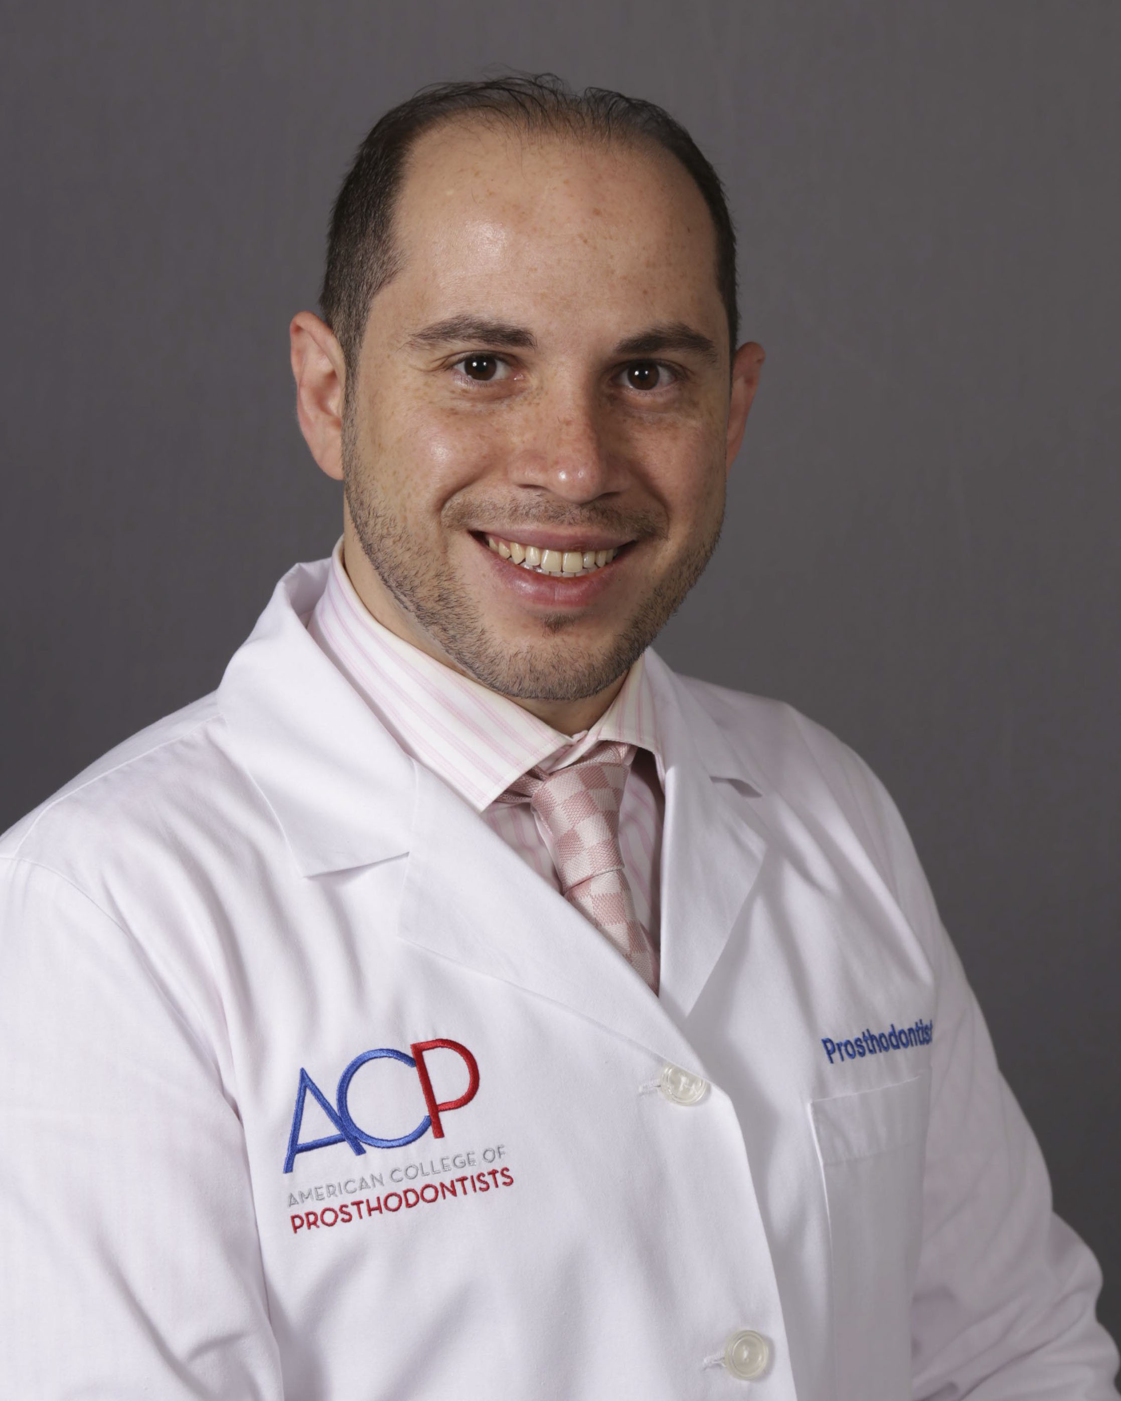

Biography (150 word limit)
Dr. Baaj Has earned his masters in dental sciences and completed a prosthodontics residency at the University of Medicine and Dentistry of New Jersey, USA, in which both clinical practice and academic research are included. Earned his Phd in Biomedical Informatics; Dental Implants Hoops Strains, from Rutgers University, USA. Teaching Prosthodontics first, second, third year and the International Dentist Advanced Placement Program at University of Toronto, Canada. He is a reviewer for many prestigious dental journals such as Journal of Prosthetics Dentistry and Journal of Oral Implantology
Email: rakanbaaj@aol.com

Notes/Comments:

Resume is included in the email to Amanda clarke

