Ectodermal Dysplasia, Multiple dentures treatment approach
Rakan Baaj DDS, MSC, Phd

Abstract (300 word limit)
Back ground: Ectodermal dysplasia is a condition affecting many organs in the body including the oral cavity. The oral rehabilitation of treating the early stages of this condition is done usually by using complete dentures.
Case description: The following case report shows multiple case scenarios for treating such patients as they go through phases of changing their teeth from primary dentition to permanent one. It also demonstrates how to utilize the present teeth for more retentions and more patient acceptance by using resin composite material and elastomeric materials as well to over come teeth alignment and not over bulging the buccal flange of the denture.
Practical impaction: It’s important to maintain the present teeth, even if they were misaligned, and use them during the oral rehabilitation as they provide retention to the prostheses and provide an important psychological imminence to the patient.
Key words: ectodermal dysplasia, multiple dentures, primary teeth, permanent teeth, mixed dentition, elastomeric material, psychological acceptance.

Photograph
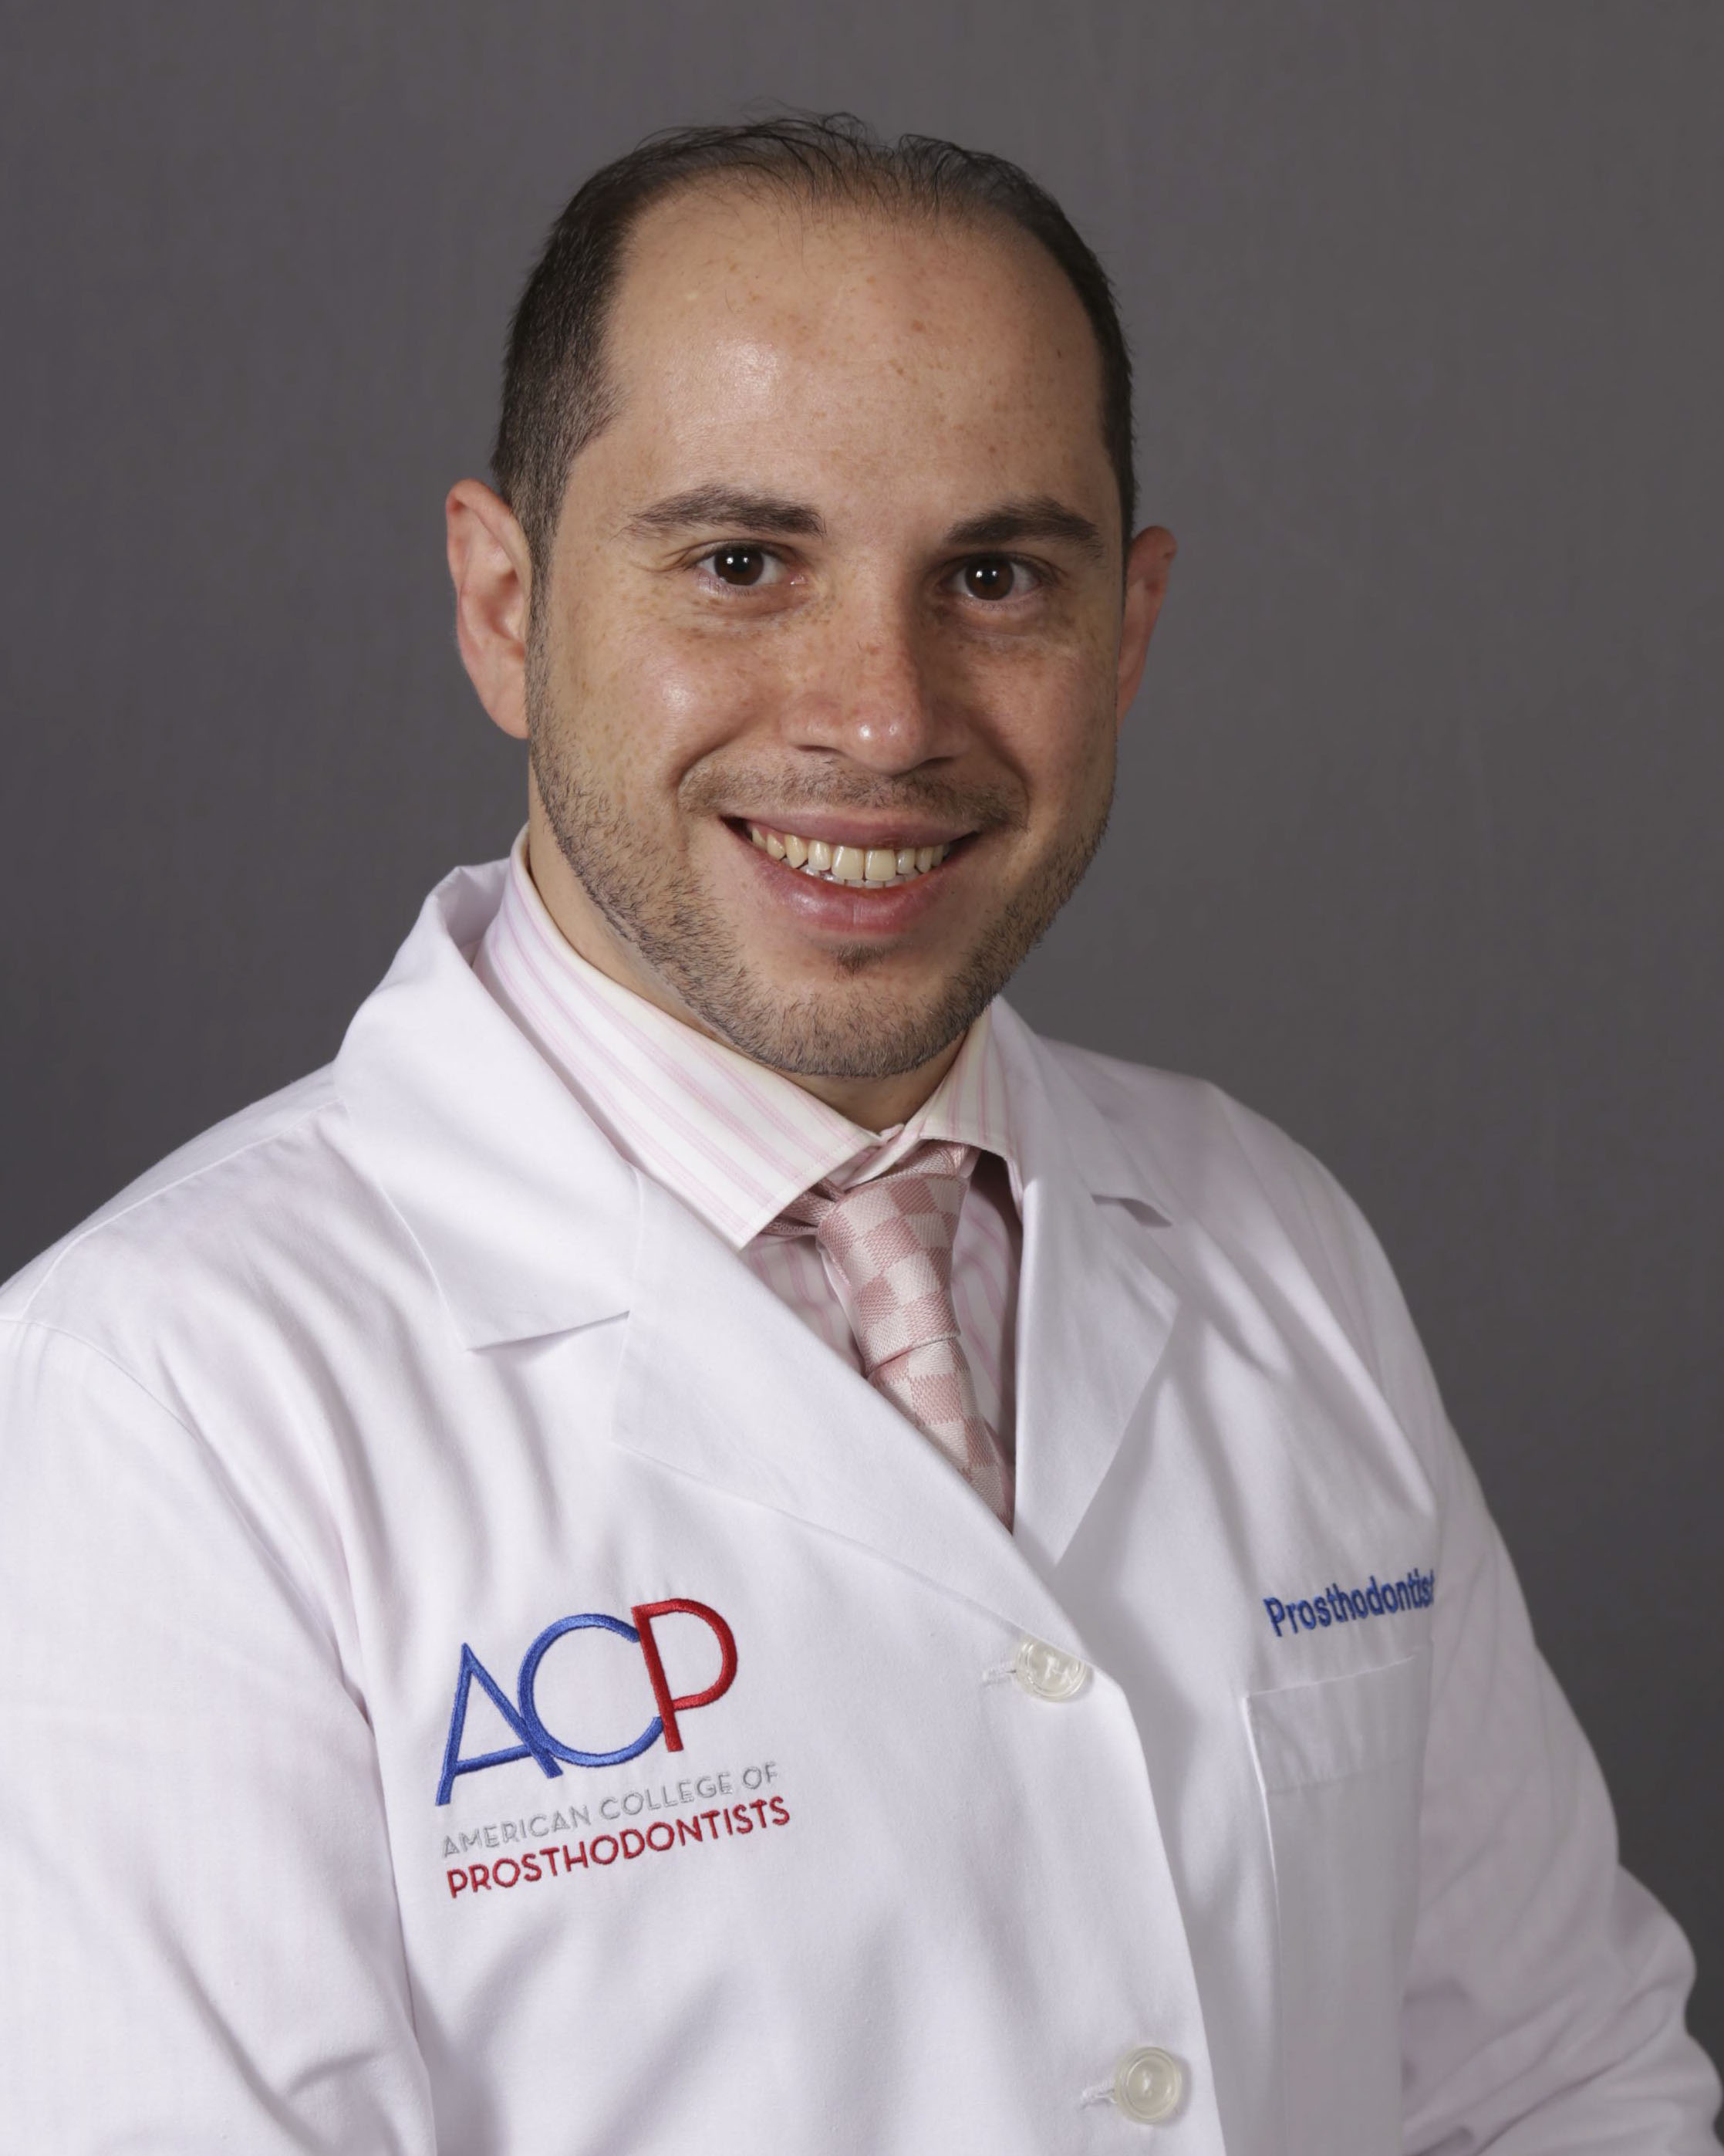

Biography (150 word limit)
Dr. Baaj Has earned his masters in dental sciences and completed a prosthodontics residency at the University of Medicine and Dentistry of New Jersey, USA, in which both clinical practice and academic research are included. Earned his Phd in Biomedical Informatics; Dental Implants Hoops Strains, from Rutgers University, USA. Teaching Prosthodontics first, second, third year and the International Dentist Advanced Placement Program at University of Toronto, Canada. He is a reviewer for many prestigious dental journals such as Journal of Prosthetics Dentistry and Journal of Oral Implantology
Email: rakanbaaj@aol.com

Notes/Comments:

Resume is included in the email to Amanda clarke

