

Title: Binder-free trimetallic phosphate nanosheets electrode materials

XXXX L1, XXXXX ES1, XXXX ALD1, 2,
Iftikhar Hussain, Muhammad Ahmad, Xi Chen, Li Yuxiang, Kaili Zhang*
Department of Mechanical Engineering, City University of Hong Kong, 83 Tat Chee Avenue, Kowloon, Hong Kong

Keywords: supercapacitors, energy storage, metal phosphate.
- Abstract Body (up to 300 words)
Transition metal phosphides and phosphates are newly emerged electrode material candidates in energy storage devices. For the first time, we report a uniformly distributed, interconnected, and well-aligned two-dimensional nanosheets made from trimetallic Zn-Co-Ga phosphate (ZCGP) electrode materials with preserved crystal phase. It is found that the ZCGP electrode material exhibits about 2.85 and 1.66 times higher specific capacity than mono- and bimetallic phosphate electrode materials at the same current density. The trimetallic ZCGP electrode exhibits superior conductivity, lower internal resistance (IR) drop, and high Coulombic efficiency compared to mono- and bimetallic phosphate. The charge storage mechanism is studied for mono- bi-, and trimetallic electrode materials which illustrate the diffusion-dominated battery-type behavior. By means of density functional theory (DFT) calculations, ZCGP shows superior metallic conductivity due to the modified exchange splitting originating from 3d-orbitals of Co atoms in the presence of Zn and Ga. Moreover, hybrid supercapacitor (ZCGP//rGO) device is engineered which delivered a high energy density (ED) of 40 W h kg-1 and a high-power density (PD) of 7,745 W kg-1, lighting 5 different colors of light emitting diodes (LEDs). These outstanding results confirm the promising battery-type electrode materials for energy storage applications [1].

Image:
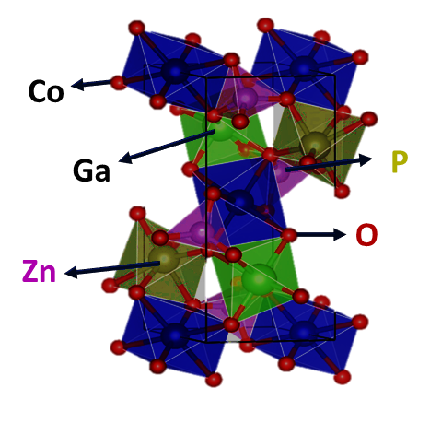
- Reference:

1 Journal of Materials Chemistry A 2021, 9 (33), 17790-17800, DOI: 10.1039/D1TA04855D.

Biography:
Iftikhar Hussain has completed his Master degree from Yeungnam University South Korea and now studies PhD from City University of Hong Kong. He has published more than 25 papers in reputed journals on energy storage devices.

Presenting author details
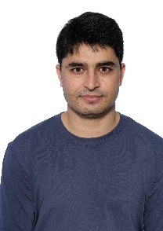
Full Name: Iftikhar Hussain
Contact number: 56445118
Twitter account: ihussaintoori1
Session name/ number:
Category: (Oral presentation)
Passport Number JT6903502

