
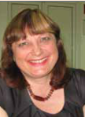
Faculty of Dental Medicine, Medical University, Sofia

New Approach for Laser Dental Education
Julia E. Kamenoff, DDS, PhD, HDG, President BALDM

Abstract (300 word limit)
The author is presented a new approach for Laser Dental Education based on Biological Medicine principles. The new educational program involves knowledge about laser biostimulation, photoinfrared photobiomodulation, Laser Eliminating Therapy as Allergy and Environmental Medicine, Immunological Allergies, Autonomic nervous System Hypersensitivity Allergy and alternative methods of Combined Laser Treatment. This new approach of teaching show how to build Model of Individual Optimum Laser Stimulation and require education on four level: First level – laser biostimulation and biomodulation, Second level – Healing effect of Infrared Laser beam, clinical application. Next third level involves skills on Laser acupuncture and Combined Laser Biosynergetics. The higher level of laser education gives information about Turbulence Laser Medicine clinical application. All levels of Laser training require workshops with different types of Dental laser machines. This new approach of education has been approbated in Department of Prosthodontics, Laser Educational center for post graduated education at Faculty of Dental Medicine, Medical University, Sofia. Results after the laser education show a great effectiveness.

Key words: Curriculum guidelines for Standard Laser Education, PDT, Lasers in Dentistry

Image
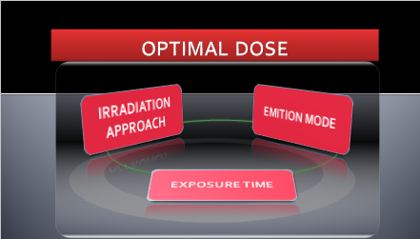
Recent Publications (minimum 5)
- Kamenova.J, (2014) Laser Diode Systems application in Dental Medicine, Sofia, Ivray , Direct Services, ISSN 978-953-9388-44-2, p. 263

Biography
Julia Kamenoff has her expertise in evaluation and passion in Laser Dental Medicine, Biologic Medicine, Turbulence Medicine and Prosthodontics. Julia Kamenoff is a President of Bulgarian Association of Laser Dental Medicine – BALDM, and a President of a Laser Center in Educational Center for post graduated development at Faculty of Dental Medicine, Medical University, Sofia, Bulgaria.
Full name (As per the passport): Julia Emilova Kamenoff
University/Industry/Organization name: Faculty of Dental medicine, Medical University, Sofia
Designation(Director/Prof/Assistant or Associate prof/Researcher/Student): Professor
Country: Bulgaria
Mobile number (00359887888458) :
Email: baldm.fdm@gmail.com
Track number: http://optics.physicsmeeting.com/call-for-abstracts.php (For track number follow this link)
Category (Oral presentation):
Research interest: Education on Dental laser systems clinical application. New approaches of laser training.
Your profile page URL in your department:
Year of birth:
Linked In/Facebook/twitter account:

Note: Please fill up the Red mark fields so that it would be easier for us to cite your details in the conference particulars. (Please do not forget to fix your photo and Logo above the title)

