“Technological and Scientific discoveries of dental education”
3rd International Conference on Advanced
Dental Education
November 15-16,2018 I Edinburgh, Scotland

Difference in root canal length between populations

J.M. KAYEMBE BUKAMA :Endodontic Unit, Service of Operative Dentistry, Teaching Hospital of Kinshasa University, Kinshasa, Democratic Republic of Congo.
Aim
To compare the root canal length of each type of Bantu (black African) teeth with that of Caucasians and Asians.

Methodology
A prospective study based on conventional radiography and tactile sensation was carried out. We performed 1539 canal measurements on 818 teeth from 720 adult Bantu subjects (18 to 45 years old) who consulted at Kinshasa university clinics from 2014 to 2016. The results obtained were compared with those of the literature. Student's t-test and Turkey tests were used for the statistical analysis of the difference in tooth length.

Results
The average difference with Asians is 0,8 mm more for Bantu versus 0.4 mm less compared to Caucasians.
The greatest difference between Bantu and Asians is found in the palatal canal of the upper second molar (3.1 mm), followed by the distal canal of the second lower molar (3.0 mm ),the canal of the second lower premolar (1.8 mm)and palatal canal of the first upper molar (1.7 mm).

The greatest difference between Caucasians and Bantu is found in the mesiolingual
canal of the second lower molar (1.9 mm), followed by the upper central incisor (1.7 mm).

Conclusion
In most cases, the teeth of Caucasians are the longest, followed by those of Bantu and Asians. The palatal canal of the first upper molar, the distal canal of the second lower molar as well as the second lower premolars of Bantu were the longest in all three populations.
Keywords: Teeth, Canal Length, Bantu, Caucasians, Asians

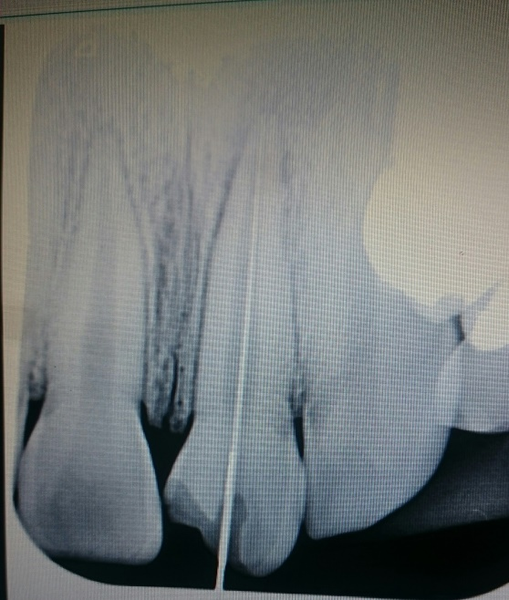

Fig 1: Determination of root canal length on upper central incisor
References
- Reddy S, Shome B, Patil J, Koppolu P. A clinical correlation between stature and posterior tooth length. The Pan African Médical Journal. 2017;26:17.
- Naulakha D, Agrawal M, Naulakha N. Determination of tooth length variation of Maxillary canine- Analytical study. Journal of Medical College 2014; 3(1): 40- 45.
- Dohaithem AJ, Bakarman EO, Veitz-Keenan A. Tactile working length determination for root canal therapy in underserved setting. Evidence-Based Dentistry 2014; 15:56-57.
- Kim E, Fallahrasteger A, Hur Y, Jung L-Y, Kim S, Lee SJ. Difference in root canal length between Asians and Caucasiens, International endodontic journal 2005 Mar, 38 (3): 145-51.
- Alam MS, Aziz-us-salam, Prajapati K, Rai P, Molla AA. Study of tooth length and working length of first permanent molar in Bangladeshi people. Bangladesh Med Res Counc Bull. 2004; 30(1):36-42.
- Kayembe JM et al. Determination of the root Canal Length of Teeth of Bantu Patients Attending the Teaching Hospital of Kinshasa University. Open Journal Of Stomatology, 2018, 8, 16-23.

Biography
Jean Marie Kayembe graduated at the University of Kinshasa as a Dental Surgeon.
He became Specialist and is now Chairman of the service of Conservative Dentistry and Endodontics at the Dental Medicine Department of the Teaching Hospital of Kinshasa University in the Democratic Republic of Congo.
His research focuses on endodontics in the context of African population especially of Bantu (Black African).
He is also a visiting teacher at Dental school of the “Université des montages” in Cameroon.

E-Mail: jmkayembe2003@yahoo.fr

