
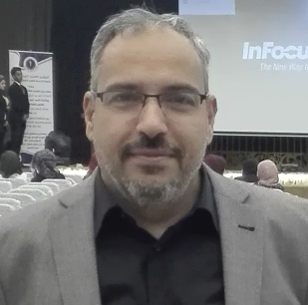

Dental Students’ Views of Their Clinical Cognitive Skills
A Qualitative study
Ass. Prof. Faaiz Alhamdani, PhD
Head of Clinical Sciences Department, College of Dentistry, Ibn Sina University for Medical and Pharmaceutical Sciences

Abstract
Introduction: Clinical skills involve students’ cognitive and technical skills, which represents the essential aspects of professional competency. Clinical skills’ development was a focus of many recent studies. Previously conducted studies showed that undergraduate dental students have more interest toward developing their technical clinical skills, which include simple and complicated dental extractions, rather than developing cognitive skills. However, to the best of the author’s knowledge no previously conducted qualitative study to understand students’ perception of their cognitive clinical skills. Materials and methods: This focus group study was conducted in Almustansiryah College of Dentistry. The study sample was nine students. Six students were fifth year students, and three were fourth year students. Focus group discussion was conducted using a set of openended questions based on previous study and the author’s 10 year clinical teaching experience. The model on which the discussions were made was Patient Information Sheet of Oral Surgery Department.
Results: Reaching diagnosis and making logical treatment decision in the used patient information sheet model, as perceived by students, seem to be a daunting process. The study showed that students have three overlapping views regarding diagnosis and treatment planning items, importance contradict, ambiguity, and deterrence. There are no clear-cut boundaries between these aspects, as important aspects for some participants still ambiguous for others. Ambiguous items is considered by some students consider them as deterrent items.
Conclusions: Undergraduate dental students seem to have critical awareness toward the diagnostic and treatment planning process, which might indicate that students have interest to develop their clinical cognitive skills. However, the pressure of time with the clinical requirement appears to drive students to give more emphasis on technical skills.

Key words: qualitative research, framework approach, students’ clinical cognitive skills, oral surgery.
Image
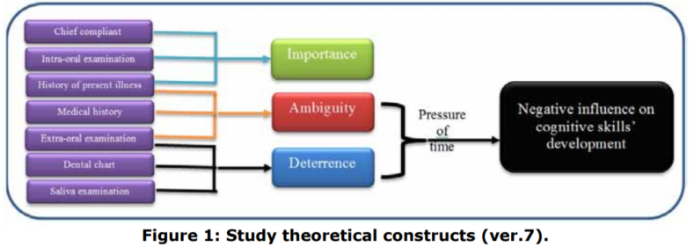
Recent Publications (minimum 5)
1- An introduction to qualitative research data analysis artistic approach, International Journal of Development Research Vol. 06, Issue, 12, pp.1061610619, December, 2016
2- Dental Students› Views of Their Clinical Cognitive Skills. A Qualitative study, Faaiz Alhamdani, JODR, Vol. 4, Issue 1, 2017)
3- Medical Research from Realism to Abstractism, Faaiz Alhamdani, Public Health Open Journal, Vol.2, Issue 2, 42-45.
4- Drawing as Learning Aid in Human Anatomy, Students’ Based Evaluation, Faaiz Y Alhamdani and Hatem A Hatem, Journal of Oral Health and Craniofacial Sciences, Issue 2, 90-95, 2017.
5- Issues in Clinical Dental Education, Faaiz Alhamdani, Journal of Dentistry and Oral Biology, Volume 2 | Issue 6 | Article 1045

Biography

Dr. Faaiz Alhamdani finished his PhD in Newcastle University, UK in 2012. Since then he became interested in qualitative research methodologies. Beside his interest in qualitative research he is also interested in educational research and quality of life research,
From 2012 he co-organized most of Iraqi Division (IAOR) events and in August, 2017 he was the main organizer and President of the 4th IAOR Scientific Conference in Antalya Turkey. He is also member of The American Association for Advancement of Sciences.

Presenting author details
Full name (Faaiz Yaqub Kadhum Al- Hamadani):
University: College of Dentistry, Ibn Sina University for Medical and Pharmaceutical Sciences
Designation(Assistant or Associate prof):
Country: Iraq
Mobile number: 009647706047791
Email: faaiz68@gmail.com
Track number: http://optics.physicsmeeting.com/call-for-abstracts.php (For track number follow this link)
Category: (Oral presentation)
Research interest: Qualitative Research, Educational Research
Your profile page URL in your department: http://www.ibnsina.edu.iq/upload/upfile/ar/653.pdf
Year of birth: 1/12/1968
Linked In/Facebook/twitter account:

Note: Please fill up the Red mark fields so that it would be easier for us to cite your details in the conference particulars. (Please do not forget to fix your photo and Logo above the title)

