

How to make clear & diagnostic-x-ray images

Abstract
Making bitewing and periapical x-ray for different dental services may consume the patient and dentist time.
This will make the assistant frustrated and lost the dentist time for repeating unclear x-rays images.

Unclear x-ray images could lead to misdiagnosis and wrong dental treatment.

Understanding the mouth and teeth anatomy in addition to the correct film position in the mouth for x-ray exposure, for sure will lead to clear and diagnostic x-ray images.

I will simplify in this presentation the steps for making correct X-Ray images.
Perapical and bite wing x-ray

Objectives:
1-imagination for clear x-ray images before exposure taken.
2- How to make clear and diagnostic x-ray images
3-how to reduce patient exposure to radiations

4-easy technique for digital sensor adaptation in the mouth without using Rinn instrument

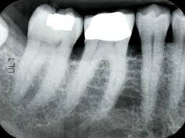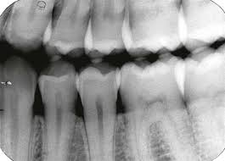

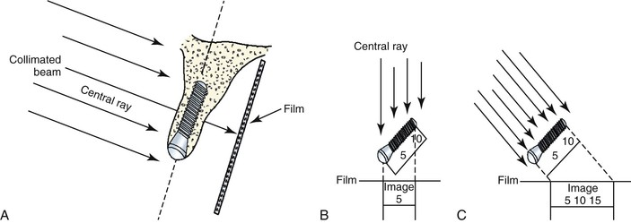

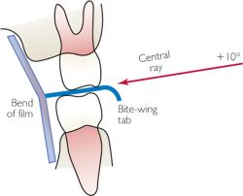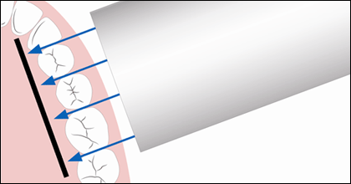

Biography
BDS.AEGD-ARD-RESTORATIVE CONSULTANT
20 years of experience in clinical dental practice –providing many training course in
different dental subjects.
Author of
- Principle for dental assistant practice book
- Operative dentistry in the phantom lab book

Dr.Fahad Hussain AlQahtani
Restorative and cosmetic consultants
Medical Director of Moustashark dental center and training center
Riyadh – King dom of Saudi arabia
Mobile number 00966554477749
Email:mrfahad55@hotmail.com
Category - Oral presentation 15-30 minutes

