Structural of Pd(II) and Pt(II) complexes of N-phenyl-N′-(4′-methylthiazol-2′-yl)-thiourea by mass and infrared spectroscopy
Suhair M. S. Jambi , Samir S. Kandil ²
University of Jeddad, Chemistry Department, Jeddah, Saudi Arubia
²University of Tanta Chemistry Department Tanta, Egypt

Abstract

An efficient synthesis of ligand N-phenyl-N′-(4′-methylthiazol-2′-yl)-thiourea via the reaction of 2-amino-4-methylthiazol and Phenylisothiocyanate under mild conditions has been developed. This reaction proceeded well at room temperature, to products in excellent yields for a wide range of substrate. The corresponding complexes of these ligand were synthesized by the reaction of the ligand with Pd(II), Pt(II) at molar ratio of 1:2. The structures of compiexes were identified by physic-chemical and spectroscopic techniqes (IR, Mass spectrometry). IR spectrum of the ligand displays two bands at 3340 cm⁻¹ and 3165cm⁻¹, attributable to υ(N1–H), υ(N2-H), respectively. The IR spectra of the complexes showed stretching frequency for the N2H group and the disappearance of the band of N1H. The disappearance or absence of the strong band at 650cm⁻¹ in the free ligandis a strong evidence for the coordination of the nitrogen atoms of the thiazole ring in the metal complexes. The mass spectrum of the PdL₂ complex revealed the highest peak at m/z = 602 corresponds to the molecular weight of the parent cationic species [M]⁺. This assign mentis based on the atomic weight of Pd-106 isotope. The mass spectrum of the [PtL₂ClH₂O] complex revealed the highest two peak with low intensity at m/z = 692 and 693, based on atomic weight of Pt-195 and Pt-196, respectively, among the isotope cluster peaks assigned to a molecular ion of the complex. The mass spectrum of the [PtL¹₂].4H₂O complex revealed the highest peak at m/z = 691 corresponds to the molecular weight of the parent cationic species [M]⁺. This assign mentis based on the atomic weight of Pt-165 isotope among the isotope cluster peaks assigned to a molecular ion of the complex. This corresponds to the molecular weight of the non-aqueous cationic complexPtL₂^{┐+.}.

Image

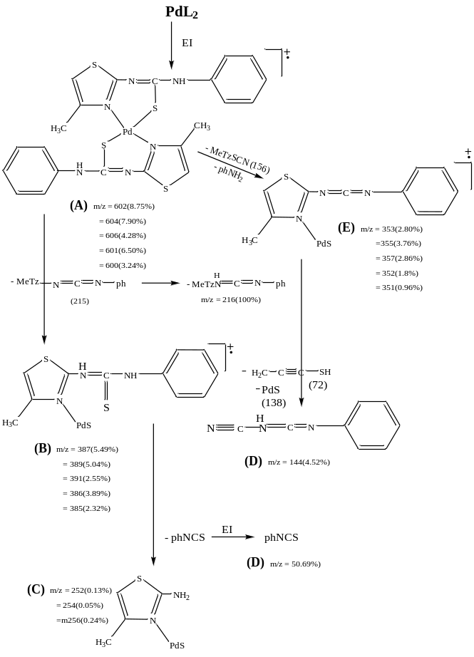

Scheme. Fragmentation pathways of [PdL₂]

Recent Publications (minimum 5)
1. A.Shokrollahi , K.Ramdar , Journal Of Taibah University For Science , 11 (2017) 782-787.
2. F.Wang, X.Tang, X.Wang, K.Huang, H.Feng, Z.Chen, Y.Liu,H.Liang, European Journal of Medicinal Chemistry,155 (2018) 639-650.
3. X.Ju, K.Igarashi, S. Miyashita, H.Mitsuhashi, K. Inagaki, S.Fujii, H.Sawada, T.Kuwabara, A.Minoda, Bioresource Technology,211 (2016) 759–764.
4. Y.Zeng, R.Cao , J.Yang , X.Li , S.Li ,W.Zhong, European Journal of Medicinal Chemistry,119 (2016) 83-95.
5. Y.Shimizu , Y.Yoshikawa , T.Kenmotsu , S.Komeda ,K.Yoshikawa , Chemical Physics Letters , 678 (2017) 123-129.

Biography (150 word limit)
Suhair Mansour Jambi, has completed her PhD at 2011 from King Abdulaziz university in Saudi Arabia in Jeddah. She is interested in modern technologies in the field of metallic complexes, the structure of metal complexes using modern methods, thiourea complexes and their use in the treatment of some microbes and some diseases such as cancer. She had published more than 13 papers in a reputed journal such as Z.Kristallogr.NCS, journal of Molecular Liquids, journal of Molecular Structure, journal of Sulfur Chemistry. Now she is work at the university of Jeddah..
Email: smjambi@uj.edu.sa

Notes/Comments:

